WorkSpaces Manager – Admin guide

Updated 5th Sep for WorkSpaces Manager 5.4.0

Product highlights:
- WorkSpaces Environment Management with optional application self-service feature for domain group-based application deployment
- Task driven User & WorkSpaces provisioning
- Performance monitoring
- Multi-AWS Account
- Multi-Domain
- Automatic reboot schedule defined on a per WorkSpaces basis
- Cost reporting and Cost Optimisation
- WorkSpaces Performance Monitor Agent to report on Processer, Memory and Disk statistics

WorkSpaces Manager provides a full Amazon WorkSpaces management portal. Containing both a user self-service portal and administration portal administration of WorkSpaces in a simple to use browser-based portal. This removes the need to provide staff with access to the AWS console and provides easy searching across all WorkSpaces and User information.
The User portal can be extended to provide application self-service if the environment, provide group-based application deployment service such as Cloudpaging, Liquidware FlexApp, Chocolatey, Microsoft SCCM or similar products.
WorkSpaces Manager is deployed as an appliance from the AWS Marketplace as an EC2 instance. It can be also deployed as a Packer AMI onto AWS.

Revision History

Revision Date | Version | Changes
13/01/2021 | 1.0 | Initial Document.
21/01/2021 | 1.1 | Minor changes to wording.
08/02/2021 | 1.2 | Updated to version 4.1 (added Fixed Tags and Auto Provisioning) and amended supported browsers
15/02/2021 | 1.3 | Amendment to AP Profile regarding Tags
18/03/2021 | 1.4 | Upgraded to WSM version to 4.2.0
07/04/2021 | 1.5 | Upgraded to WSM version to 4.3.0
02/06/2021 | 1.7 | Upgraded to WSM version to 4.4.0
15/06/2021 | 1.8 | Upgraded to WSM version to 4.5.0
13/08/2021 | 1.9 | Upgraded to WSM version to 4.6.0
14/09/2021 | 1.10 | Upgraded to WSM version to 4.7.0
18/11/2021 | 1.11 | Upgraded to WSM version to 4.7.2  Compatible with Cost Optimizer 4.2.0
18/03/2022 | 1.12 | Upgraded to WSM version to 5.2.0
09/05/2022 | 1.13 | Upgraded to WSM version to 5.3.0
05/09/2022 | 1.14 | Upgraded to WSM version to 5.4.0

Contents
Revision History 2
1. Introduction 4
2. User Self-Service Portal 5
2.1 Browser requirements 5
2.2 Walkthrough the portal 5
2.3 3rd Party applications management 6
3. Administration of the Portal 7
3.1 Admin Dashboard 7
3.2 Managing Objects 8
3.3 WorkSpaces 17
3.4 Task Queue 28
3.5 Help 28
3.6 User Preferences 29
3.7 Nuvens Scheduler 30
4. Config 31
4.1 Resources 31
4.2 Update 34
4.3 Options 36
4.4 Reports 70
5. Presenting applications to users via various delivery methods 83
5.1 Active Directory (AD) Group Applications 84
5.2 Cloudpaging applications 86
5.3 AppStream applications 88
6. Multi-Domain forest 90
7. Multi AWS Accounts 92
7.1 Step 1: In Account A 92
7.2 Step 2: In Account B 94
7.3 Step 3: Config WorkSpaces Manager in your main account (Account A) 97
8. Creating Dynamic Applications in AppStream 100
8.1 Creation Process 100
8.2 Administration Process 105

1. Introduction
This guide has been authored by experts at Nuvens to provide information and guidance on using WorkSpaces Manager.

Information in this document is subject to change without notice. No part of this publication may be reproduced in whole or in part, stored in a retrieval system, or transmitted in any form or any means electronic or mechanical, including photocopying and recording for any external use by any person or entity without the express prior written consent of Nuvens Consulting Ltd.

2. User Self-Service Portal

This covers the ‘User’ section of the Portal.

2.1 Browser requirements

- Chrome 22.x
- Firefox 12.x
- Opera 12.x
- Safari 5.1x
- Microsoft Edge 88.x

2.2 Walkthrough the portal

Users can save time by accessing the WorkSpaces Manager website by using the same URL as WorkSpace Administrators use. If they are not members of your WorkSpaces Admin roles specified in the ‘Options > Administrators’ and ‘Options > Roles’ sections of the WorkSpaces Manager portal, they will get a limited Portal which is specific to their Workspace(s) that use the logon that they are logged on with.
This saves a user calling the Service Desk if they cannot connect to their WorkSpace (for example, if the status is UNHEALTHY and they cannot connect to their WorkSpace) or they can stop it without any intervention from support. If the ‘User Restore’ and/or ‘User Rebuild’ options are checked in the ‘Options > Settings > Additional Options’ section of the WorkSpaces Manager admin portal, then these will appear too in the list.
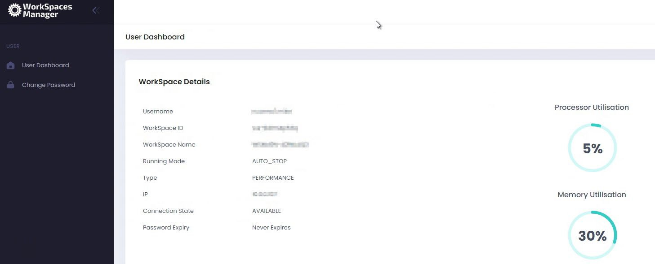

2.3 3rd Party applications management
If your company uses products such as Liquidware or App-V to deploy their applications to users within the WorkSpaces (as well as other devices such as PCs) then users can add and remove the applications themselves within constraints on licensing with some applications.
Users can now add and remove applications via Self-Service from:
- Active Directory Groups
These applications are delivered by the likes of App-V, FlexApp, etc. Users are free to add and remove ‘Free’ applications themselves. Those that are not deemed as ‘Free’ are license based and will require administrative intervention.
- Cloudpaging
If you use Numecent Cloudpaging, users can add and remove applications to their Cloudpaging client on their WorkSpace.
- AppStream
Users can add and remove ‘dynamic applications’ to their AppStream session (if administrators permit). Please refer to the Section 8 for more information on ‘AppStream Dynamic Applications’ for more information.

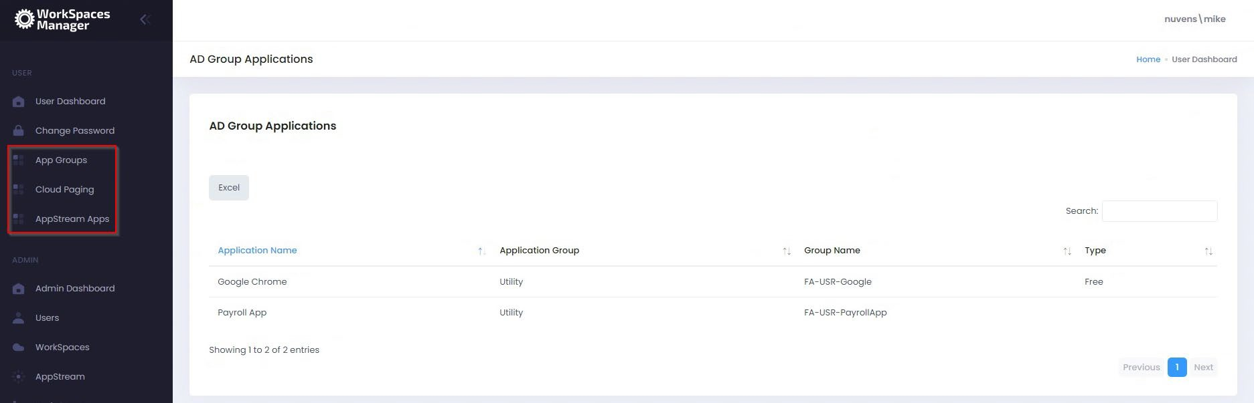
This is an example user who has gone to the portal and can see that they currently have no applications assigned to them.

3. Administration of the Portal

This covers the ‘Admin’ section of the portal. The Portal reports back to Nuvens the version in use, so that we can better support customers and versions.

3.1 Admin Dashboard

This gives an overview of your environment, along with an audit of actions carried out by portal admins and recommendations made. The audit log is fully searchable by anything that you see.
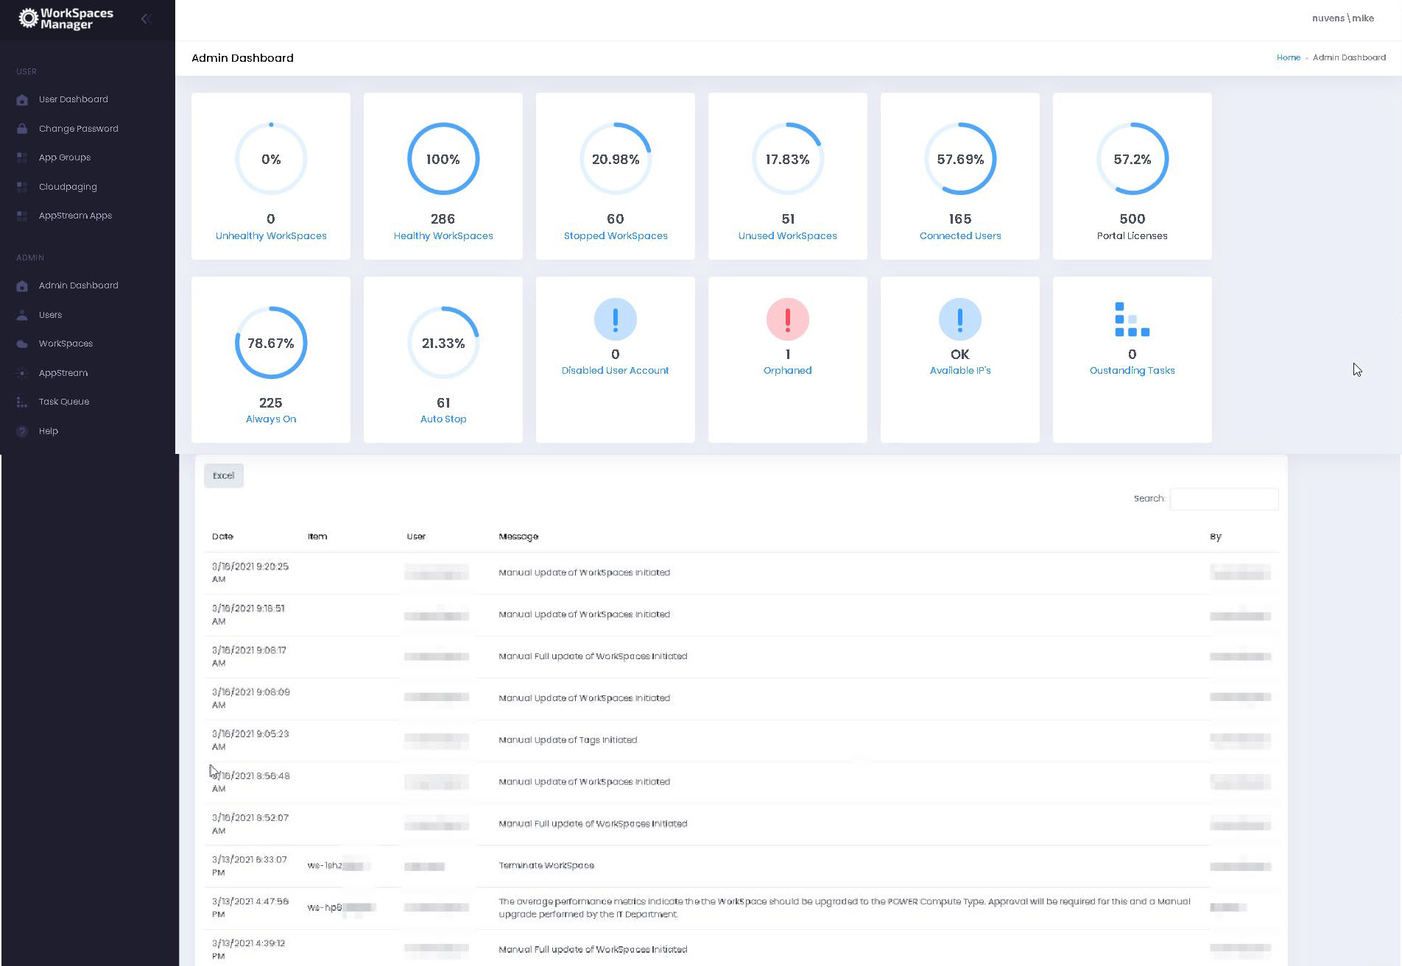

Clicking on each of the symbols provides information on each item. All are self-explanatory and are covered throughout this document, and you can action where appropriate (e.g., Unhealthy WorkSpaces, Disabled User Accounts and Orphaned WorkSpaces).
You can, per example, check the API calls logged to the Nuvens License Server if these calls have failed; or the API rates over the last 24 hours if exceeded. Or Auto-delete events are also tracked here.

3.1.1 Viewing available IPs

If you select ‘Available IPs’, it will give you the remaining IPs available to WorkSpaces in each WorkSpace Directory.
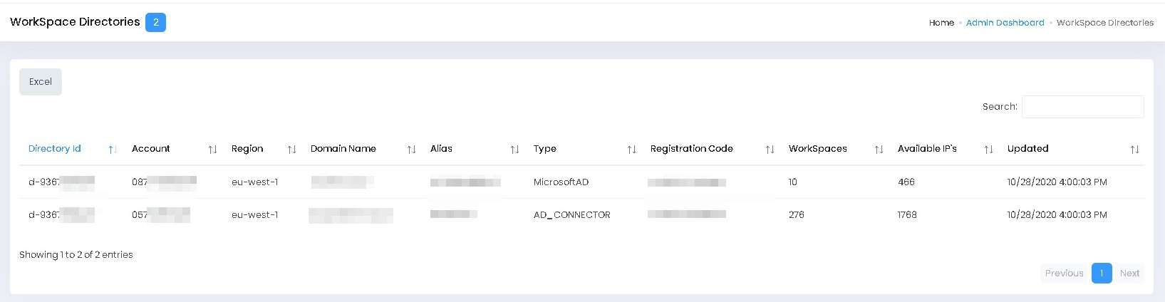

3.1.2 Customisation of the Admin Dashboard

You can customise the tiles in the dashboard by referring to Section 3.6 - User Preferences.

3.2 Managing Objects

3.2.1 Creating a new WorkSpace for a user

If you are in an organisation where every new user will automatically be assigned a WorkSpace, you can assign them one from within WorkSpaces Manager. WorkSpaces Manager can also seamlessly integrate with your joiners and leavers software such as SalesForce.

If you are doing this yourself, there are four ways of creating a user a WorkSpace:
- Adding a single new user
- Bulk importing users
- Creating one when you create a new user where you are using another user as a copy ‘template’
- Creating one for an existing AD user

3.2.1.1 Adding a single new user and creating them a WorkSpace

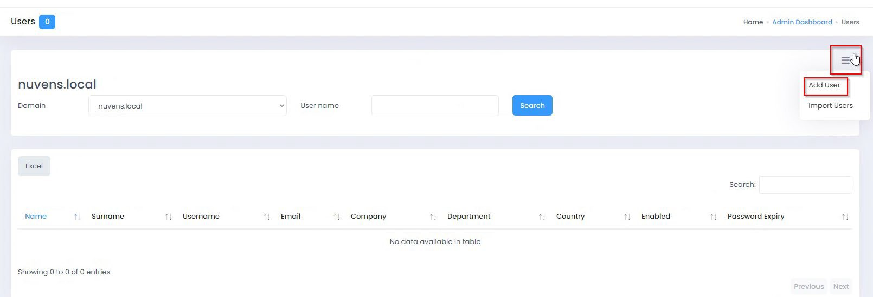
In the WorkSpaces Manager dashboard, go to the Users section and select the Actions button on the right-hand side. You will see an option for ‘Add User’.

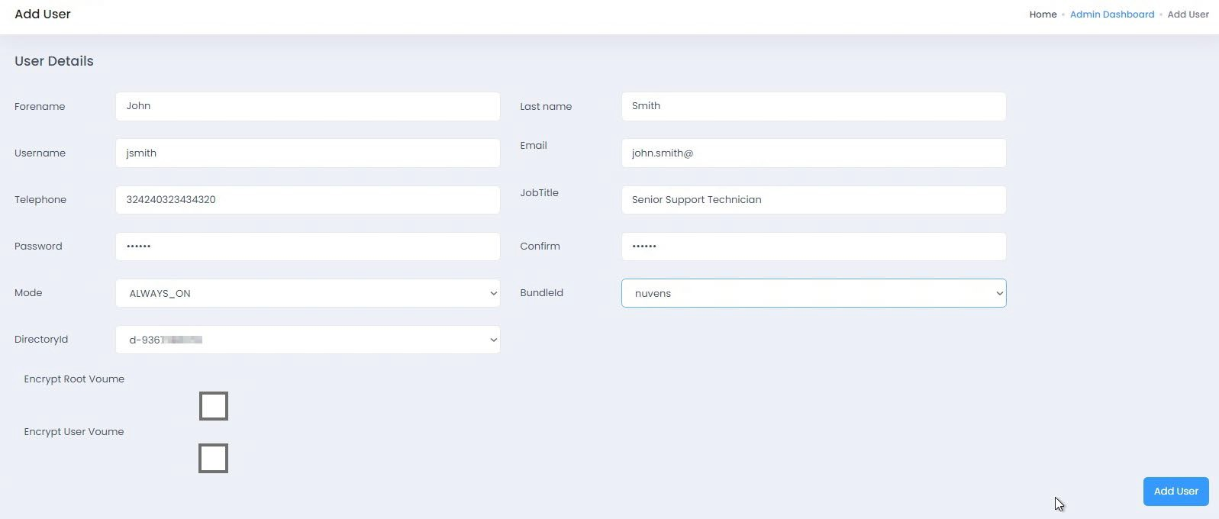
Fill in the details and select what type of WorkSpace you would like the user to have (Mode can be either ALWAYS_ON or AUTO_STOP and the preconfigured Bundle ID of your choice). Select ‘Add User’ and you now get a confirmation box to confirm if you would like to proceed.

The WorkSpace will take around 20-45 minutes to set up, depending on if it is to be encrypted. Nuvens always recommend encrypting both volumes. An email is automatically sent to the user with instructions on how to access their WorkSpace.

3.2.1.2 Bulk importing new users and creating them a Workspace.

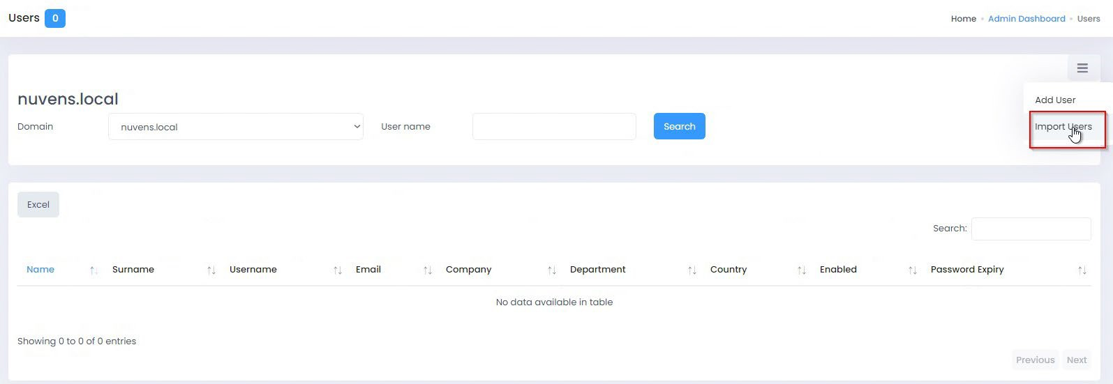
In the WorkSpaces Manager dashboard, go to the ‘Users’ section and select the ‘Actions’ button on the right-hand side. You will see an option for ‘Import Users’.

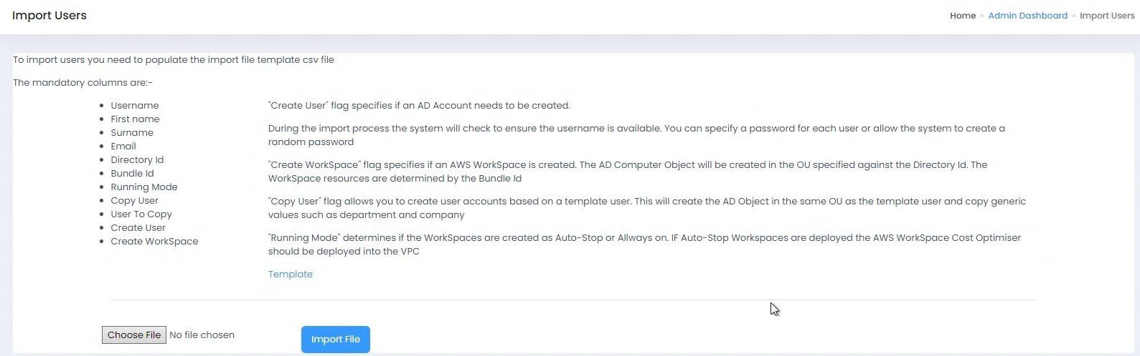
You will now see the following screen where you will be guided on how you need to fill in the template.

Select ‘Template’ and the template (Import_Template.xlsx) will be automatically downloaded. You will already have a sample user in there so you can see what you need to fill in. You will need to ensure that you have the correct Directory ID (as you may have more than one depending on where in Active Directory you want the users WorkSpace to be created) as well as the correct Bundle ID for the user (which may contain a different application set from other users).

- If you do not wish to create the user a WorkSpace at this point, set CreateWorkspace to FALSE

- If you do not wish to copy from a template user, set CopyUser to FALSE. You can specify which OU to place the new user in by entering the full OU location in the CreateOU column.
- If you want to copy from a template user, set CopyUser to TRUE and specify the username. This will place the copied user in the same OU as the template user. At this point, the process ignores whatever is in the CreateOU column.
Once you have filled in the users that you will need to back to the ‘Import’ screen, select your template from ‘Choose File’ and then select ‘Import File’.

When you select ‘Import File’, you are automatically taken to the ‘Task Queue’ option where you are advised of the status of your request. If you fill in an information incorrectly (such as DirectoryID and\or BundleID) then you will get an error stating that the WorkSpace could not be created.
The Task Queue will tell you at what stage the job is at. It will:
- Change User to TRUE when the user account is created.
- Change WorkSpace to TRUE if a WorkSpace has completed creation.
- Change Invite to TRUE if a user has been sent an email inviting them to connect to their WorkSpace.
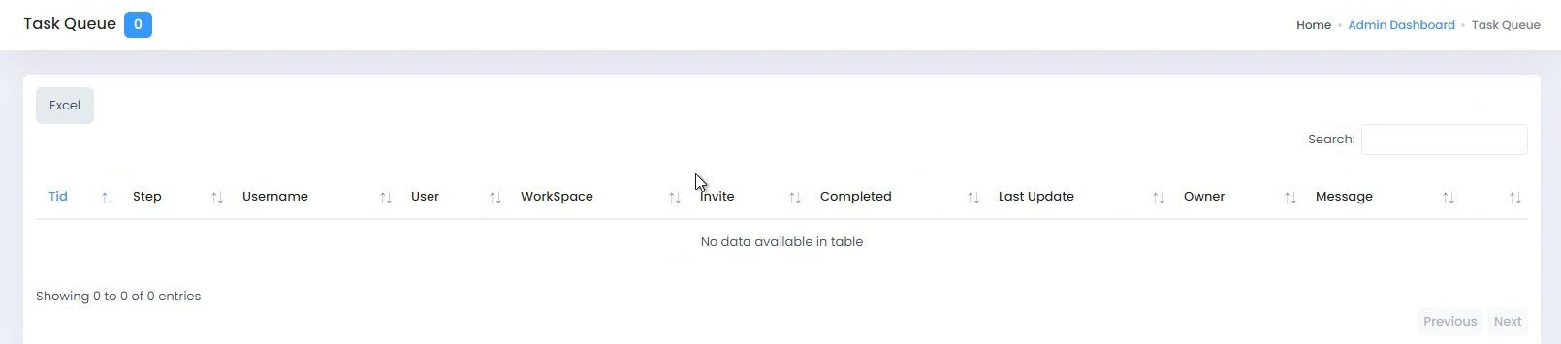
- Change Completed Status to TRUE if (a) a user account has been created but no WorkSpace creation was specified in the template or (b) a user account and WorkSpace has been created.

3.2.1.3 Copying an existing user and creating them a WorkSpace

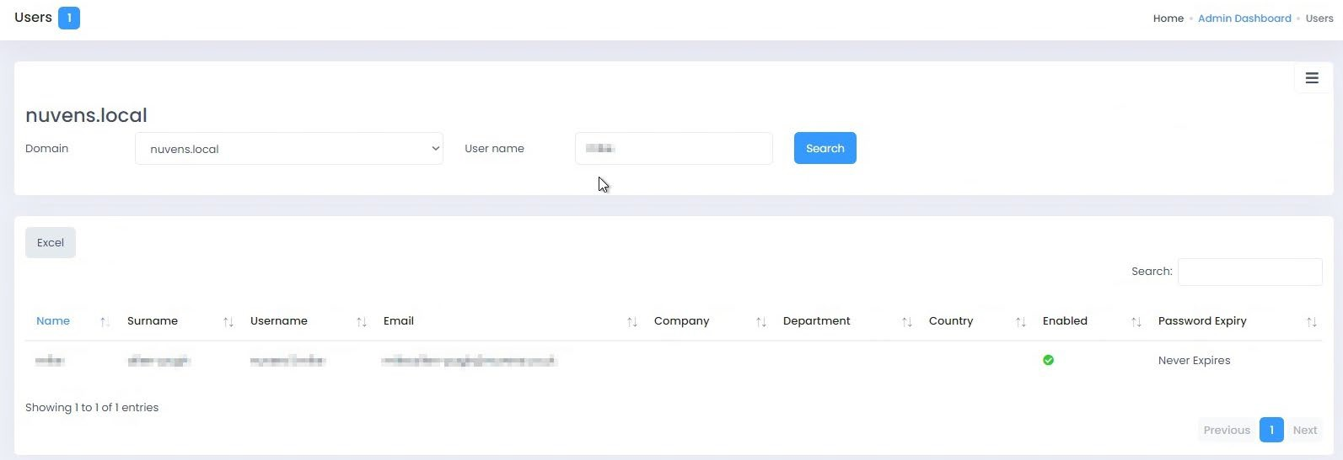
If you want to create a new user in Active Directory which is copied from an existing user (which will also copy all their AD groups) and create a WorkSpace for them at the same time, firstly search for the user that you want to copy in ‘Users’.

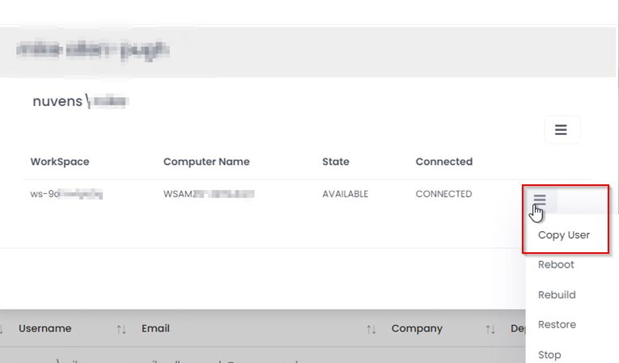
Then select the action button next to the user you want to use as a copy template. You can see at this point; this user has a WorkSpace and you can perform various actions. In this case, select ‘Copy User’.

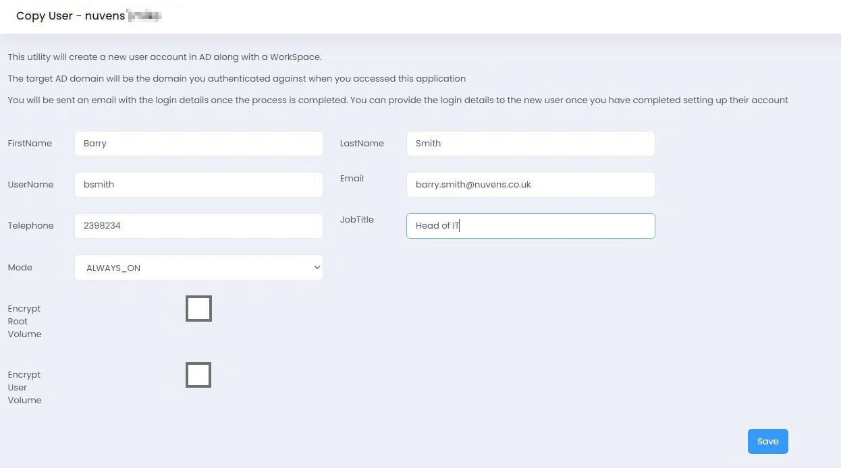
You then get a screen to fill in the information for the new user. When you have finished, select Save. This then goes into the Task Queue (which you can view from the menu). When complete, it will disappear from the list. The user will also get an email to say that their WorkSpace has been set up if that option is chosen.

3.2.1.3 Creating a WorkSpace from a user already in Active Directory
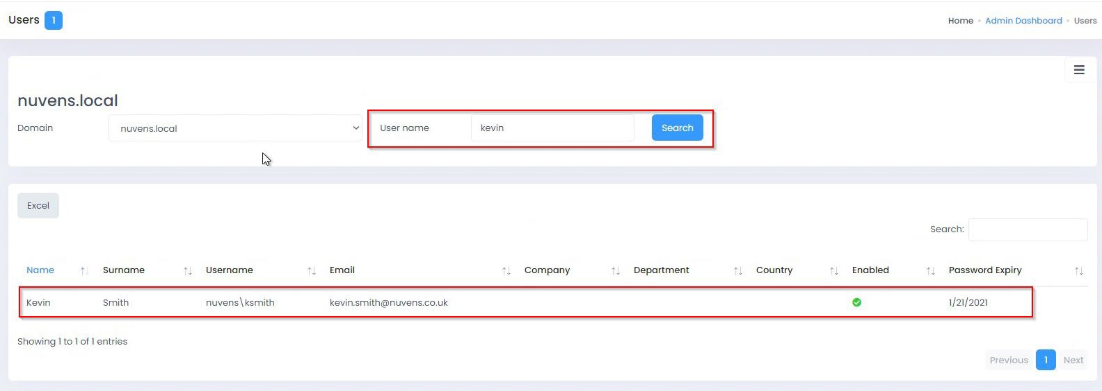
If your user already has an account in Active Directory, search for their account in ‘Users’. Select the domain that you are searching if you are using multi-domain. NOTE: As with any account you want to assign a WorkSpace to, it must have an email address associated with it. If an account has no email address, it will not show up in this search.

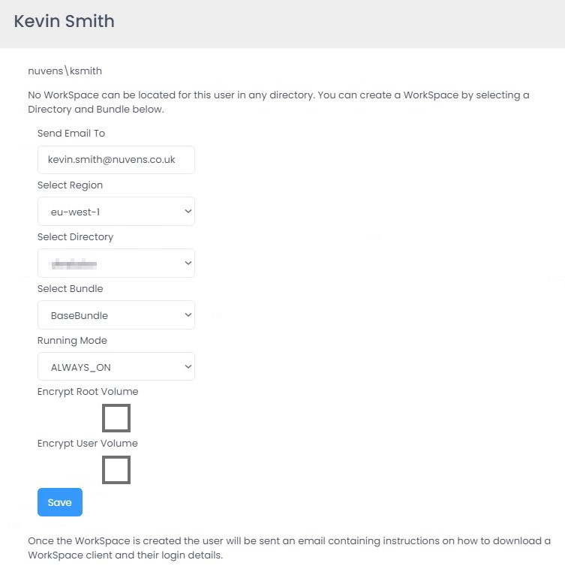
Select the user and WorkSpaces Manager will inform you if there is no WorkSpace for the user. You can now fill in the Directory, Region, Bundle, Running Mode and drive encryption options. When complete, select Save. As it says at the bottom, the user will be sent an email when the WorkSpace is created. If you wish to see the progress of the creation request, go to Task Queue in the main menu.

3.2.2 Adding an application to a user

A user can assign an application delivered to them via the likes of FlexApp, Cloudpaging, SCCM, etc, via their user portal (see Section 2.2). However, this may be a ‘paid for’ application (for example, MS Visio) and would require an administrator to add it for them.
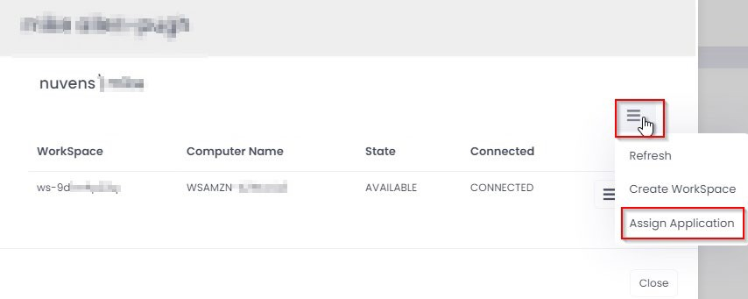
Also, administrators can add applications that are ‘not paid for’ themselves. To set up these applications, please refer to Section 5.

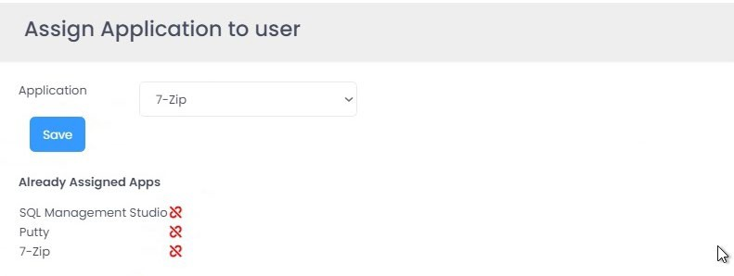
To add an application to the user’s WorkSpace, select the application from the dropdown list and select ‘Save’. To remove an application from the user’s list, select the icon to the right of the application in ‘Already assigned apps’.

3.2.2 Migrating user’s WorkSpaces to a different bundle
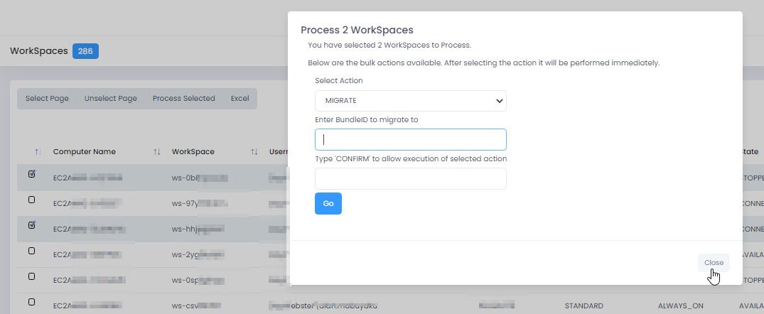
To migrate WorkSpaces to a different WorkSpace bundle, select the WorkSpace(s) from the WorkSpaces menu and select ‘Process Selected’. Then select Migrate and type in the bundle ID that you want to migrate to.

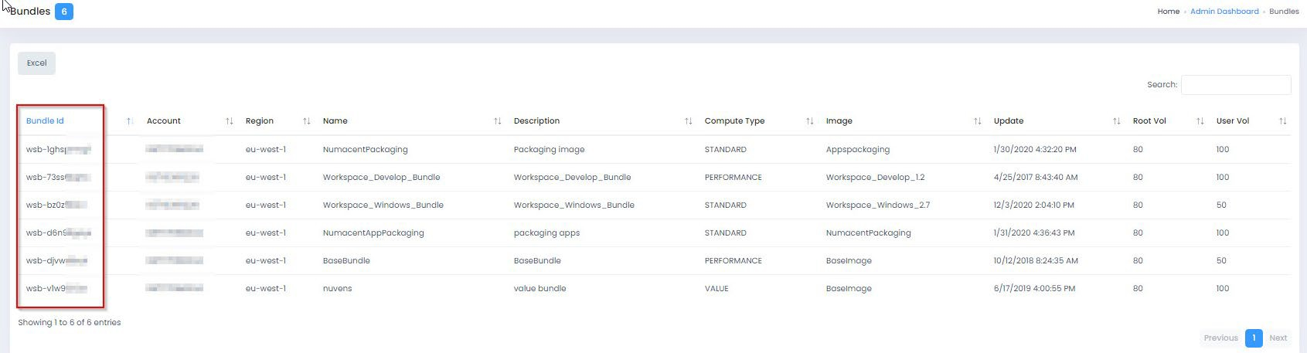
You can see your bundles IDs from Config > Resources > Bundles.

3.3 WorkSpaces

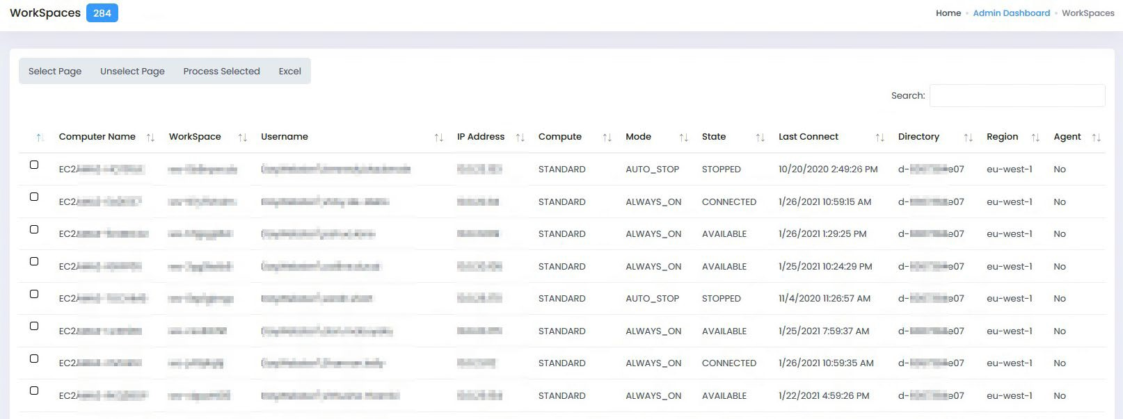
If you go to the WorkSpace tab, you will see a list of the users with WorkSpaces. This list is fully searchable by part searches on the contents of any column.

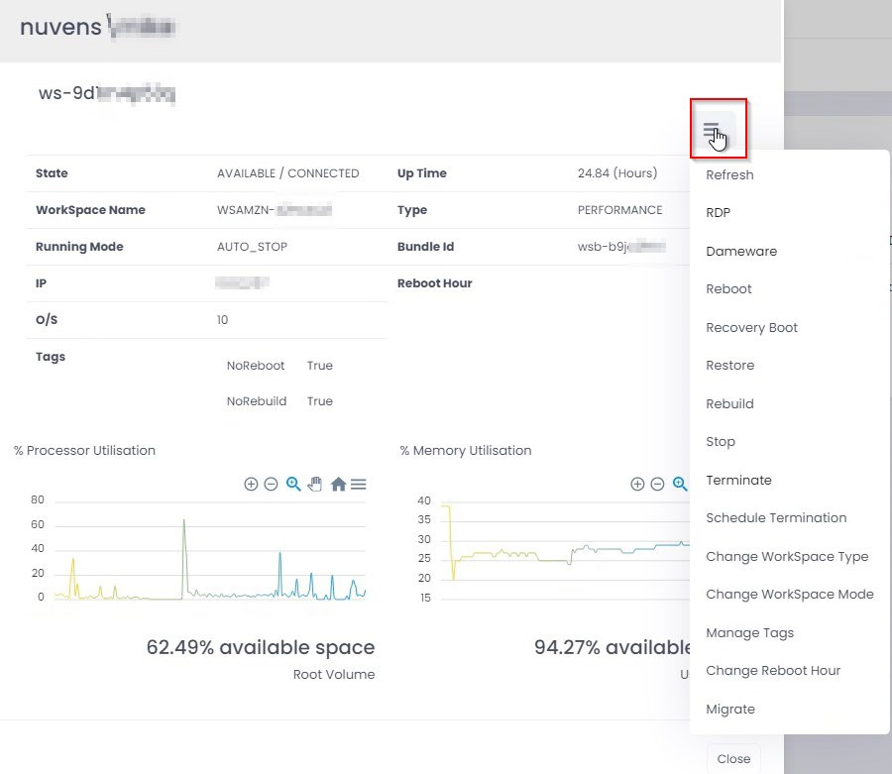
If you select a WorkSpace, you will see the details for it. To manage it, select the Actions button. This will give you a range of options.

3.3.1 Migrating user’s WorkSpaces to a different bundle
Refreshes the state of the WorkSpace to the latest state.

3.3.2 RDP
Downloads an RDP file so you can connect to the user’s WorkSpace. Note, this is not shadowing a user. It just lets you get on to their WorkSpace to look at processes, memory, etc. Username and password must be compatible with the WorkSpace credentials.

3.3.3 Dameware
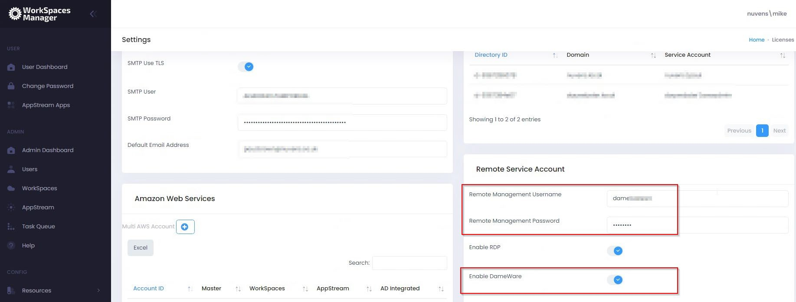
This requires the Dameware agent to be installed onto the WorkSpace. For this to generate the correct downloadable batch file with the credentials already filled in to connect, you must enter the correct connection account name in the Remote Service Account section of ‘Options > Settings’.

We have also tested this process with other session sharing tools such as TeamViewer. Please contact us for more information. The settings to auto-connect via DameWare can be found here.

3.3.4 Reboot
Reboots the user WorkSpace.

3.3.5 Recovery Boot
In the event of your WorkSpace residing on faulty host and it will not start, a recovery reboot will move it to another host.

3.3.6 Restore
Restores a user’s WorkSpace to the last known ‘good’ backup (AWS automatically takes backups every 12 hours).

3.3.7 Rebuild
If there are any issues with a user’s Workspace that cannot be resolved, you can rebuild the Workspace to its original state. This will rebuild the WorkSpace C drive and will restore the contents of the D drive the last automatic backup (D drive backups occur every 12 hours).

3.3.8 Stop
Stops the user’s WorkSpace.

3.3.9 Terminate
Deletes the WorkSpace permanently. Please note that if a WorkSpace is deleted, all contents will be lost. If a user has been storing configurations and documents on their D drive, then these will be permanently removed.

3.3.10 Schedule Termination
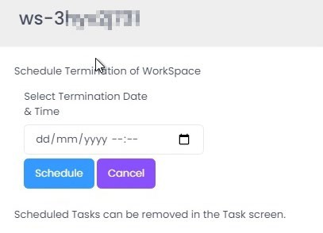
You can schedule a termination of a WorkSpace by entering the date and time of termination.

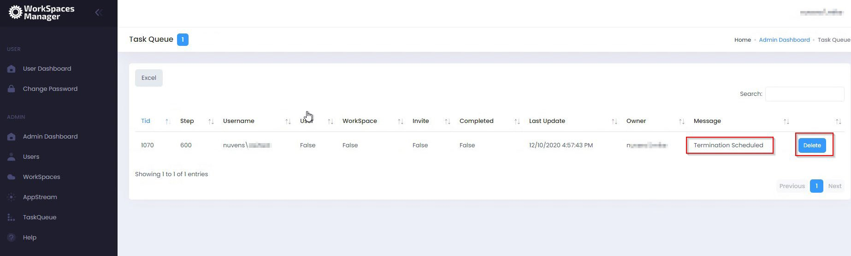
If you want to see what WorkSpaces are scheduled for deletion, go to the Task Queue option. If you want to delete the Scheduled Termination task, select ‘Delete’.

3.3.11 Change WorkSpace Type
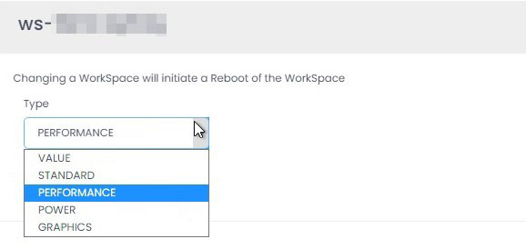
This allows the administrator to change the type of WorkSpace to a different compute type. This is not available to normal users through User Dashboard as they could choose a more powerful (and more expensive) WorkSpace without the administrator(s) being advised. Note that you can only change a WorkSpace type again after 24 hours has elapsed.

3.3.12 Change WorkSpace Mode
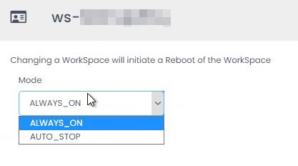
Allows you to manually change the WorkSpace from ALWAYS_ON to AUTO-STOP and vice versa. There is no limit to how many times this can be changed in any given period. This option is only available to WorkSpaces Manager administrators.
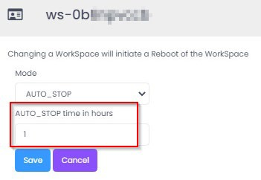
You can also change the AutoStop timeout if a WorkSpace is in AUTO-STOP mode.

3.3.13 Manage Tags
Allows you to add tags to the WorkSpace. You may need this for such things as billing. An example of tagging could be:
- Cost Code = 2344
- Department = Finance
- Owner = DevOps Team

You can also use Fixed Tagging (see Section 4.3.7) which provides consistency for your tagging and saves on typing.
** If you do not want your WorkSpace to be rebooted or rebuilt as part of a schedule, you can set a user WorkSpace tag as NoRebuild = True and/or NoReboot = True.
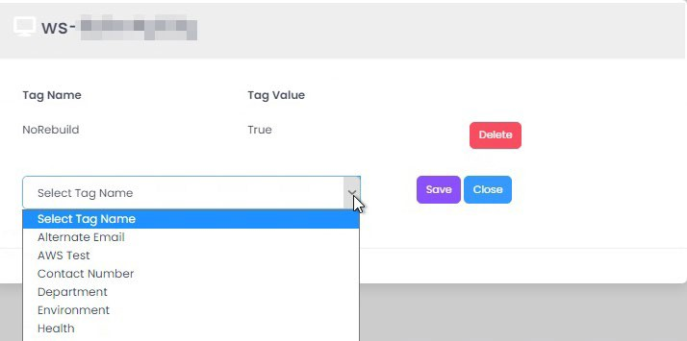
An example is if a user is a developer user and they have installed applications on their WorkSpaces. A WorkSpace rebuild will return the WorkSpace back to the original bundle build which will not have their custom applications. Hence, setting NoRebuild = True will stop this occurring as part of any automated task.

3.3.14 Change Reboot Hour
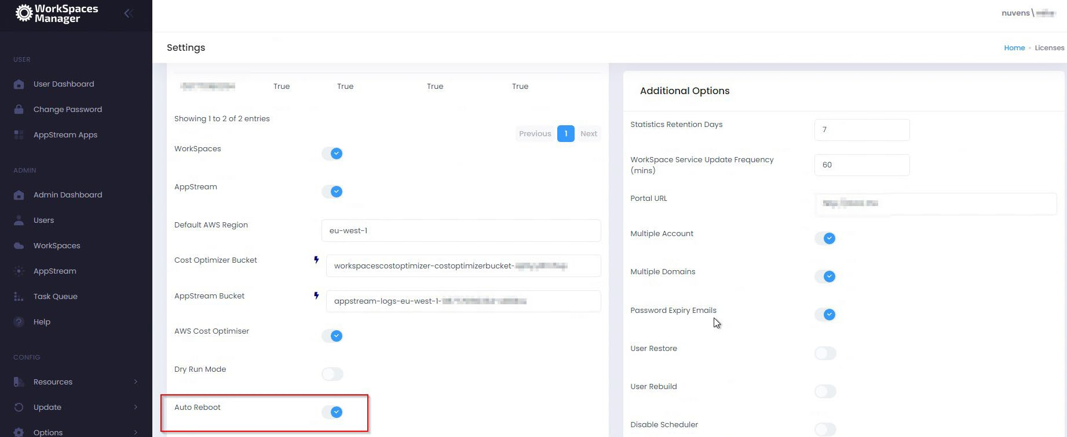
If you turn on the ‘Auto Reboot’ option in the Options > Settings > Amazon Web Services section, you can set the reboot time for individual WorkSpaces. By default, WorkSpaces do not automatically reboot, and this option allows you do set the option of doing so based on a time best suited to your user (or users).

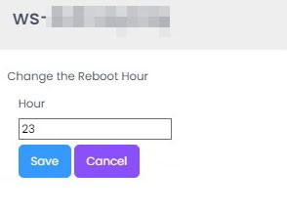
You can then set the reboot hour (24-hour format). This is in 24-hour format (i.e. 11pm is 23).
The Auto Reboot hour can be also applied via a AWS tag as specified in settings. The TAG value must be an integer representing the hour to reboot. Adding a TAGName will override any WorkSpace with a custom reboot hour.

3.3.15 Migrate
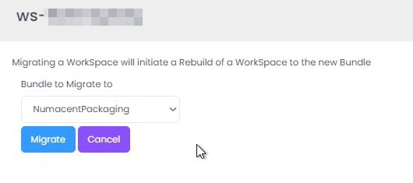
This enables you to migrate a user from one bundle to another.

3.3.16 Processor and Memory utilisation
Statistics are available if you have installed the WorkSpace Performance Monitor Agent (Windows only) as highlighted in the ‘Workspaces Manager Installation Guide’. By hovering over points in the graph, you can see approximately when spikes occur. You can also zoom in and out and download graphs in SVG, PNG and CSV format.
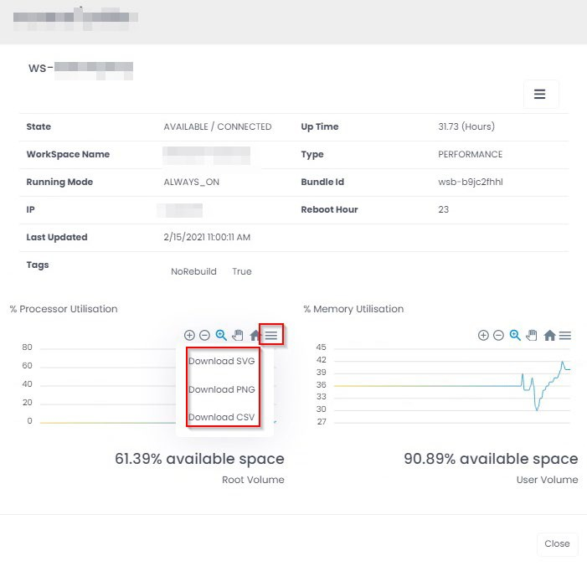
At the bottom, it shows the % Free space on the root (C) and user (D) volumes.
3.3.17 Client IP and approximate location
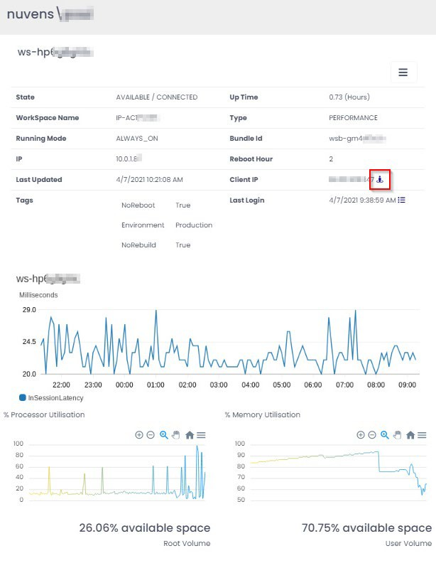
You can view the approximate location of a user by selecting the icon next to their ‘Client IP’.

This will then show you their approximate location (based on the provider).
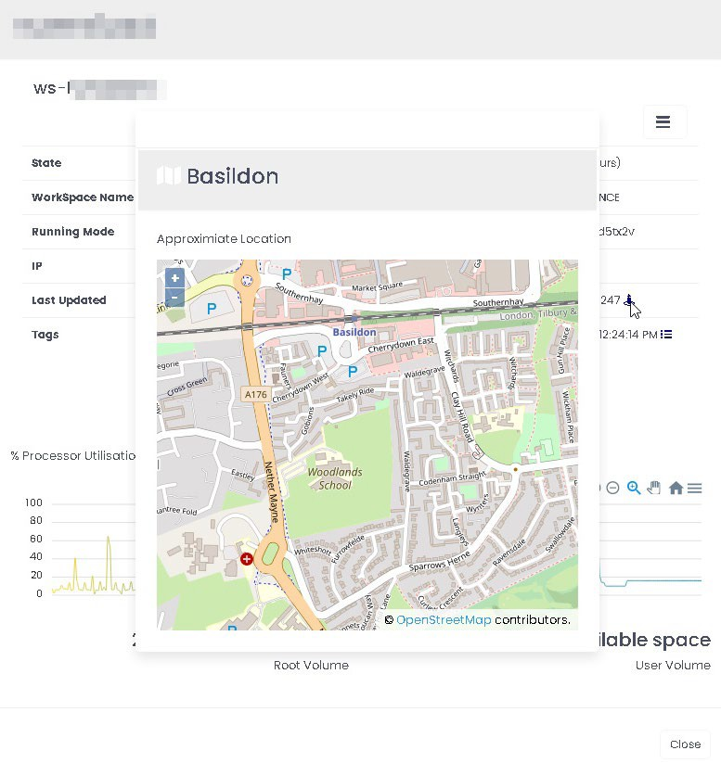
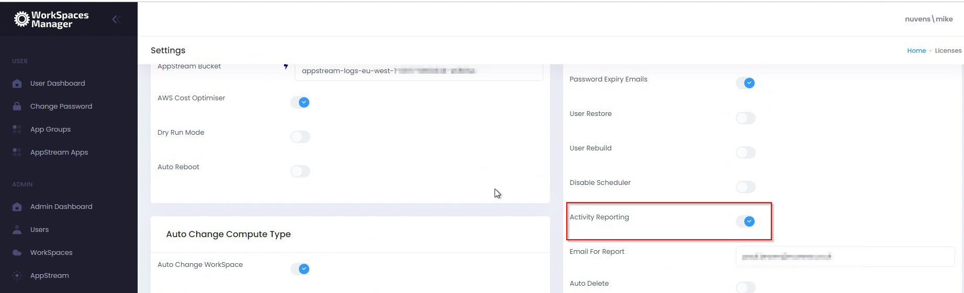
You can enable\disable the activity reporting function in the ‘Additional Options’ section of Options\Settings.

3.3.18 User last login times and dates.
You can view user activity (logon\logoff\disconnect\idle) times and dates of a user by selecting the icon next to their ‘Last Login’.
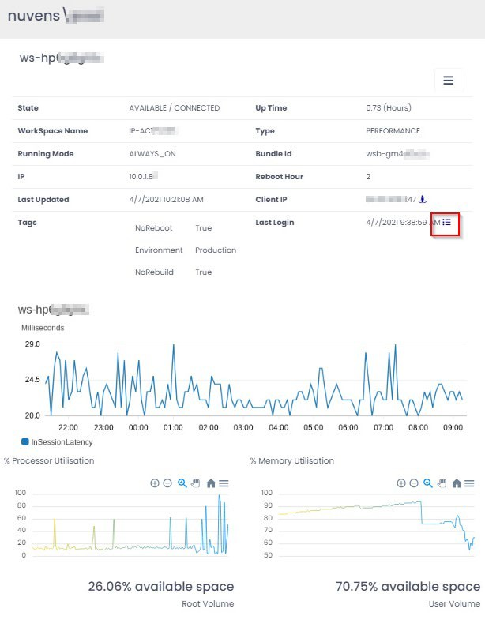
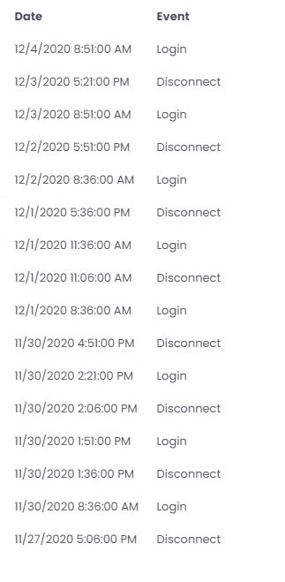
This shows their activity.

3.3.19 In-Session Latency
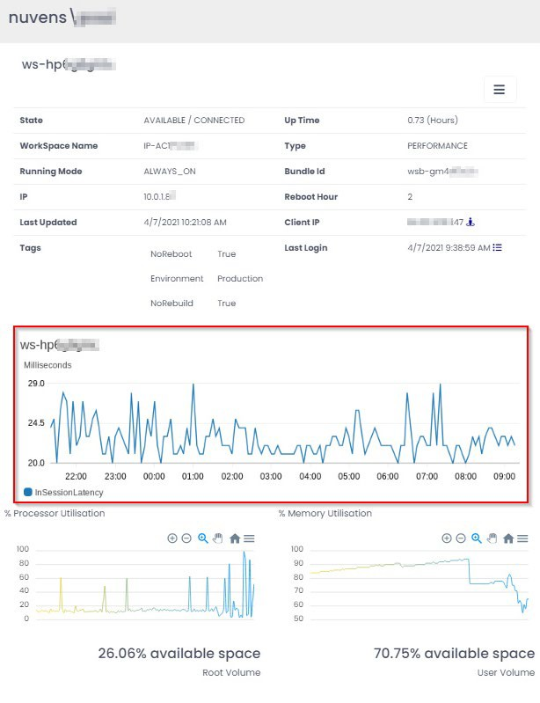
This shows the in-session latency of the session over a period.

3.4 Task Queue

This shows you the status of creation of WorkSpaces and users accounts if you are using the Import Template function. The update job runs every 10 minutes, hence please wait for the status to be updated in the next running job update phase. This list is fully searchable by part searches on the contents of any column.
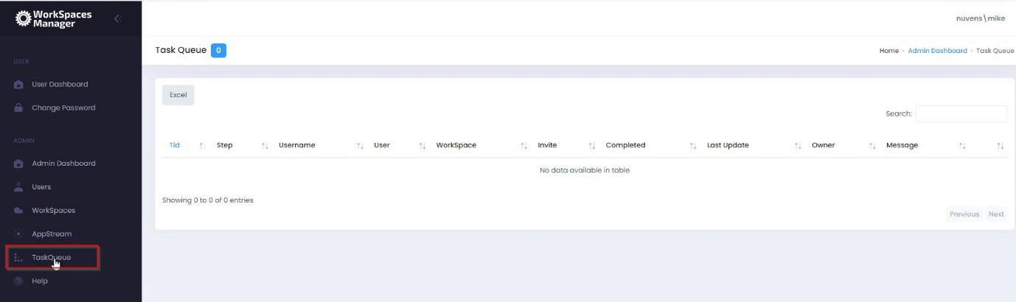
It also shows you tasks such as scheduled terminations of WorkSpaces.

3.5 Help
This shows some of the latest help topics that users and admins considered more common. Latest changes are also seen here.
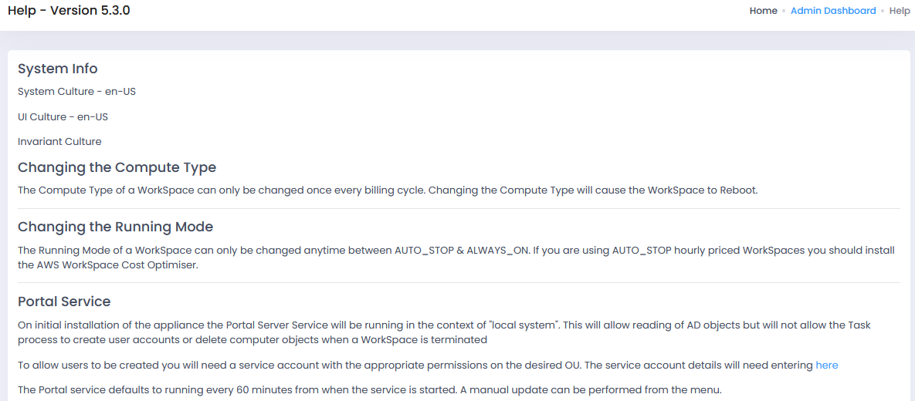

3.6 User Preferences
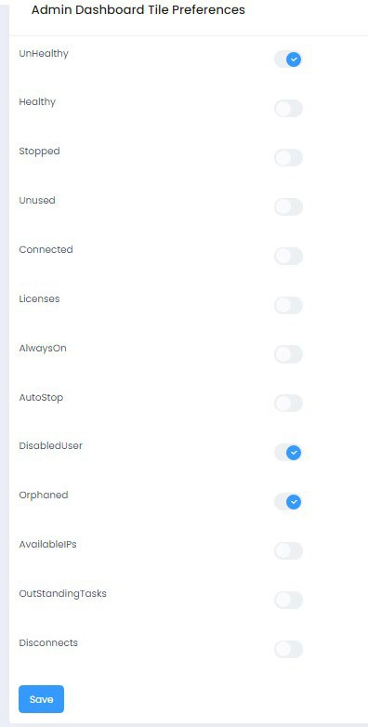
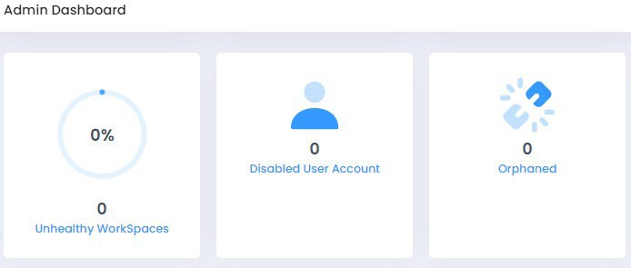
This offers the user the ability to set what they see in their Admin Dashboard. Here, we have selected to see unhealthy WorkSpaces, WorkSpaces with disabled user accounts assigned to them, and orphaned WorkSpaces

3.7 Nuvens Scheduler
In order to run all the scheduled tasks, the WorkSpaces Manager Appliance must have the Nuvens Scheduler service running. This can be checked on the Windows Services application (services.msc).
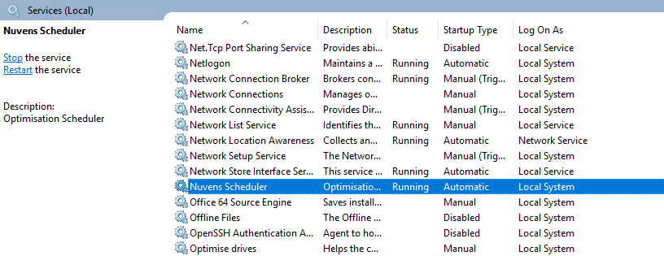

When the service is not running, the appliance will detect it and advice it with a message.
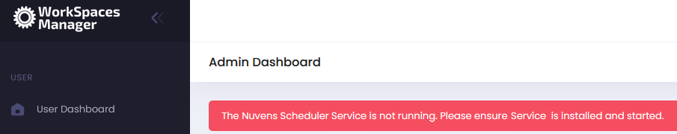

4. Config
This covers the Config section of the Portal.

4.1 Resources

4.1.1 Bundles
Lists all the WorkSpace bundles in the AWS account. The Search feature is available to filter. This list is fully searchable by part searches on the contents of any column. Since version 4.7.0, now it is included new Windows 2019-based WorkSpaces.
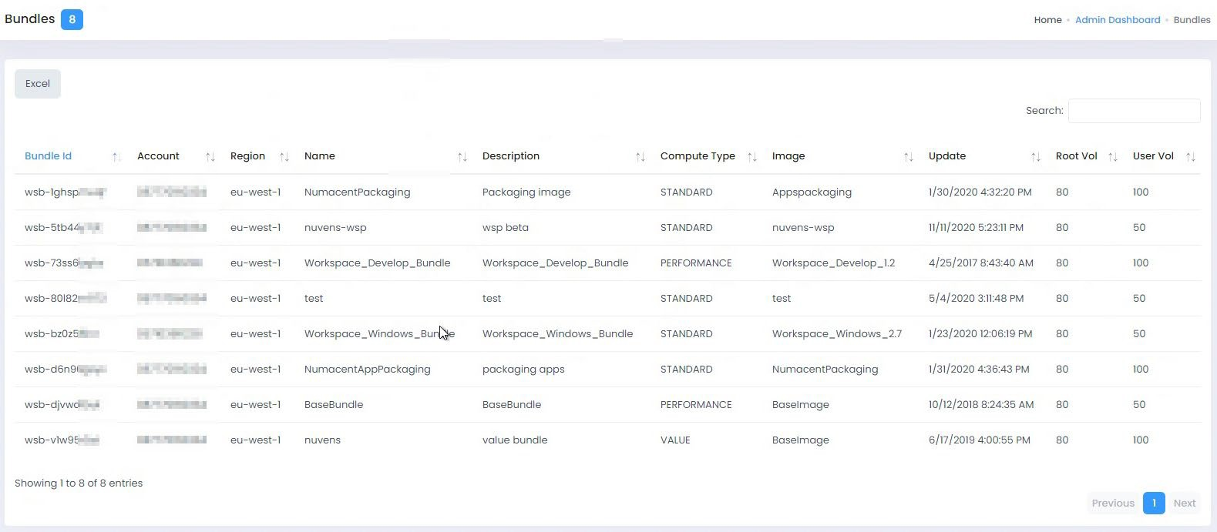
4.1.2 Directories
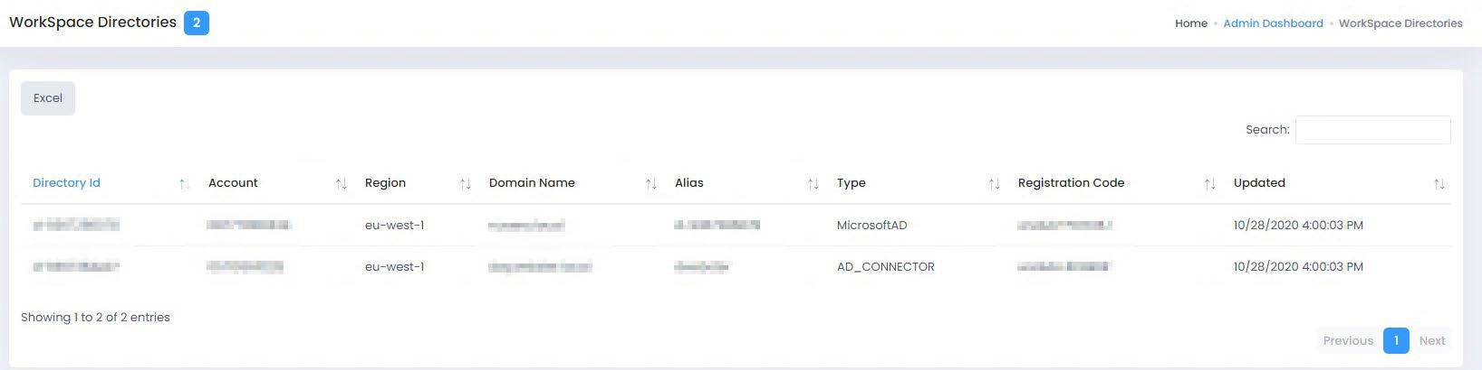
Lists all the WorkSpace Directories in the AWS account. This list is fully searchable by part searches on the contents of any column.

Here, we can also test the AD Service with the blue button on top:
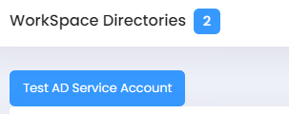

This action will result in a report with some best practices notes and information:
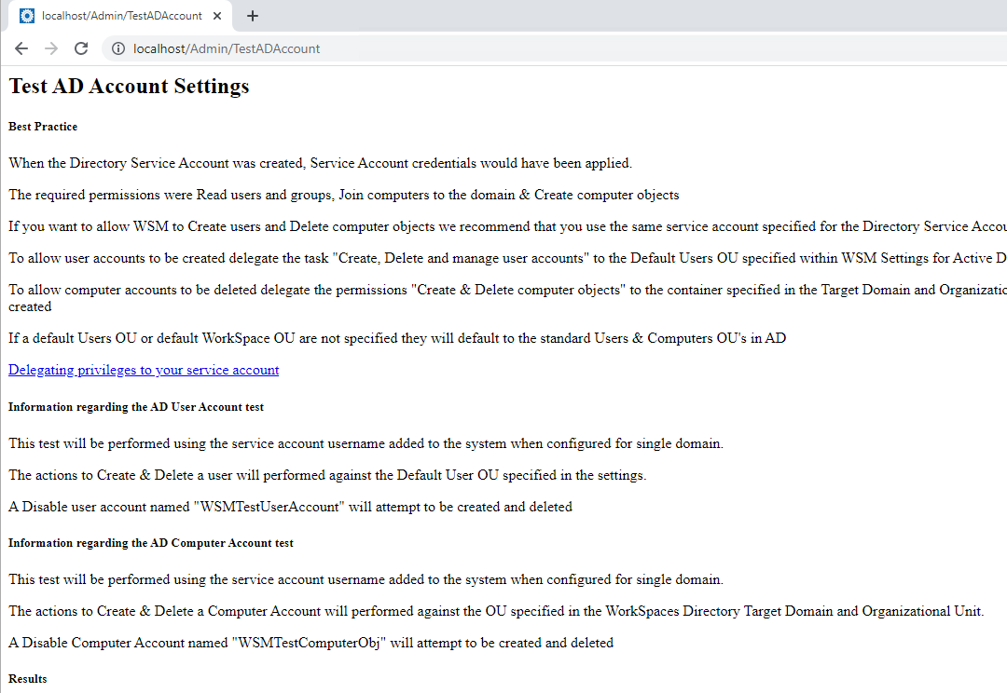
If the action times out or give an error, there is an issue with the credentials or the connectivity.
4.1.3 Regions
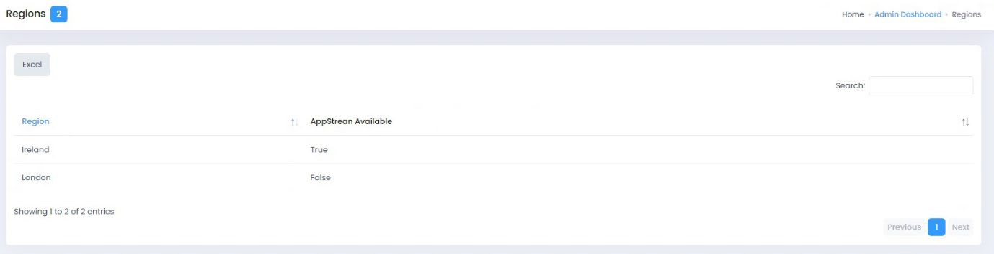
Lists all the regions configured for the account and whether the AppStream service is available in them. This list is fully searchable by part searches on the contents of any column.

4.1.4 Images
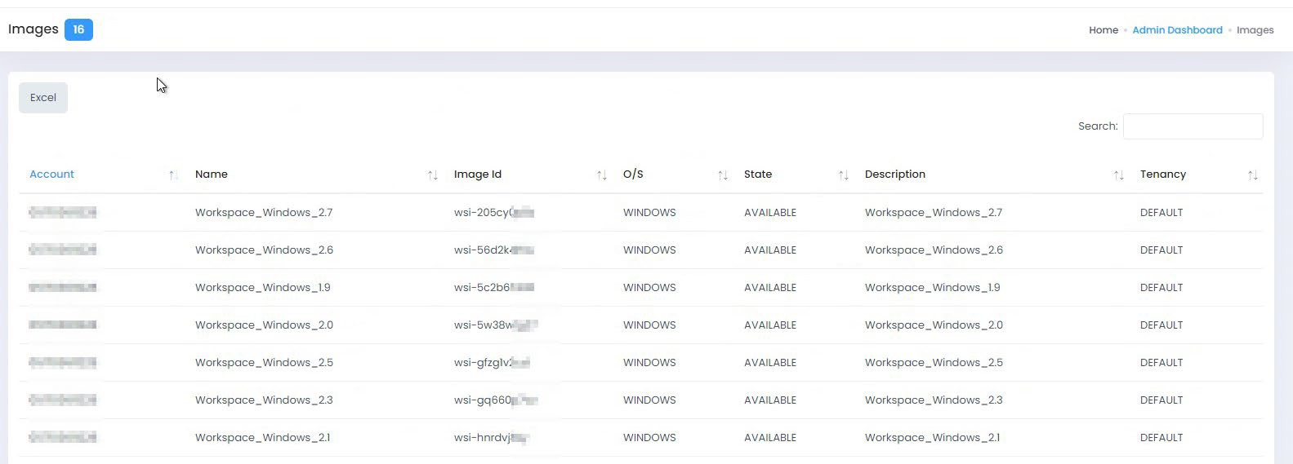
Lists all the WorkSpace images in the AWS account. This list is fully searchable by part searches on the contents of any column.

4.1.5 Email Templates
Email Templates can be managed through this interface which also allows dynamic variables.
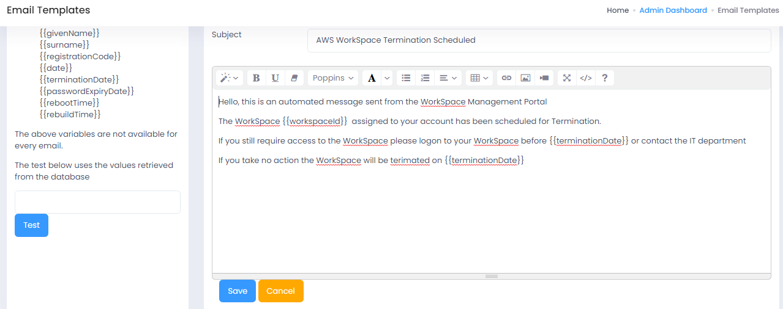
There are some cases in which the email templates are not downloaded when the appliance is deployed. In that particular, we can click on the “Check Missing Templates” button until the templates are visible.
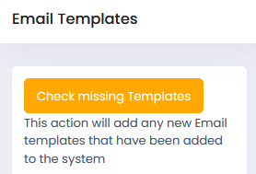
As of this version, there are currently a total of 5 templates, whose names are:
- DeleteScheduled
- PasswordExpiry
- RebootScheduled
- RebuildScheduled
- WorkSpaceCreated

4.2 Update
This ensures that the data that you are presented with for AD users, WorkSpaces, etc, is fully up to date in the local database on the WorkSpaces Manager appliance. You can choose whichever section of the database you want to update. If you do a Full Update (‘All’), it will take longer as it will do each of the updates. If you are working in a large Active Directory environment with a lot of WorkSpaces, this may take some time. It will inform you of when it is complete.

When you select an update on any of the options, wait for the status update to say, ‘Update of WorkSpaces Completed’.
4.2.1 WorkSpaces
Performs a quick update of existing WorkSpaces. This will only update WorkSpaces that you have permission to manage.
4.2.2 Tags
Updates Tags of existing WorkSpaces. This will only update Tags for WorkSpaces that you have permission to manage.
4.2.3 Sync Role Groups
Updates the AD groups used as Roles and its users.
4.2.4 Orphans
This is the same report as in Section 4.4.
4.2.5 Directories
This will update directories in all Regions.
4.2.6 Check Tasks
It will trigger an internal process to ensure that all the tasks related to checking services and objects are up-to-date.
4.2.7 Auto Provision
Performs a verification of auto provision profiles to detect if new WorkSpaces should be created.
4.2.8 All
Performs every update option in this list. This can take some time, especially in large environments with many WorkSpaces
4.2.9 Update Fleet Usage
Executes the internal trigger to retrieve fresh information about the AppStream Fleet Usage.
4.2.10 Update Session Data
Updates the AppStream Fleet Session Data.

4.3 Options
4.3.1 Settings
This is your main setup page. Most will have been filled in as part of your installation.

4.3.1.1 Licenses
This shows the WorkSpaces Manager version, the number of licenses procured, the current number of licenses in use and the expiry date of the license.
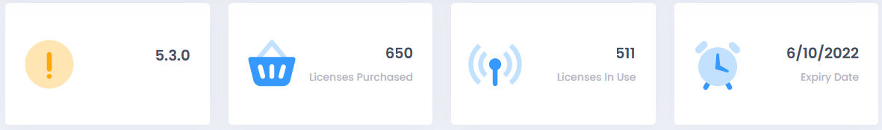
4.3.1.2 SMTP
This enables you to send emails to users when their new WorkSpace is ready and\or if their password is to expire.
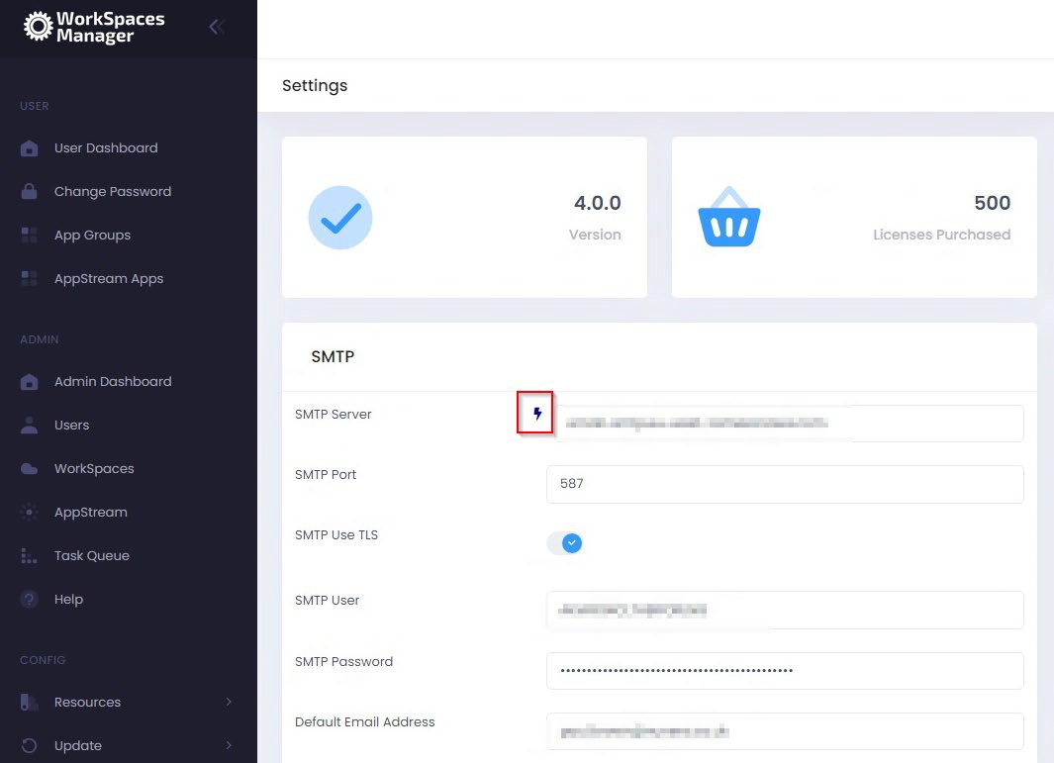
You could use AWS Simple Email Service (SES) to achieve this or your own SMTP relay. You can test the connection by selecting the icon highlighted.

4.3.1.3 Active Directory
It allows to modify the AD information set up during installation:
- AD Service Account
- AD Service Password
- NetBios Name
- FQDN
- Default User OU
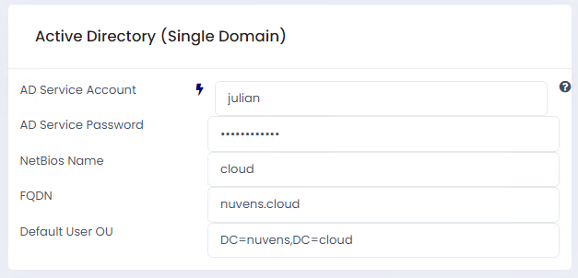

It also has an option (blue thunderbolt) to test connectivity.

4.3.1.4 Remote Service Account
This is an account that you configure to remote control user devices using Dameware, etc. This is the generic account that you connect with (which will be standard throughout your organisation). You can remote control a user’s WorkSpaces by selecting ‘Dameware’ (if you have selected the ‘Enable Dameware’ option in ‘Additional Options’ and it downloads a connection file for you to run. You can also manage actions on the Service Account from the portal, like deleting it.
Enable RDP
Enables the option for downloading an RDP file to connect to the user’s WorkSpace from within the Portal.

Enable DameWare
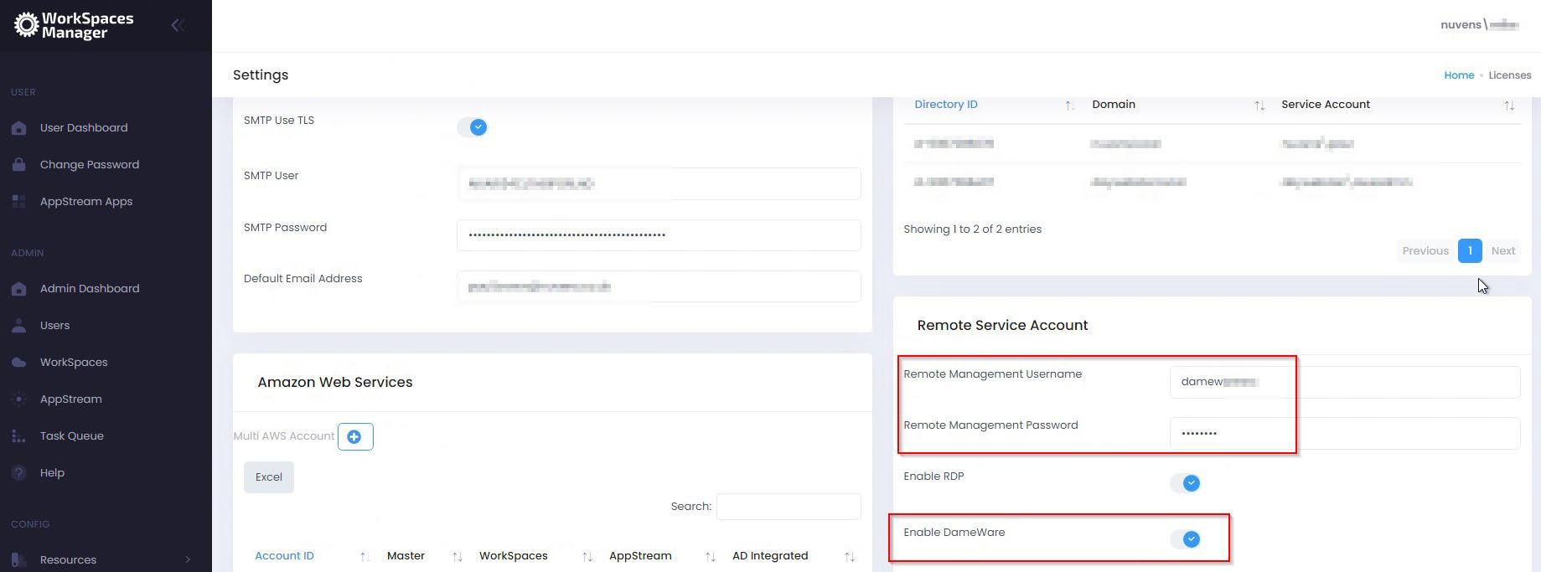
Enables the option for downloading an RDP file to connect to the user’s WorkSpace from within the Portal.

4.3.1.5 Amazon Web Services

Single\Multi-AWS Account
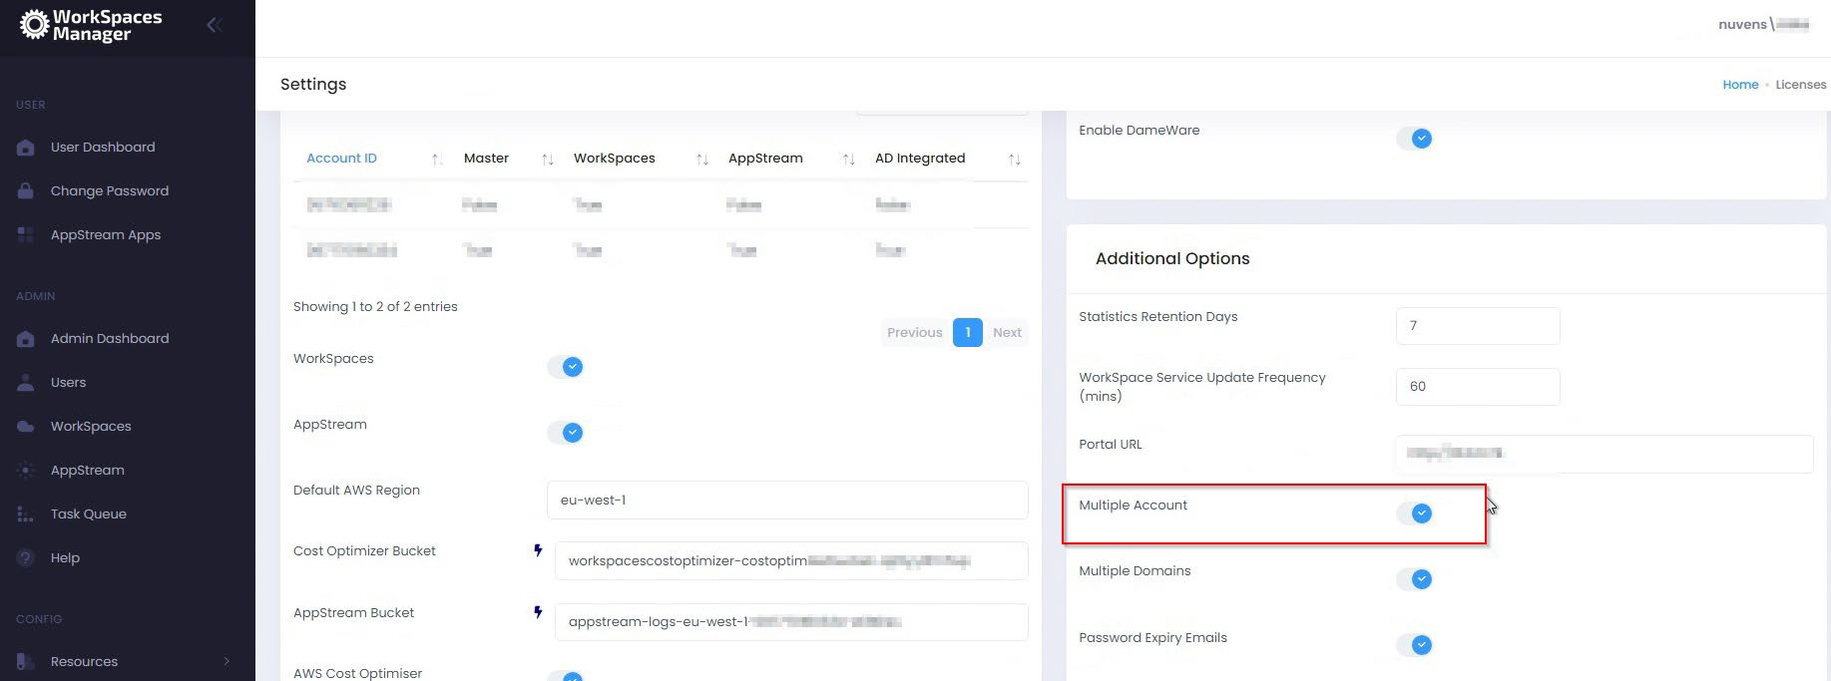
WorkSpaces Manager allows you manage WorkSpaces across single, or multiple, AWS accounts. When you set up WorkSpaces Manager, you will set up a single account. You can set up multi- AWS accounts by enabling this function and following the instructions in Section 7 of this document.

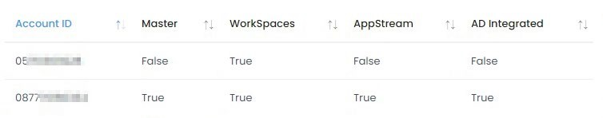
You will see a summary of the Account ID(s) when they are added.
Click on one and you will see the options. You can turn some on and off (like Dry Run mode) as preferences
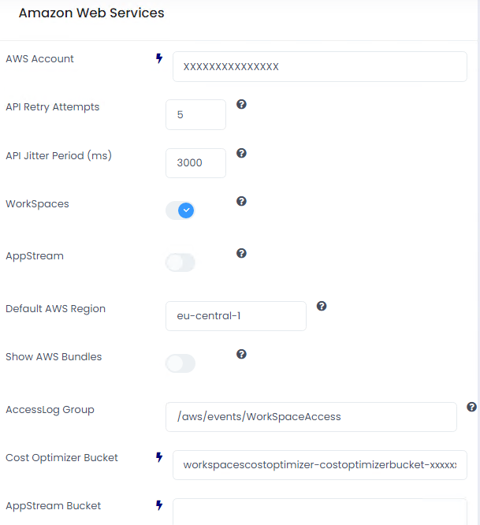
API Retry Attempts
Number of attempts to retry an AWS API call.
API Jitter Period (ms)
Number of milliseconds used to create a random delay between API Calls to AWS.
WorkSpaces
Turns on the WorkSpaces Management menu function.
AppStream
Turns on the AppStream Management menu function.
Default AWS Region
This is the AWS Region that your Amazon WorkSpaces are hosted in. For example, Ireland will be eu-west-1. A full list of regions can be located here. Unused regions can also be deleted if needed.
Show AWS Bundles
Enables visualization of AWS Default Bundles for WorkSpaces.
AccessLog group
This is the bucket name mentioned in the ‘AWS WorkSpaces Cost Optimizer’ section earlier on the document.
Cost Optimizer Bucket
This is the bucket name mentioned in the ‘AWS WorkSpaces Cost Optimizer’ section earlier on the document.
AppStream Bucket
Specifies the AppStream Usage bucket.
AppStream Settings Bucket
Specifies the AppStream Settings bucket.
AWS Cost Optimizer
This enables the AWS Cost Optimiser, which is recommended. The info can be checked here. However, since this CloudFormation template uses Lambda and ECS tasks within AWS, if it cannot be used, when this option is disabled, it will use the inner functions on the Appliance to obtain the Costs and provide some optimization recommendations.
Dry Run Mode
Running the Cost Optimiser in Dry Run Mode will show you the changes that would have been made.
Auto Reboot
This gives the ability to set reboot times on WorkSpaces. This is available once you have set up the Portal.
Auto Reboot Tag Name
If AutoReboot is enabled and a value is added in this field, the “Reboot Hour” will be taken from the Tag value.

4.3.1.6 Auto Change Compute Type
You can opt for WorkSpaces Manager to automatically change compute type of a WorkSpace. This is useful if, for example, you had a user running heavy spreadsheets on a Standard WorkSpace and it would benefit them with being upgraded to a Performance WorkSpace.
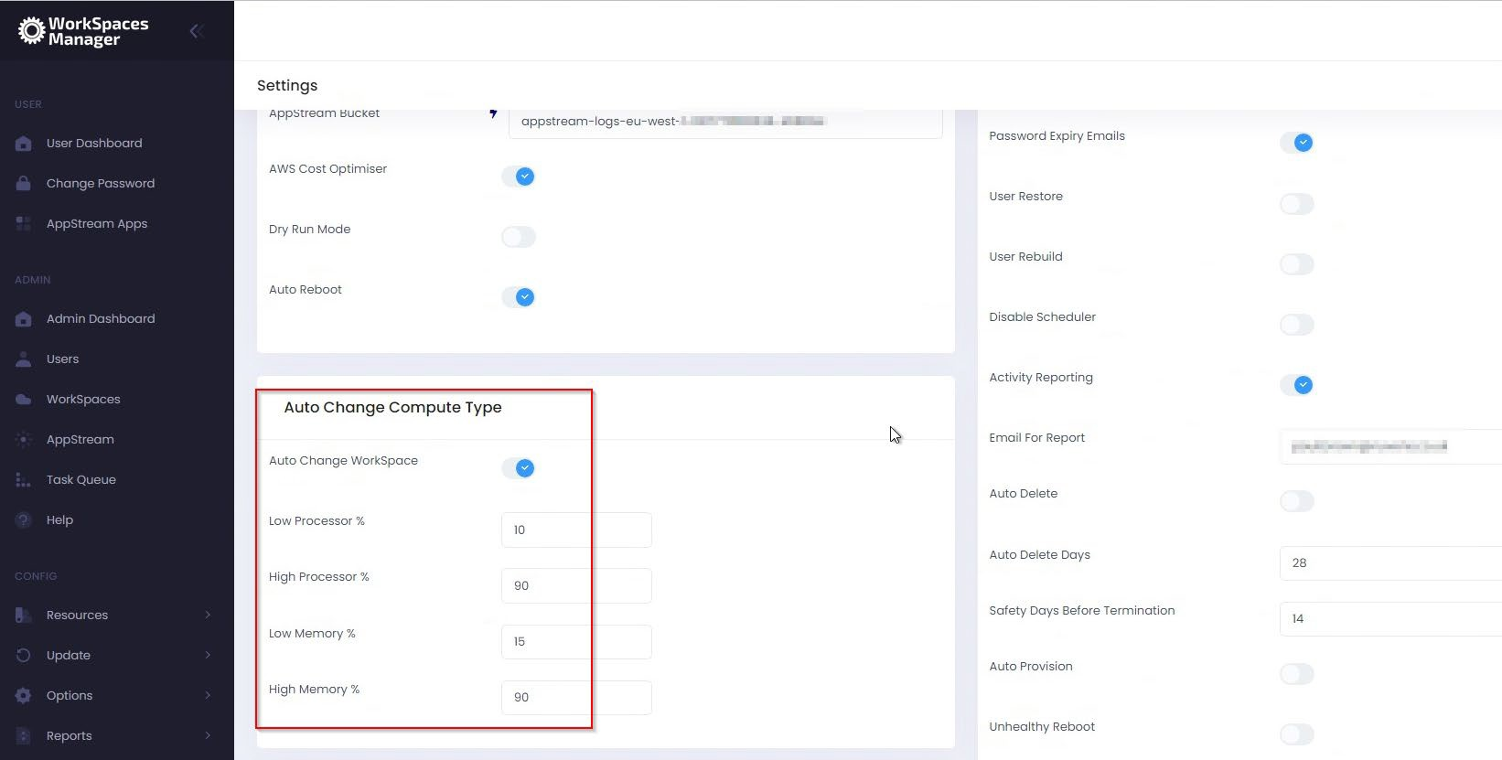
Set Low and High Processor and Memory values (these are up to you). WorkSpaces Manager will also advise you of recommendations.

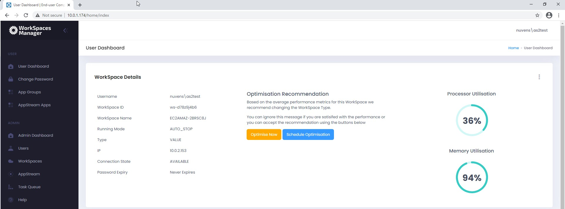
It will also advise the user in their portal if an optimisation recommendation is required. They can either schedule it there and then, or can schedule it at another time (i.e., when they are not working).

4.3.1.7 Active Directory (Single\Multiple Domain Forest)
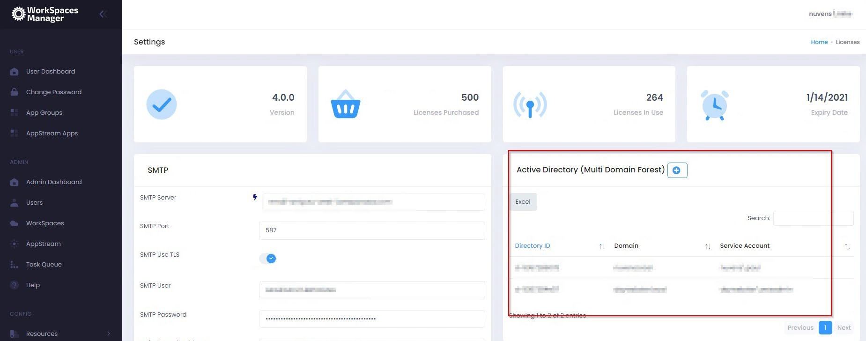
When Multi Domain is enabled, we can add more directories.

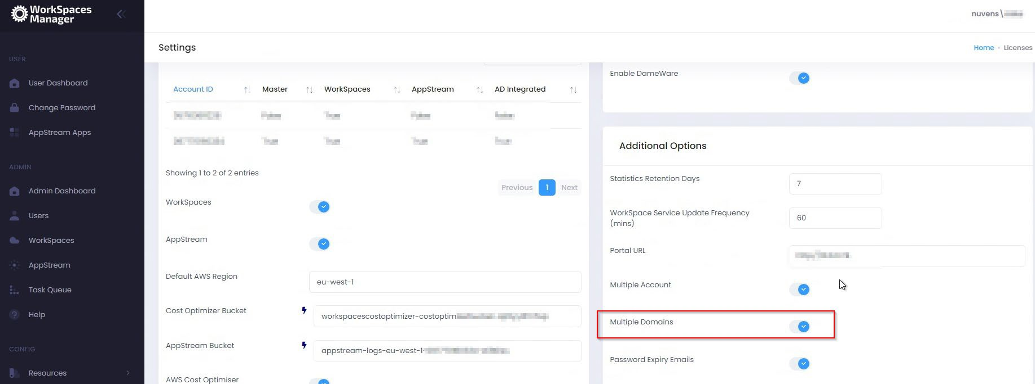
On initial setup, and by default, you will have one domain. You can enable multiple domains by enabling the feature below in Additional Options.

You will then add the details for your domain.
AD Service Account and password:
When creating the AD Service Account to support AWS WorkSpaces you will have already provided an account with permissions to create computer objects within AD to the OU specified at the time.
We recommend using the same service account and providing additional permissions to delete computer objects.

NetBIOS name:
NetBIOS name of the domain that your WorkSpaces will be joining.
FQDN:
Fully Qualified Domain Name of the domain that your WorkSpaces will be joining.

Default User OU:
If you create a user in the ‘Add User’ section of the Portal, this is where it will place that user. If you use the ‘Import Template’ then you can specify where you want the user(s) to be located per OU or by copying template users.
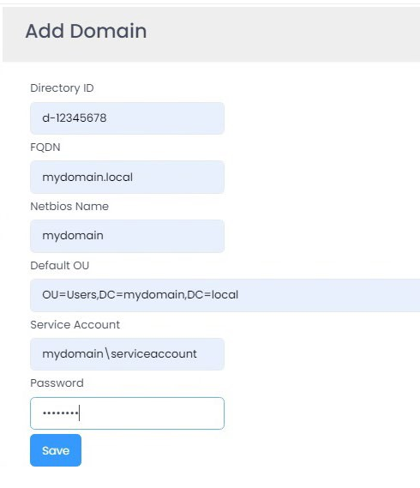
Example:
As of version 5.4.0, if you want to configure the KMS Keys by default for encrypting WorkSpaces, the “Multiple Domains” setting must be ticked, so that the directories are listed.

4.3.1.7 Additional Options
Statistics Retention Days
If the WorkSpace Performance Monitor Agent has been deployed to the WorkSpaces, it will be reporting back to the server key metric statistics periodically as defined in the Group Policy (see section in the ‘WorkSpaces Manager Installation Guide’ on ‘Installing the WorkSpaces Performance Monitor Agent’). In a large estate, this will create millions of rows within the database over a period. The number of days that are retained within the database can be specified here. If the number of days is too high on a large estate (e.g., 60) then it will have an impact on queries of statistics and increased disk space usage. For smaller estates, you can set this to 30 days and monitor from there.

WorkSpace Service Update Frequency (mins)
This will automatically update the local database with up-to-date information on this period. 15 minutes is sufficient for most cases, but you would not want to do this on, for example, a 1-minute period on a very large WorkSpaces and user estate. If you need to do a manual update for any reason, you can do this in the Update section of the portal.

Portal URL
Enter your portal URL here. e.g. http://wsmportal.mycompany.com

Multiple Account
This enables management of WorkSpaces across multiple AWS accounts. Please refer to Section 7 of this document which tells you how to set it up.

Multiple Domains
If you are using a multi-domain forest, you can add multiple domains that host your user accounts. Therefore, their WorkSpaces can be managed, searched, and reported on.

Password Expiry Emails
If this is chosen, users will receive a notification email two weeks prior to their password expiring. This can be turned on\off whenever and is not required to complete the Portal configuration at this stage.

User Change Password
Enables the portal to give the user the option to change its password in AD.

User Restore
Enables the Self-Service function for a user to restore their WorkSpace to a last known healthy state. Automatic snapshots for use when restoring a WorkSpace are scheduled every 12 hours. If the WorkSpace is healthy, snapshots of both the root volume and user volume are created around the same time. If the WorkSpace is unhealthy, these snapshots are not created.
If needed, a user can restore a WorkSpace to its last known healthy state. This recreates both the root volume and user volume, based on the most recent snapshots of these volumes that were created when the WorkSpace was healthy.

User Rebuild
Enables the Self-Service function for a user to rebuild their WorkSpace and notifies user by email of the action.
The system is refreshed with the most recent image of the bundle that the WorkSpace was created from. Any applications that were installed, or system settings that were changed after the WorkSpace was created, are lost.
The user volume (for Microsoft Windows, the D drive; for Linux, /home) is recreated from the most recent snapshot. The current contents of the user volume are overwritten.
Automatic snapshots for use when rebuilding a WorkSpace are scheduled every 12 hours. If the WorkSpace is healthy, a snapshot of the user volume is created. If the WorkSpace is unhealthy, the snapshot is not created. The primary elastic network interface is recreated. The WorkSpace receives a new private IP address.

Disable Scheduler
This quickly disables ALL automation of the WSM Appliance.

Activity Reporting
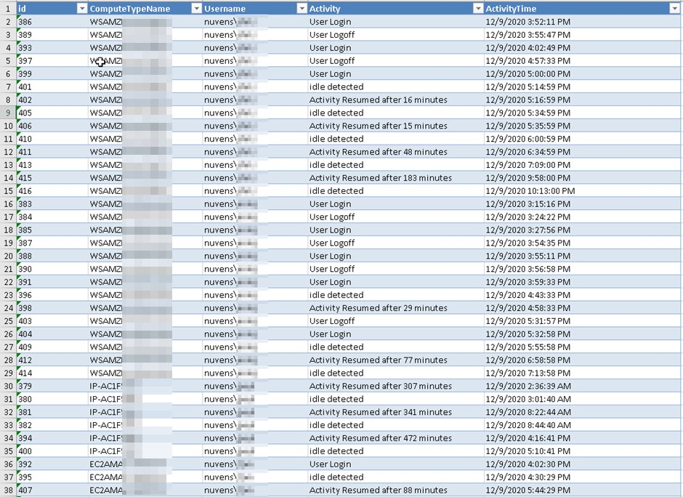
This enabled\disables the sending of a daily report on user login, logoff, idle times and when activity was resumed. The report is sent at 3am each morning. An example report is shown below:

Email For Report
The email of the person\group that receives the Activity report.

Auto Delete
You can set up WSM to automatically delete unused workspaces after a defined period of days.

Auto Delete Days
This value is the number of days a WorkSpace should be considered for deletion (e.g., 45 or 60 days).

Safety Days Before Termination
This value is the number of days a user will be given to inform their Service Desk or IT Function that they still require the WorkSpace before deletion.
For example, if Auto-delete was set for 60 days. On the 60th day of the WorkSpace being unused, the user that is associated with the WorkSpace will receive an email informing them that their WorkSpace is to be deleted in (Safety days VALUE) with the request for them to contact support remove the Autodeletion request. After the safety days value and if autodeletion is not removed.

Auto Provision
Turns on Auto-Provisioning of WorkSpaces via Active Directory groups. See Section 4.3 for more information on this.
If Auto-Provision is enabled, the service will poll the Active Directory groups every 15 minutes for new members.
Removing a user from the AD group will not terminate the WorkSpace. This functionality can be obtained in conjunction with Auto-Delete.

Auto Provision Frequency
Allows the choice of auto-provisioning period. This checks the AD groups in your Auto- Provisioning profiles at specific time periods. If it finds a user in an AD group that does not have a WorkSpace, it auto-provisions one for them based on the Auto-Provisioning settings that you have specified. The field allows 0-59 minutes, but anything more than 60 becomes an hourly check.

Unhealthy Reboot
If this option is enabled the service will check for any WorkSpaces with a status of “Unhealthy” every 10 minutes. Any WorkSpaces found in this state will have their status re-evaluated and if still found to be “Unhealthy” they will be rebooted. If after a reboot the status remains at “Unhealthy” the WorkSpace running mode will be set to “Auto-Stop” (if not already) and the WorkSpace Stopped. Once Stopped the WorkSpace will be Started again and its original running mode restored. This action can initiate a migration from the underlying physical host.
If the WorkSpace remains in an “Unhealthy” state an error is recorded on the admin dashboard.

Fixed Tag Values
Enables the Fixed Tags function in ‘Options’ (see Section 4.3.12).

Use Global AutoStop Time
Sets a global time for auto-stop all the WorkSpaces in this mode.

Auto Stop Timeout
Sets the number of hours before an idle WorkSpaces is stopped.

Alternate Email Tag
Enables the Fixed Tags function in ‘Options’.

Integrates with WSUS
Enables the integration with the Microsoft Patching services called Windows Servicew Update Server (WSUS).

WSUS Port
WSUS uses port 8530 by default, but it can be changed on IIS. It is not recommended.

WSUS HTTPS
If WSUS is configured to use HTTPS, then this option needs to be set. Also, port changes to 8531.

Use System Proxy
If WSM needs to use a proxy, this feature must be enabled.

Proxy Address
When the proxy is enabled, an address in HTTPS://address:port format is required.

4.3.1.8 Applications
This allows users to Self-Service their applications in their dashboard - from Numecent Cloudpaging and products such as FlexApp, APP-V, etc. You can enable both here.
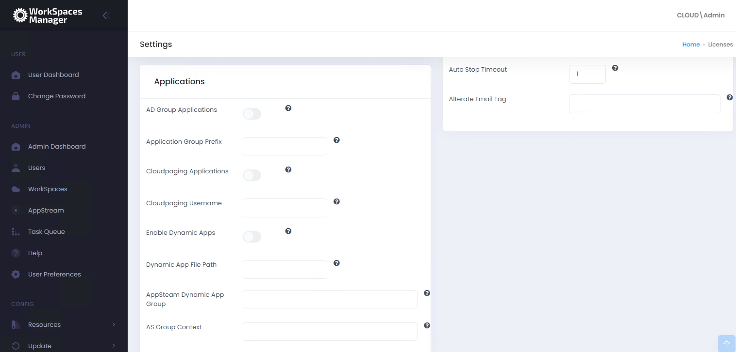

AD Group applications
Enable this is you use software distribution on to your WorkSpaces from the likes of Liquidware FlexApp, App-V, etc. This allows users to add and remove applications available to them through the Self-Service side of the WorkSpaces Manager Portal. You can change this to your own prefix when you have logged into the Portal. For example, your FlexApp groups could be prefixed ‘FA- USR’. By default, any new imported applications based on the prefix group name (in the example below, ‘FA-USR’) are given the ‘Application Group’ of ‘App’ and the ‘Type’ of ‘Free’.
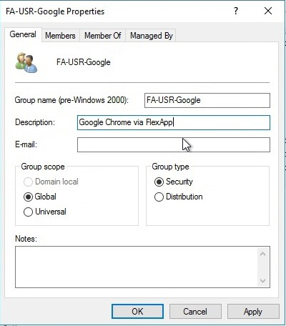
For an application group to be imported into this list, it will need to have a Description and the group prefix specified in the ‘Application Group Prefix’ field of ‘Options > Settings > Applications’. An example:

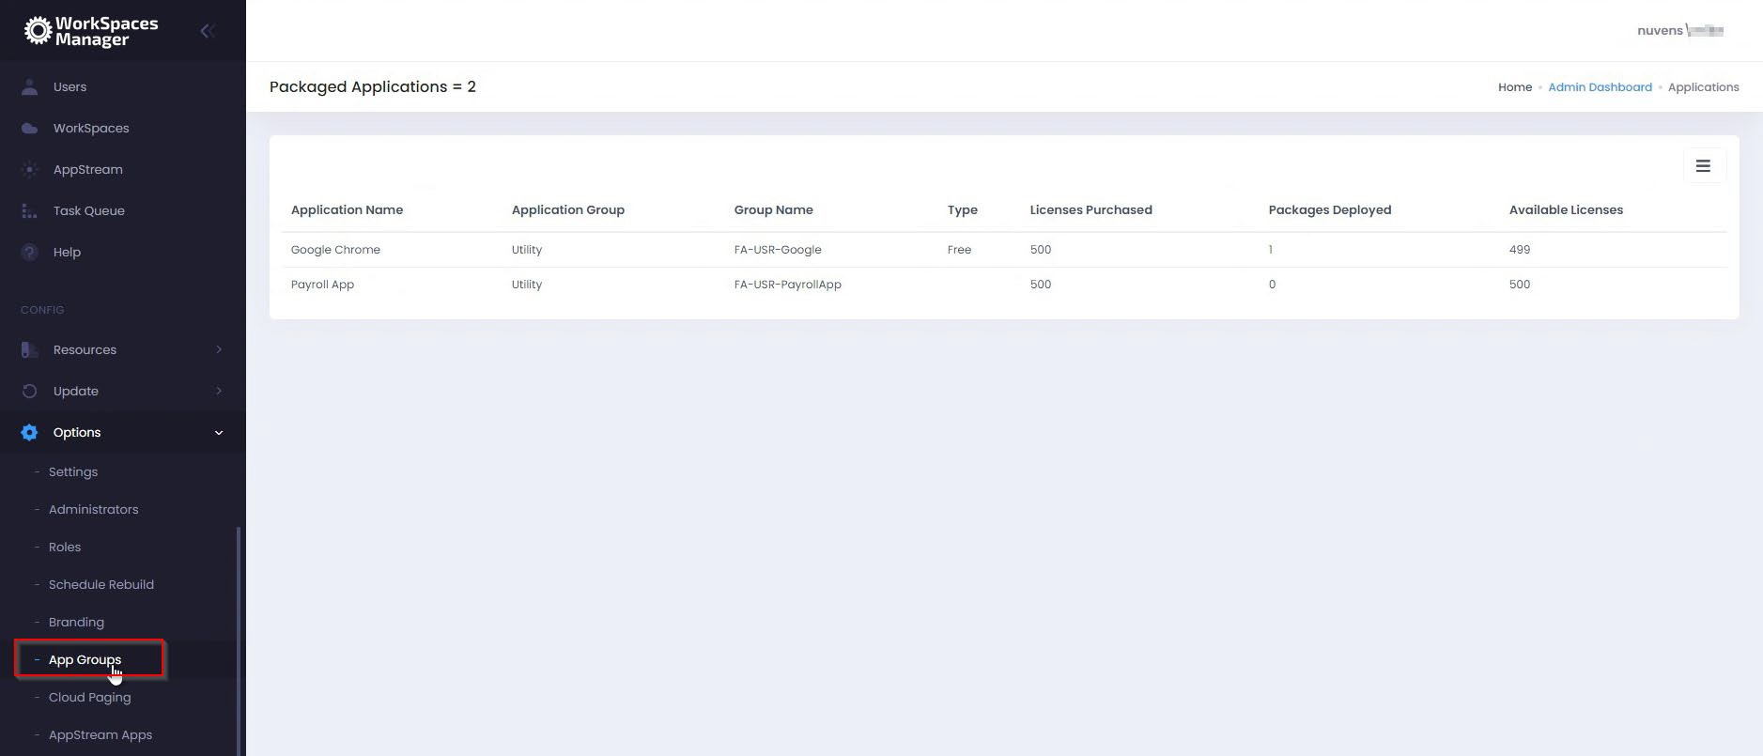
This is a list of applications that a user can add\remove as a Self-Service function in the WorkSpaces Manager portal. To know more about this, go to Section 5 where you will be shown how to amend this list where it says ‘Type’. All imported applications are ‘Free’ of Type by default - a user can add and remove themselves from the application in the WorkSpaces Manager Self- Service portal. However, you may want to amend the ‘Type’ to ‘Paid’ for such applications as Visio which have licensing constraints. A user can hence remove themselves from the group, but will have to ask the Service Desk (or another AD administrator) to add them back in.

Application Group Prefix
As above, this is the prefix of your application distribution groups with whatever product you are using (FlexApp, App-V, etc).

Cloudpaging Applications
If you want to use Numecent Cloudpaging applications with WorkSpaces, you can enable this feature on here.

Cloudpaging Username
This is where you enter the account name that you use for Numecent Cloudpaging.

Enable Dynamic Apps
This is where you enter the account name that you use for Numecent Cloudpaging.

Dynamic App File Path
This is where you enter the account name that you use for Numecent Cloudpaging.

AppSteam Dynamic App Group
This is where you enter the account name that you use for Numecent Cloudpaging.

AS Group Context
This is where you enter the account name that you use for Numecent Cloudpaging.

4.3.2 Custom Settings
This section enables administrators to configure options for the following elements:
- Password Expiry Emails
- Auto Delete
- Get Alternate Email from AD Attribute
- Custom KMS Keys
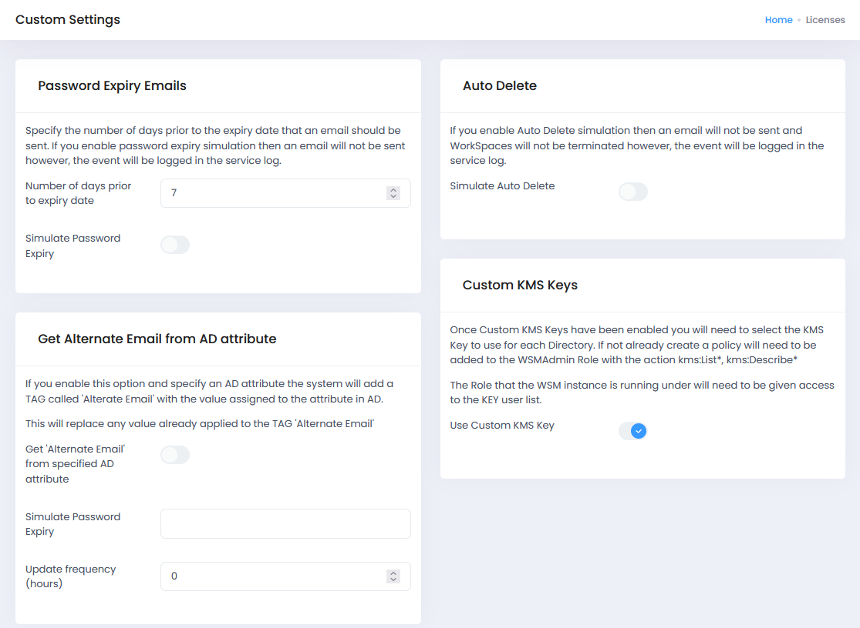
Once the KMS Keys have been enabled, these will only be seen if the “Multiple Domains” option is configured:
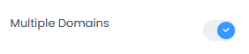
Then, in the list of directories, after choosing one of them, there will be a new option as below:

4.3.3 Administrators
You can granularly assign WorkSpaces Manager portal admin users to do specific tasks.
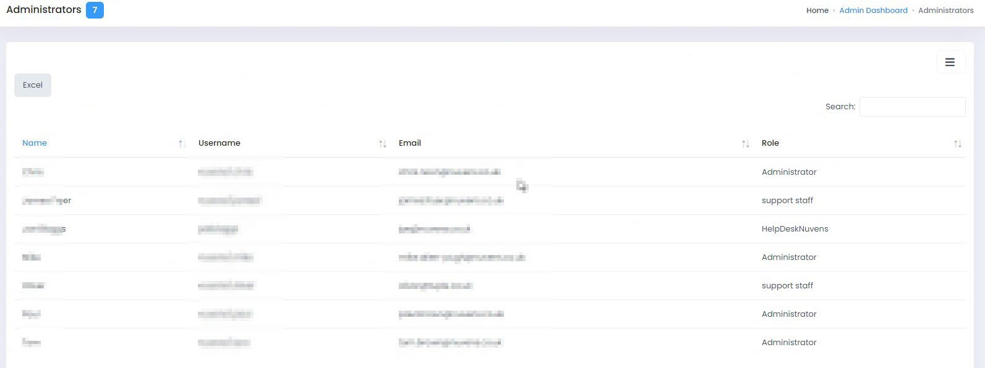
This especially useful for delegation of support roles purposes where you do not want all users to have full administration rights over every WorkSpace in the estate. For example, you may have two staff who look after users who have critical roles and policy stipulates that they are the only users who can change the reboot times for their WorkSpaces.

4.3.3.1 Adding a new portal Administrator
IMPORTANT NOTE: Before you do this, check the Roles, and make sure that there is an Administrator role set up with ‘SysAdmin’ permissions. Go to Section 4.3 and add a sysadmin role with the following selections.
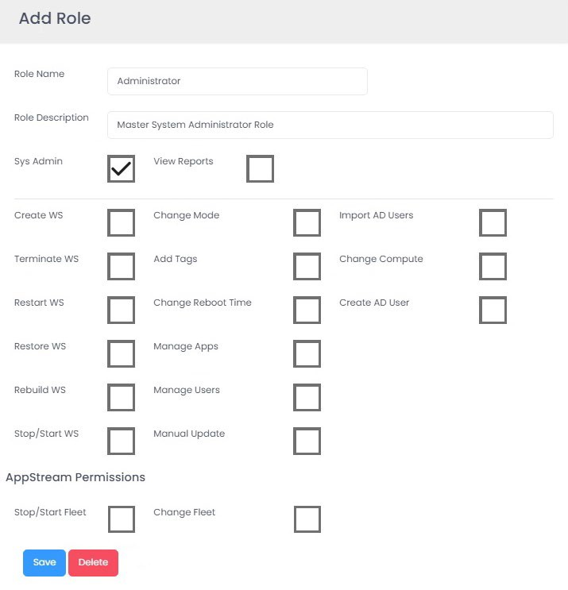

To add a new portal administrator, select the icon on the right and select ‘Add Administrator’.
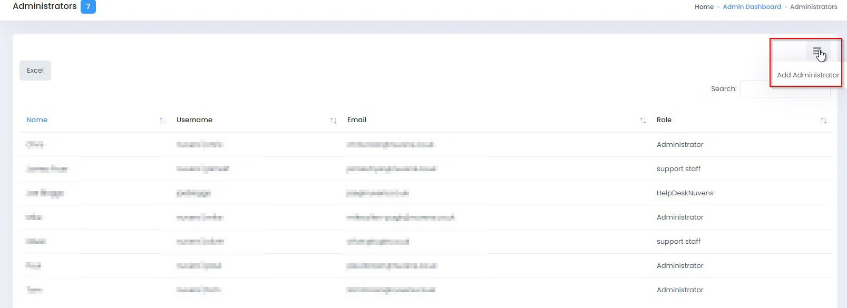
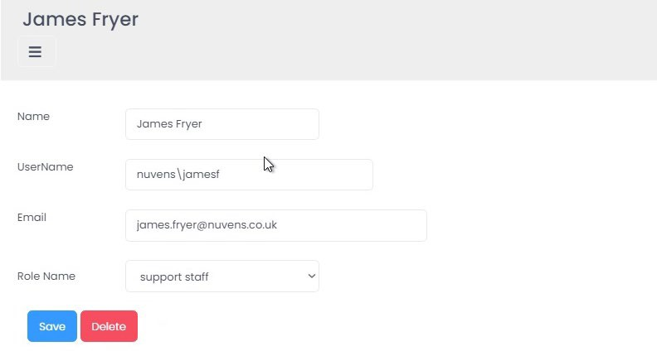
Now fill in the administrator details from Active Directory. Ensure that the username is prefixed with your domain name. You can choose the Role Name for this user. The Roles are defined in the next section and you can set up whatever roles you wish for that user to fulfil their working role. In this case, we want our portal admin to just be able to restart, stop and start a users’ WorkSpace (which we have defined in our roles as a ‘Support Staff’ role.

4.3.3.2 Restricting users to Regions, Directories or Tags
For delegation of support roles purposes, you may wish to have portal administrators restricted to WorkSpaces in specific AWS Regions (e.g., a support team in APAC), specific WorkSpace Directories (e.g., which may contain Finance and Marketing users only) or WorkSpace Tags (e.g., the Department is Finance).

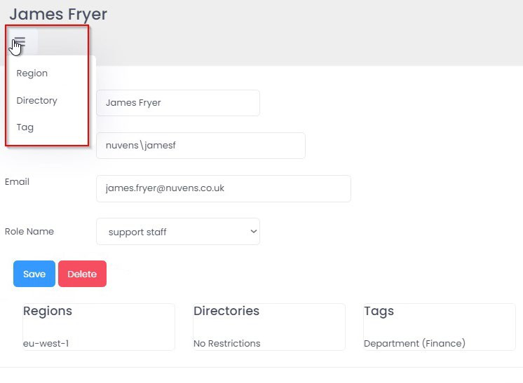
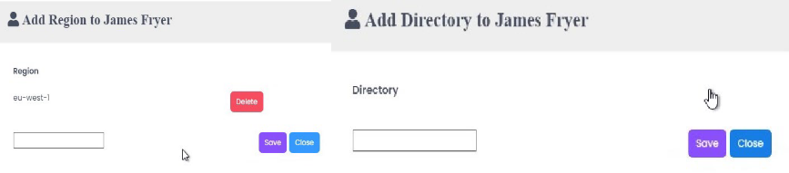
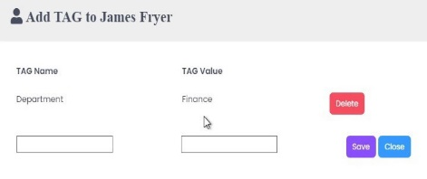
With this user, we have restricted the administrator to WorkSpaces in eu-west-1 Region, with no specific WorkSpace Directory, and any WorkSpaces that are tagged with ‘Department’ of ‘Finance’. They cannot administer anything other than these WorkSpaces (for example, they cannot terminate\reboot a WorkSpace in ‘Marketing’). You can add remove Regions, Directories and Tags but selecting the ‘Action’ button on the top left.

4.3.4 Roles
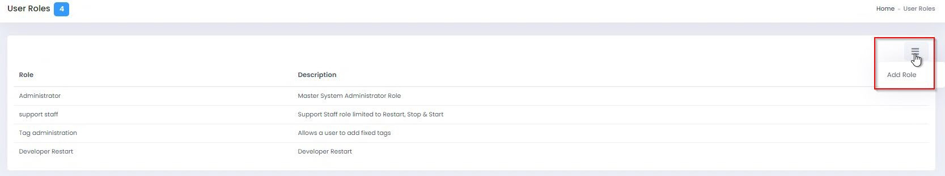
You can create roles which can be assigned to WorkSpaces Manager portal administrators. Only these functions will be available to them from within the WorkSpaces Manager portal.

You add a new role by selecting the ‘Action’ button on top right. In this example, we want to create a role which only allows the user with that role assigned the ability to Restart, Stop and Start a users’ WorkSpace. When you have chosen the actions, select ‘Save’. You can change these at any time by double clicking on the role and saving it.

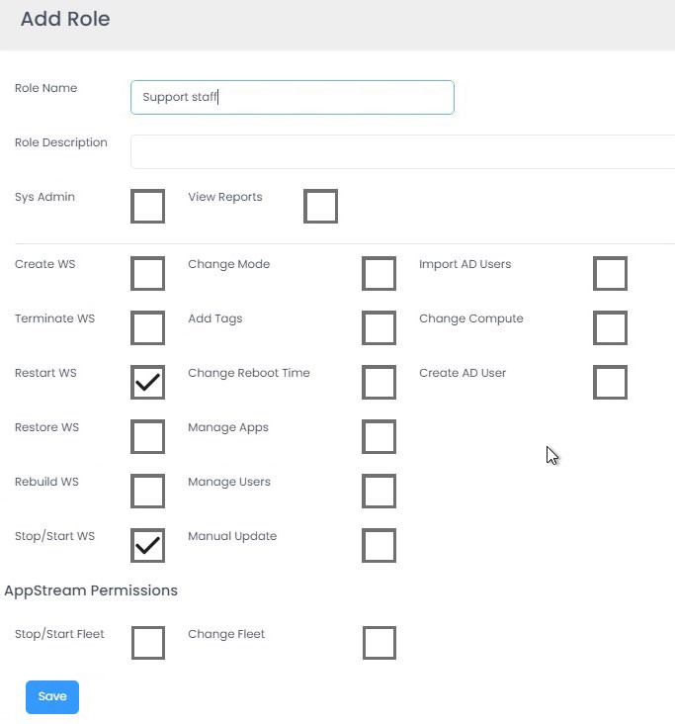
NOTE: Even though the user has permissions to restart, stop and start a Workspace here as part of their role, they may be restricted by Regions, Directories and Tags above (as in Section 4.3). So, for example, a user cannot restart\stop\start a WorkSpace of a WorkSpace tagged with ‘Department – Catering’ if they only have permissions to do so with ‘Department – Finance’ tagged WorkSpaces.

4.3.5 Schedule Rebuild
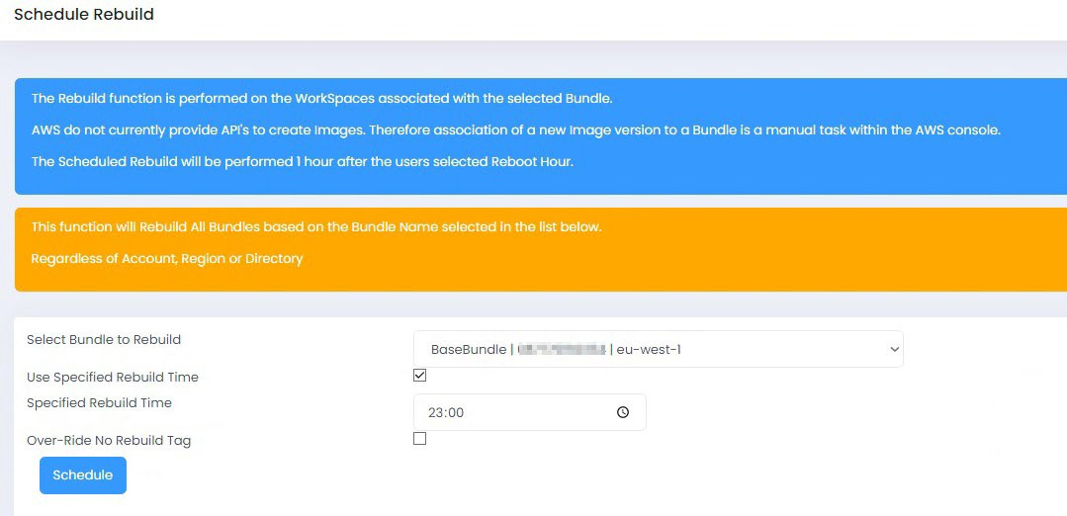
The Rebuild function is performed on the WorkSpaces associated with a selected bundle. AWS do not currently provide APIs to create images, therefore association of a new image version to a bundle is a manual task within the AWS console. The Scheduled Rebuild will be performed 1 hour after the user’s selected Reboot Hour. The function will rebuild all bundles based on the bundle name selected in the last below regardless of Account, Region or Directory. Example of a rebuild process:

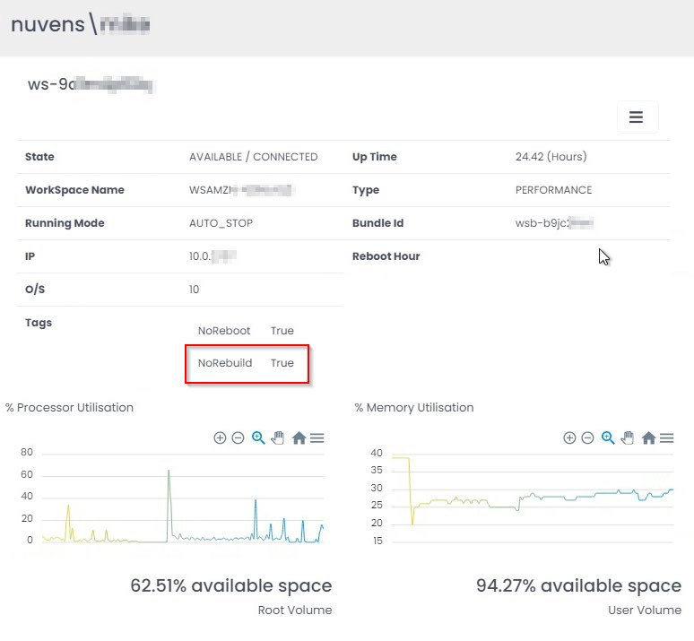
Here we are going to rebuild all WorkSpaces in a bundle called ‘nuvens-wsp’ tomorrow morning at 01:00. Some of our development users have installed applications of their own and have a tag set on their WorkSpace called NoRebuild = True. These WorkSpaces will be omitted from the task.

Select ‘Schedule’. You can, at this point, select to override the ‘NoRebuild’ tag as mentioned above.
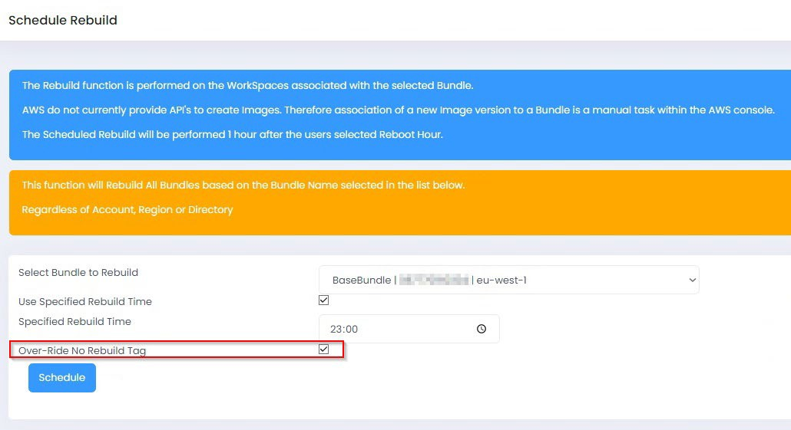

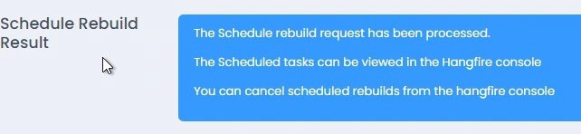
You will now see a screen confirming that the scheduled task has been submitted to the Hangfire console.

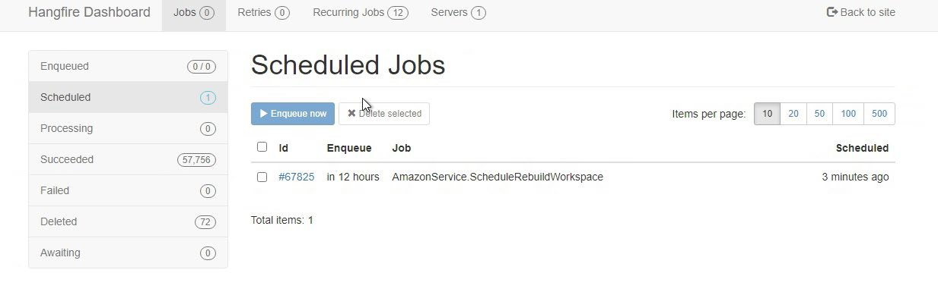
To view the task, go to the Hangfire console (http://your-WSM-IP-or-FQDN/hangfire). Go to the Scheduled Jobs tab and you will see an AmazonService.ScheduledRebuildWorkSpace task which is due in around 12 hours.

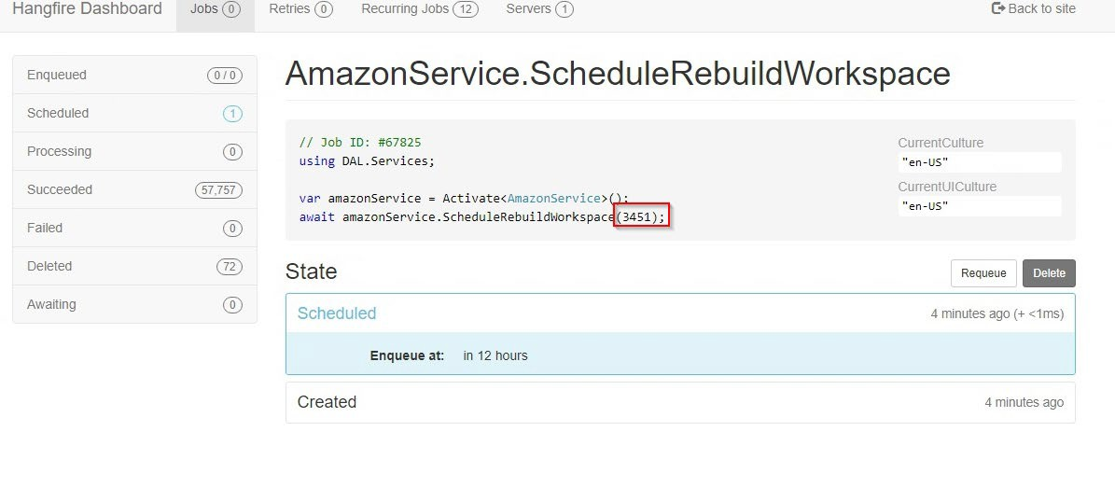
Select the ID and it will give you more information about the task. You can identify bundle ID in the red box.

4.3.6 Schedule Start
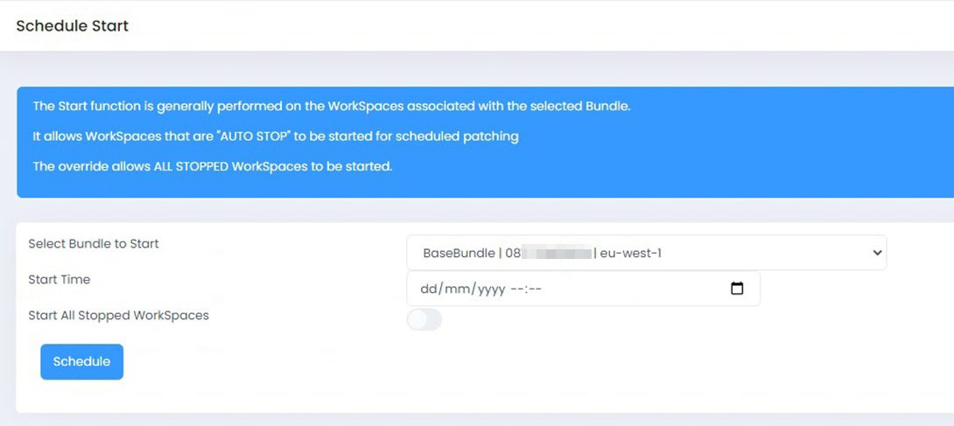
If you want to patch WorkSpaces and to ensure that they are on at the time, you can now schedule the start of stopped ‘Auto-Stop’ WorkSpaces. To do this, you select the bundle, select the date\time that you want them to start and then select ‘Schedule’. If you want to stop all stopped WorkSpaces regardless of bundle, select the button to the right of ‘Start All Stopped WorkSpaces’.

4.3.7 AP (Auto-Provisioning) Profiles
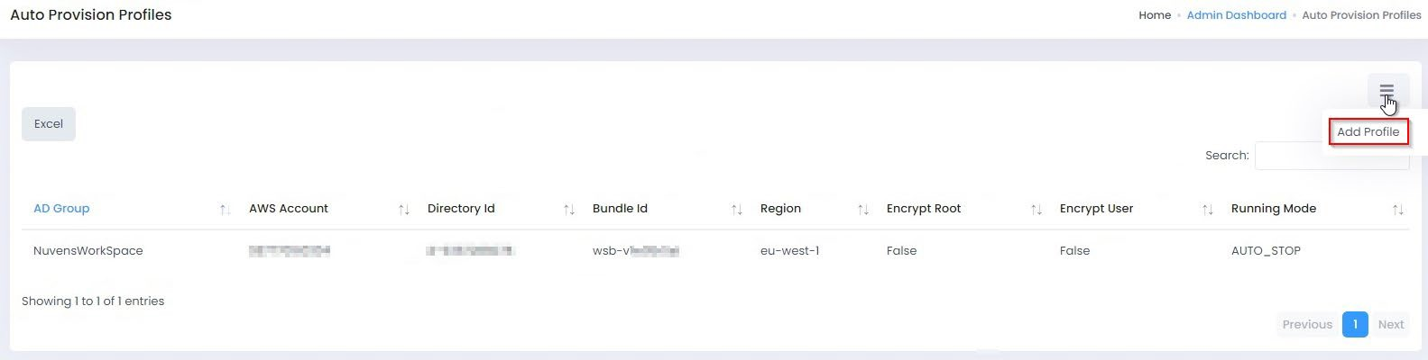
You can now choose to Auto-Provision WorkSpaces by putting users in an Active Directory group. Select ‘Add Profile’.

Now type in the Active Directory group, select the AWS Region for the WorkSpaces to be created, select the WorkSpaces directory, select the WorkSpaces bundle, select the AWS account number that the WorkSpaces will reside in, select the running mode and then select to enable\disable root and user volume encryption. Then press ‘Save’.
PLEASE NOTE: You will only be allowed to add ‘Fixed Tags’ in Profile Tags once you’ve saved the Auto-Provision profile. If you go back to edit this profile, you can then add the Fixed Tags.

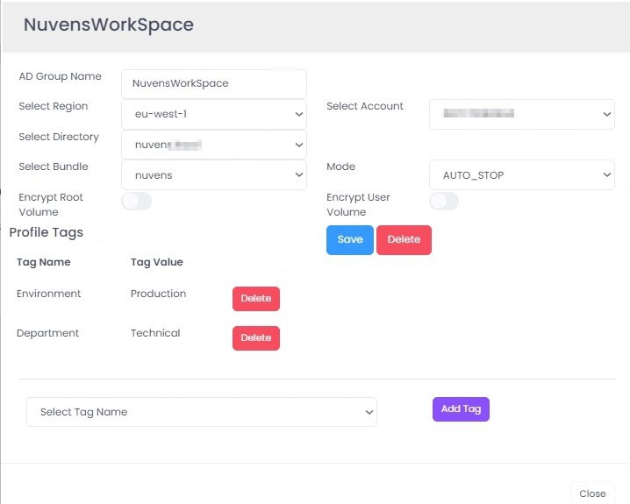
If Auto-Provision is enabled, the service will poll the Active Directory groups every 15 minutes for new members.

Removing a user from the AD group will not terminate the WorkSpace. This functionality can be obtained in conjunction with Auto-Delete.
AWS account details can be also specified so that AppStream Profiles bucket is read.

4.3.8 Password Text
It is used to configure the “Change Password Text” message that users receive from the system when their password is to expire if the option is enabled.

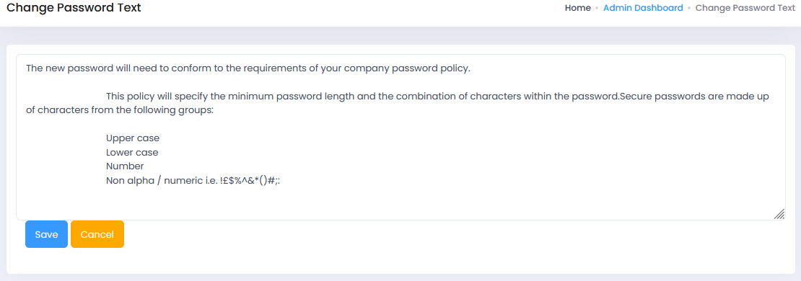

4.3.9 Branding
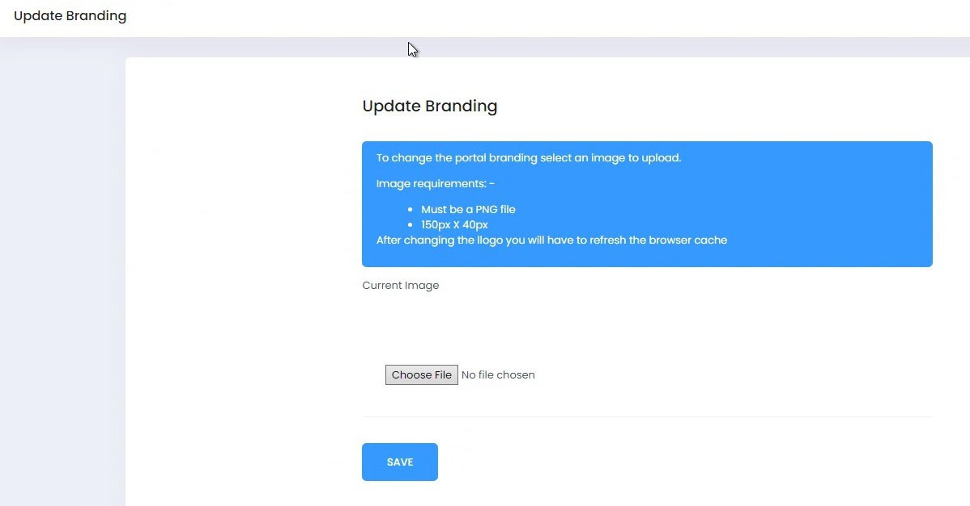
You can brand the WorkSpaces Manager portal with your company logo. It must be 150px x 40px in size.

4.3.10 Database Tools
You can now backup and restore the WorkSpaces Manager database to the D drive on the WorkSpaces Manager appliance.
Do not use ‘Rebuild Database’ unless advised to do so by Nuvens Support.

4.3.11 Service Log
It will show the system log.
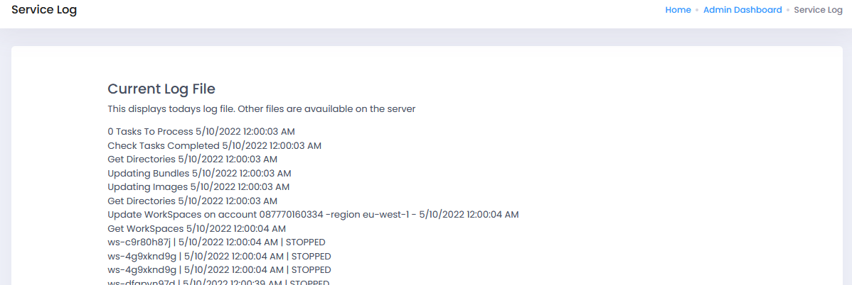
4.3.12 Fixed tags
It is important to obtain consistency when manually tagging WorkSpaces. You can achieve this with the fixed tagging functionality.
This option is not seen by default, unless specifically enabling it on Options > Settings, in the additional options section:
To be able to assign tags to user WorkSpaces, the portal administrator needs permission to do so via a role. Roles can be accessed in the portal under (Roles > Options). SysAdmin permissions have this permission by default.
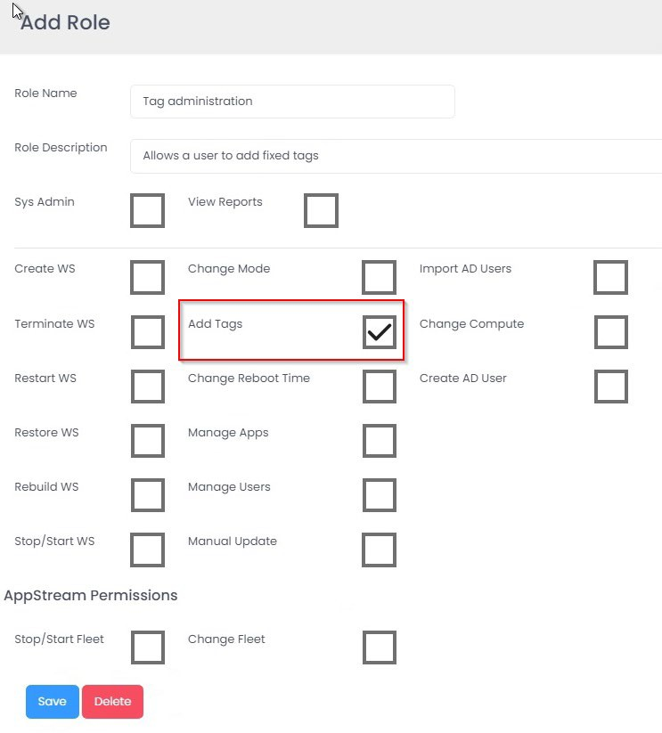
In the role below, you can see that the role assigned to an administrator only allows them to add tags.
After enabling it, we can add which tags are going to be mandatory and possible values for it.
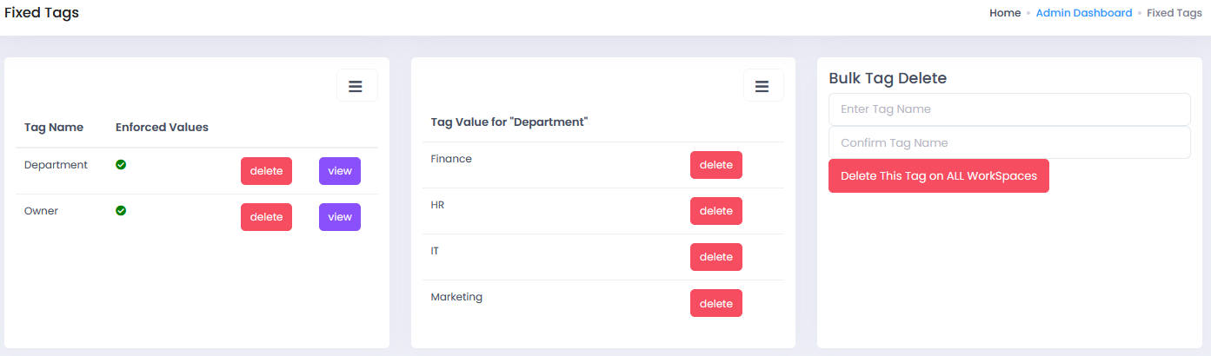

We will create a tag called Cost Centre and will populate this with some dummy values for different Cost Centres in an organisation. First, select ‘Add Tag Name’ from the menu.
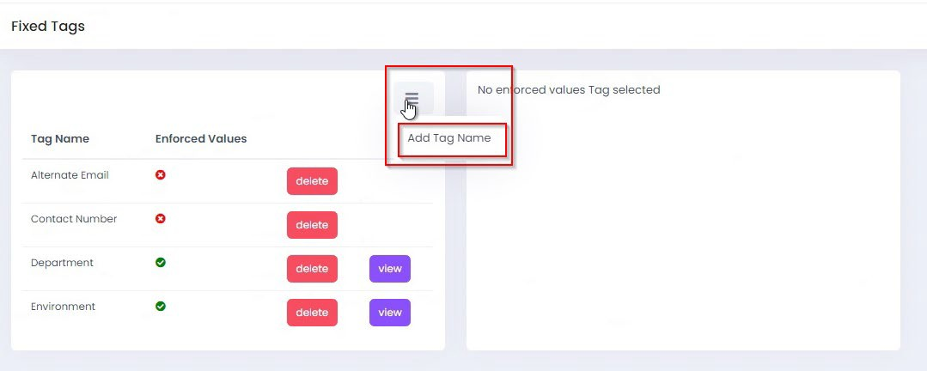

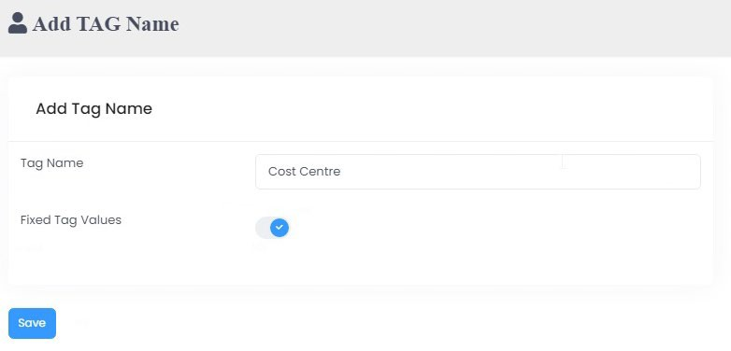
Then add ‘Cost Centre’ as the Tag name and then select the ‘Fixed Tag Values’ option and then select ‘Save’. If you don’t select this, then you can assign that tag, but you will have to type in a value (for example, something unique like an alternative email address, mobile number, etc).

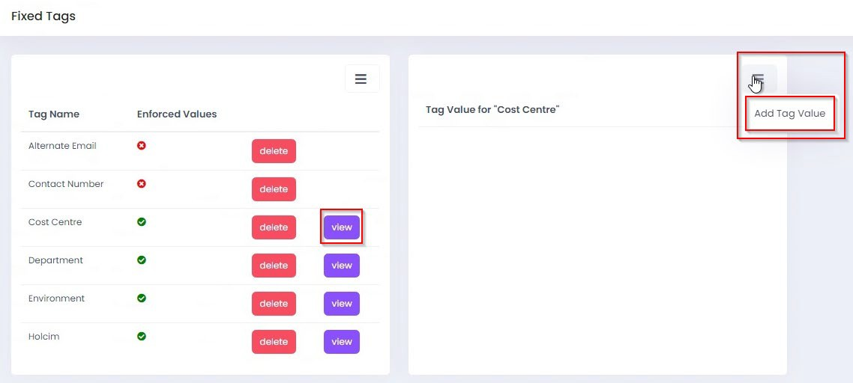
Now go back to Fixed Tags and select ‘View’ next to Cost Centre and you will see no tag values as we have not created one. Select ‘Add Tag Value’ from the menu option.

Then start adding your tags. Add one and then select ‘Save’. You then repeat the process to add others and you will see them as Tag Values against the Cost Centre tag. You can also delete tags here too if you have made any errors in typing, etc.
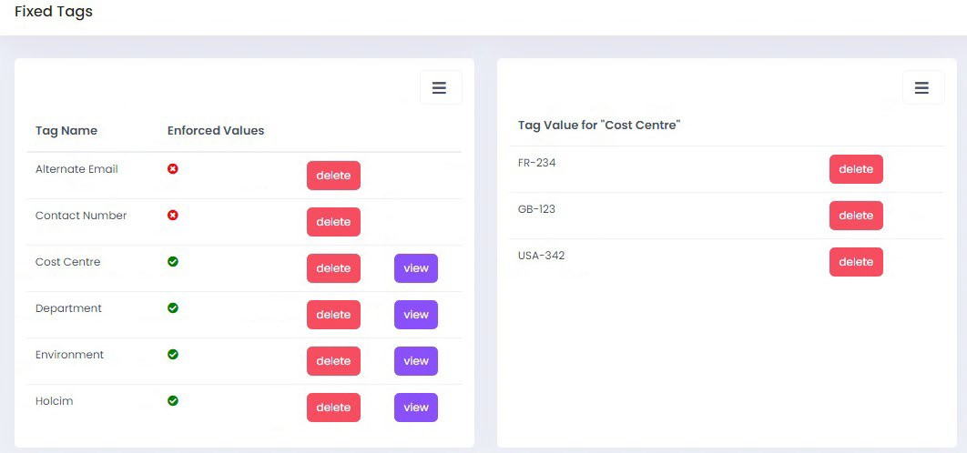
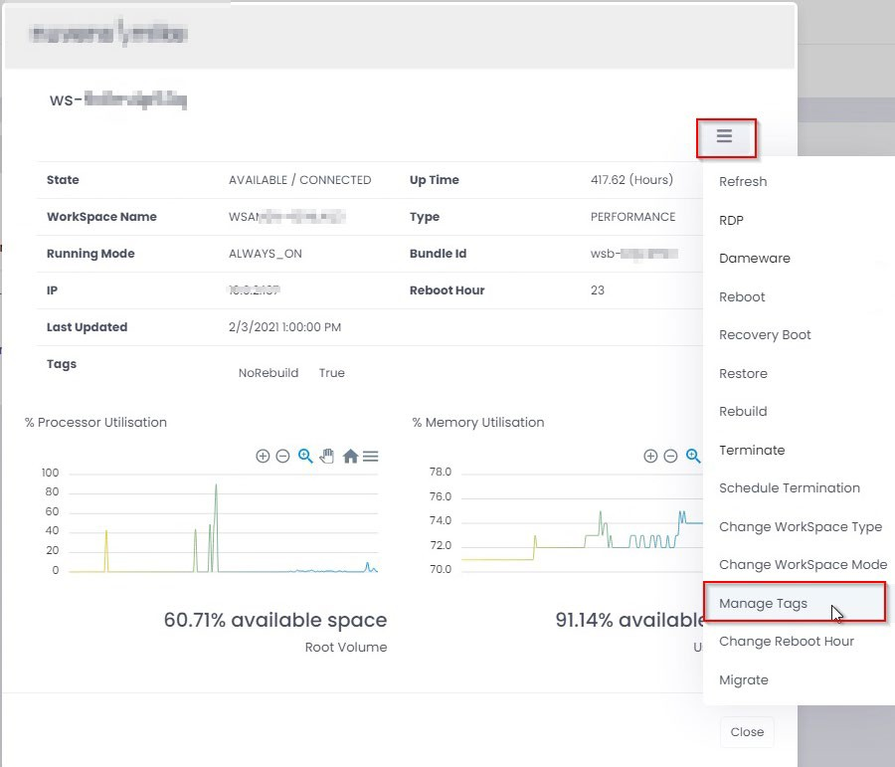
You can now add a fixed tag to a user’s WorkSpace. We will add the Country of United Kingdom to a user’s WorkSpace. Go to the list of WorkSpaces in the portal and search for your user. Select ‘Manage Tags’ from the menu.

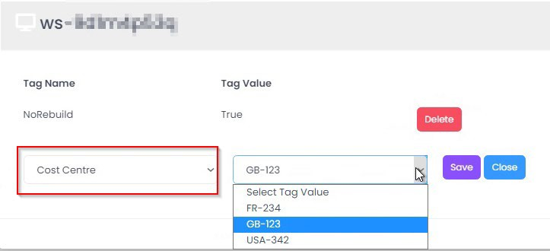
You can see that there is already a tag that exists, so we will now add the Cost Centre of ‘GB-123’ to this user’s WorkSpace. Select ‘Cost Centre’ from the drop-down box and then it will present you with your list of fixed tags. Select GB-123 and then select ‘Save’.

Carry out this process for any other fixed tags that you wish to apply.

There is also a feature to delete existing tags in a bulk mode:
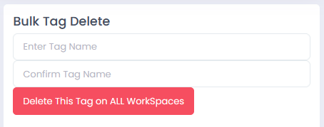
We must enter the value for the tag twice as an active confirmation. Please, bear in mind that it will schedule the deletion of all those existing tags, except those marked as “Fixed Tags” which are enforced.

4.3.13 App Groups
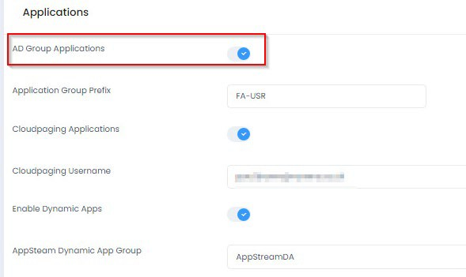
This is if you are delivering applications to users using AD groups. These also appear in the user’s Self-Service menu if they are entitled to them. The App Groups option is enabled in in Options > Settings > Applications.

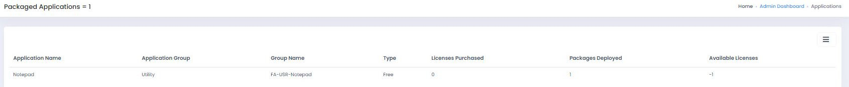
The list of applications is then shown in “App Groups”.

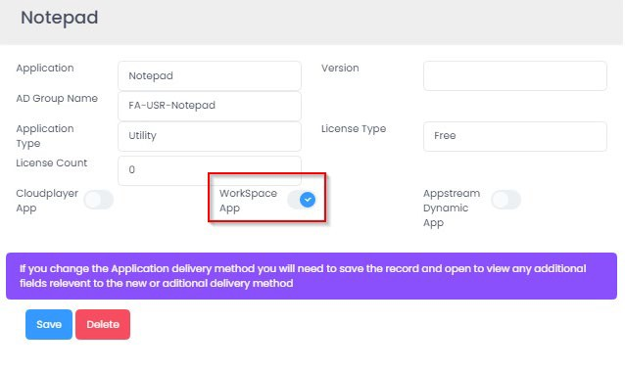
Selecting one shows the properties of the application that you have set up.
See Section 5.1 Active Directory (AD) Group Applications for more information on how to set these applications up.

4.3.14 CloudPaging
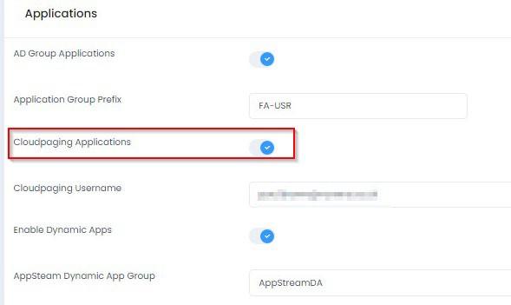
This is if you are delivering applications to users using Numecent Cloudpaging. These also appear in the user’s Self-Service menu if they are entitled to them. The Cloudpaging option is enabled in in Options > Settings > Applications.

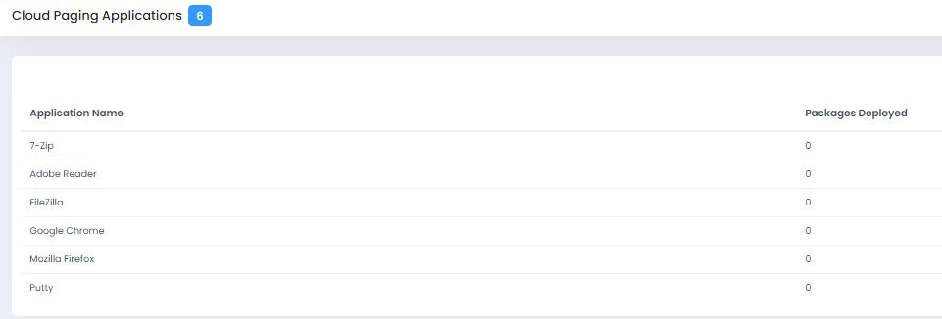
You then have your list of Cloudpaging applications that you have set up.

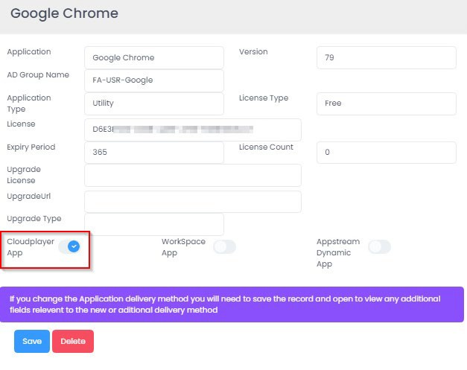
Selecting one shows the properties of the application that you have set up.
See Section 5.2 Cloudpaging applications for more information on how to set these applications up.

4.3.11 AppStream Apps
This is if you are delivering applications to users in AppStream using Dynamic Apps. The AppStream Apps option is enabled in in Options > Settings > Applications.
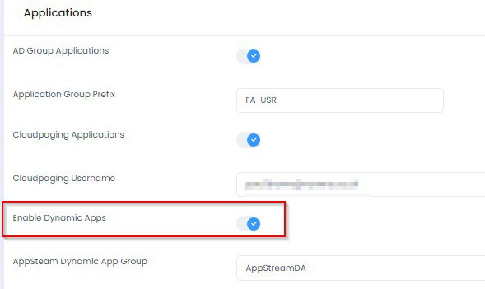

See Section 5.3 AppStream applications for more information on how to set these applications up.

4.4 Reports
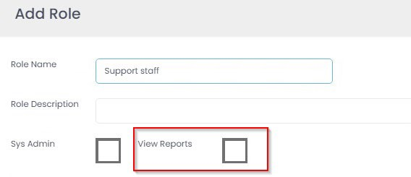
You can control who has access to the Reports section by assigning the ‘View Reports’ permission based on a role assigned to a user in Section 4.3.

The list of reports is in constant evolution, and we are continuously adding new ones. The current reports available are listed below.
Some reports may be in “Beta” status pending customer feedback. Based on feedback received the functionality may be extended.
4.4.1 User Activity Report
In this report, we can filter on per-user basis and detect the Activity for a user in a particular device.
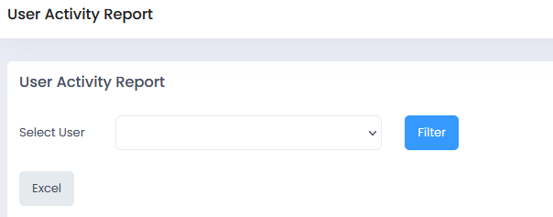
4.4.2 Audit Log
Here we can check the actions that have been performed on the system.
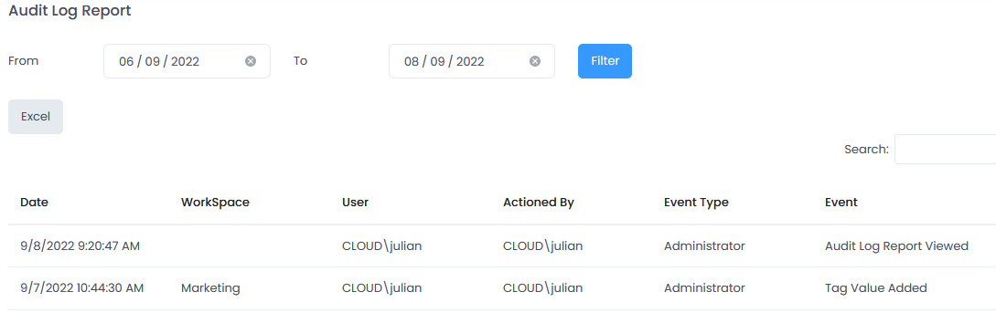
4.4.3 Cost Estimator (and Optimizer)
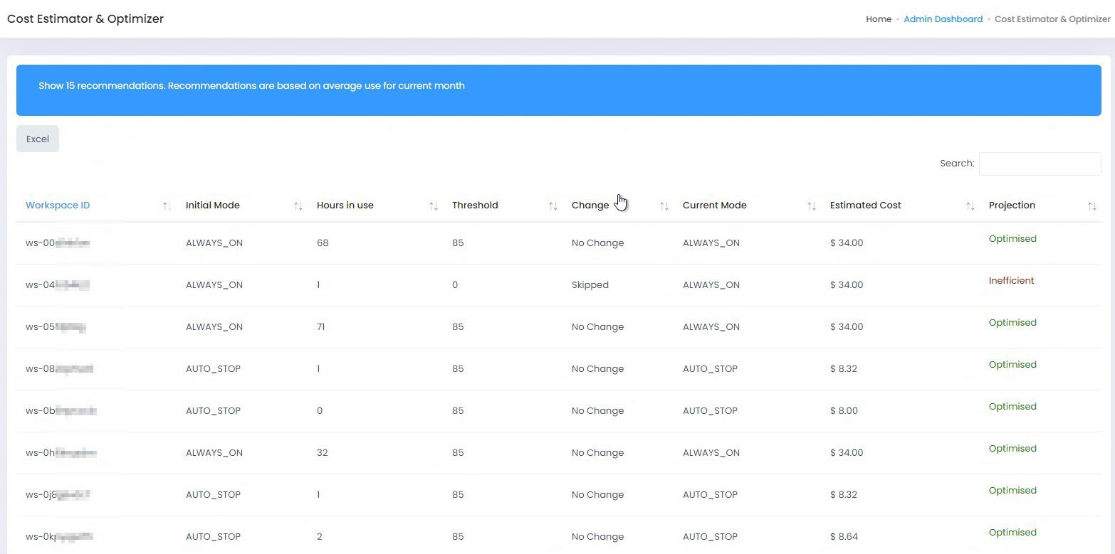
This report shows if the optimiser has is about to change, or has changed, the running modes of WorkSpaces. You can let the optimiser do it for you, or you can view the recommendations (click on the blue bar at the top) and you can change the type manually. This report can be exported to Excel.

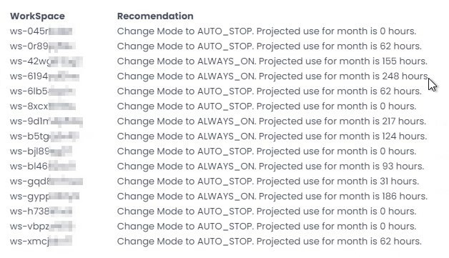
You may have a recommendation at the top of the page where, if you click on the banner, you get the recommended optimisation(s).

PLEASE NOTE: AWS WorkSpaces Cost Optimiser requires enabling on your AWS account containing the WorkSpaces for these reports to be available. Additionally, this feature must be enabled in WorkSpaces Manager portal under ‘Options > Settings’
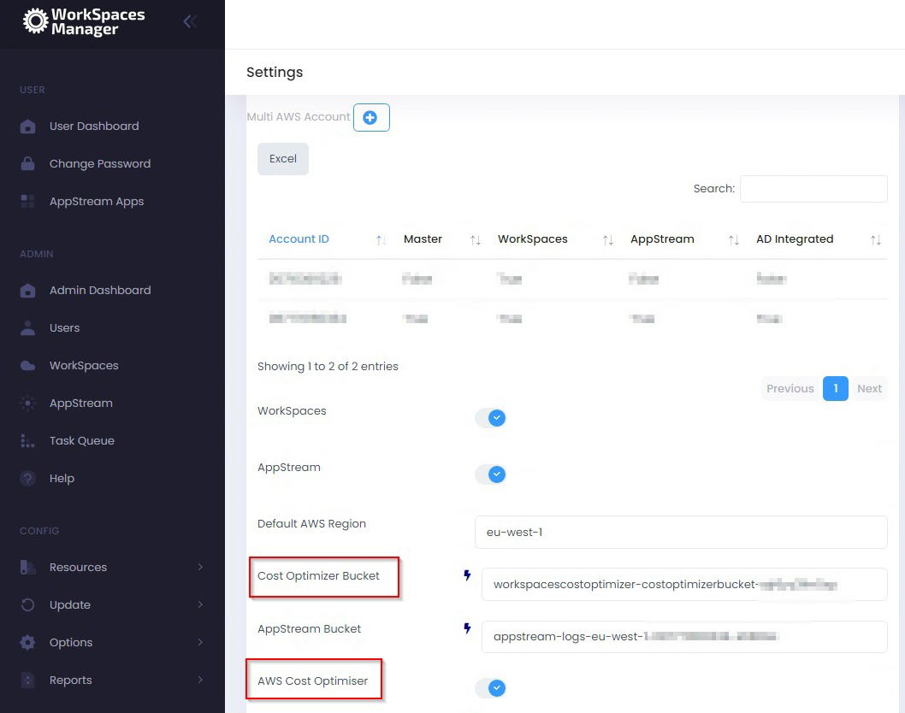
4.4.4 Cost Summary
Shows the basic breakdown of costs from WorkSpaces.

4.4.5 Cost History
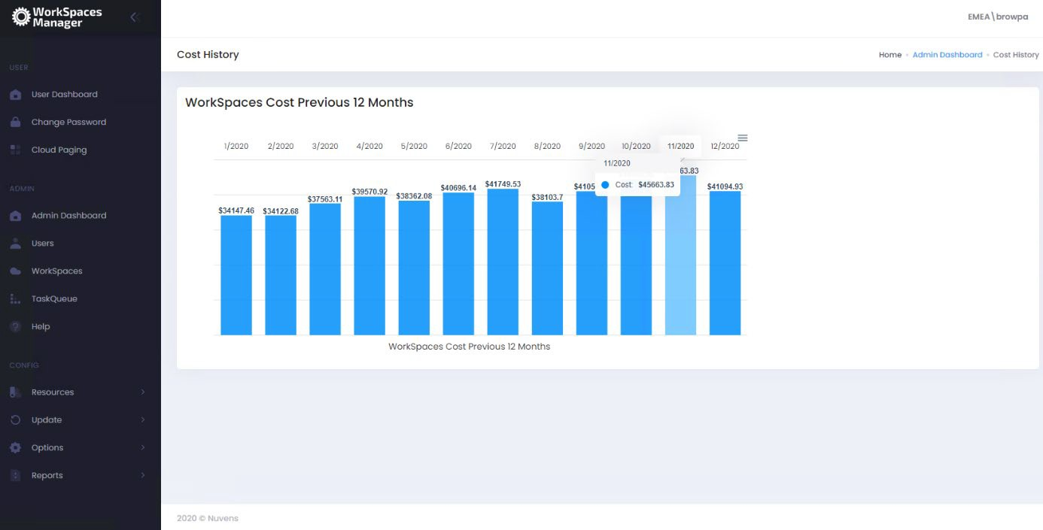
Shows the cost of your WorkSpaces over the last 12 months. The current month is based on the Cost Estimator above and will update at the end.

PLEASE NOTE: AWS WorkSpaces Cost Optimiser requires enabling on your AWS account containing the WorkSpaces for this to be available.
4.4.6 Unused
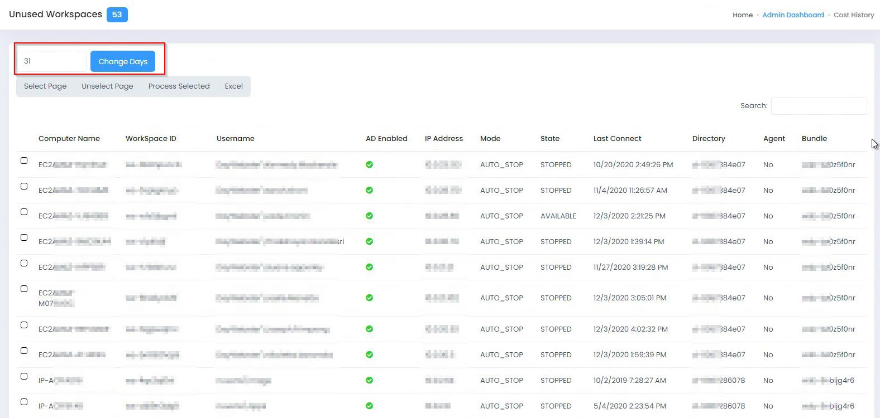
Gives a list of WorkSpaces that have not been used within 28 days (by default). Monitoring this every month can assist you in keeping your costs down. You may wish to change this to 90 days or whatever you like. If your users are not using their WorkSpace, you may query if they need it. This can be exported to Excel.

Actions:
- You can select the whole page or unselect it.
- You can also select WorkSpaces individually.
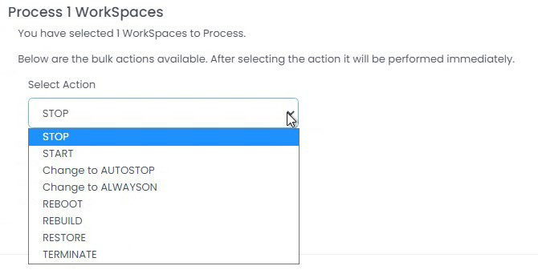
- You can then select ‘Process Selected’ to decide what you want to do with the WorkSpace(s).
If you choose Terminate, you will need to type in CONFIRM to process the termination of the WorkSpace(s).
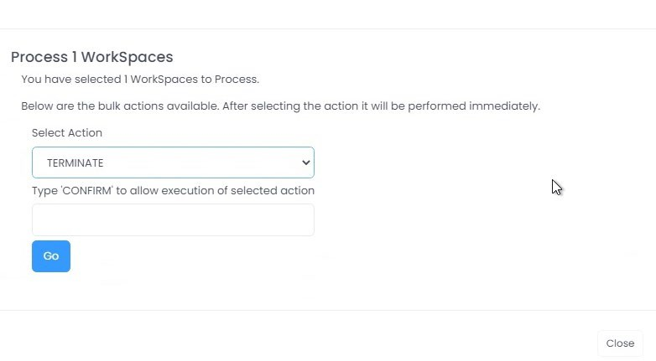
You can also click on a WorkSpace and it will hyperlink directly to the information on that WorkSpace. You can then perform actions on it as normal.

4.4.7 Unhealthy
Gives a list of WorkSpaces that are in an Unhealthy state and users will not be able to reconnect to them without action. This can be a good pro-active remediation task, but please be aware that if somebody is running such processes as heavy compute then the CPU may be high over a long period of time. With the WorkSpaces Manager User Dashboard, users can reboot their own WorkSpaces if they get the ‘Unhealthy’ status on their WorkSpaces client.
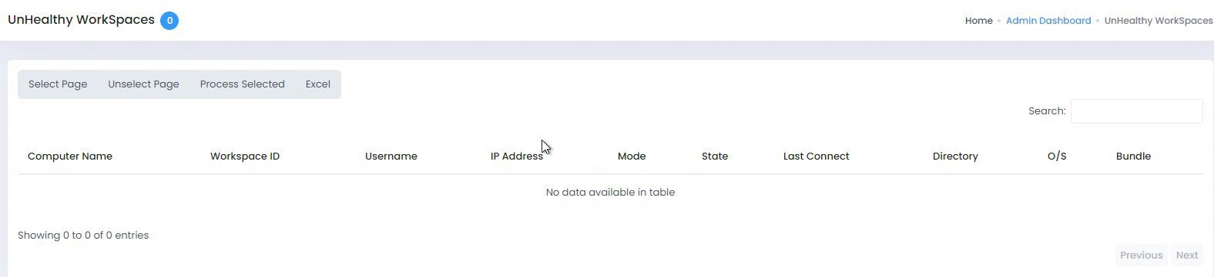
This report can be exported to Excel. You can select the WorkSpaces and select Process Selected for rebooting them.

You can also click on a WorkSpace and it will hyperlink directly to the information on that WorkSpace. You can then perform actions on it as normal.

4.4.8 Stopped
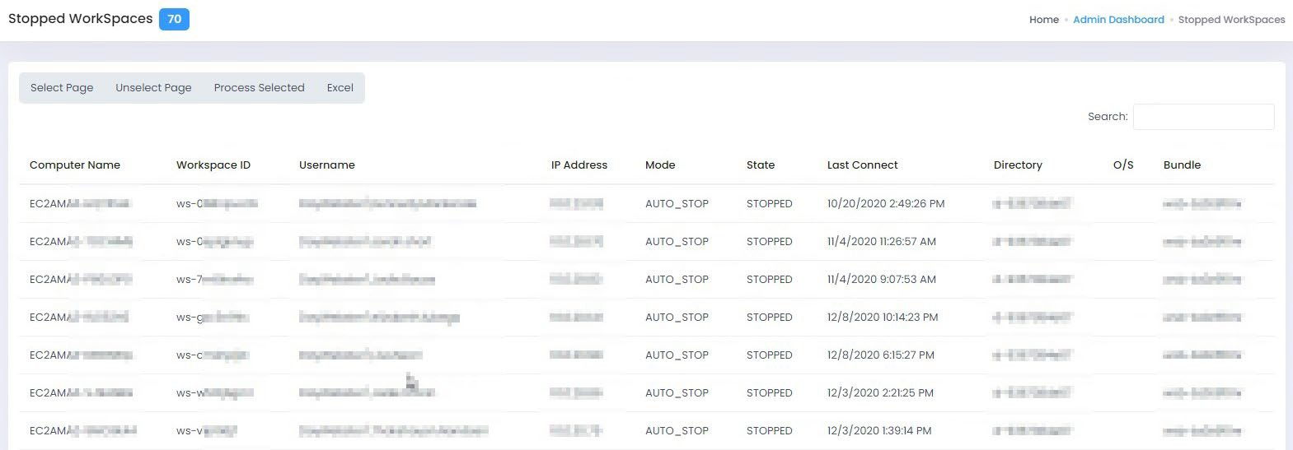
Gives a list of WorkSpaces that are in Stopped state.

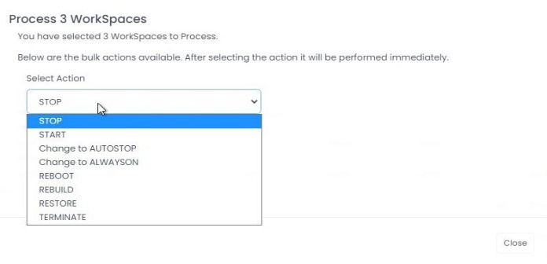
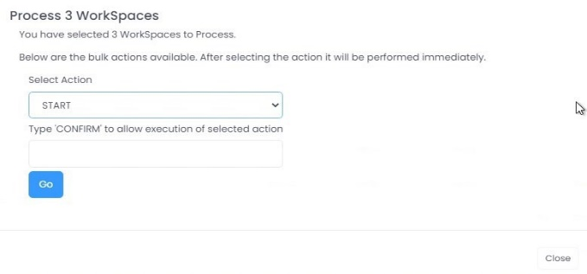
You can select them all, or select them one by one, and perform an action. You will need to type in CONFIRM to action and select ‘Go’.

You can also click on a WorkSpace and it will hyperlink directly to the information on that WorkSpace. You can then perform actions on it as normal.
This report can also be exported to Excel.

4.4.9 Orphaned WorkSpace
Check for Orphaned WorkSpaces. This will only update WorkSpaces that you have permission to manage and OU's within AD that you have access to.
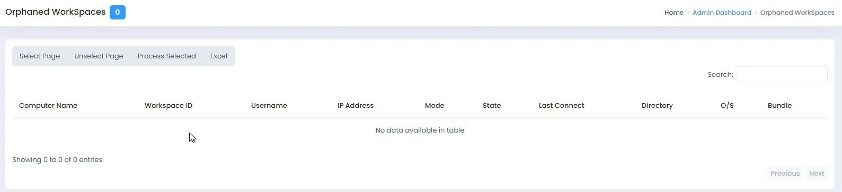
If users have been deleted from Active Directory, it is likely that their WorkSpace will remain. In the example below, two user accounts have been deleted but their WorkSpaces remain and is costing the company money.

You can select them all, or select them one by one, and perform an action. This report can also be exported to Excel.
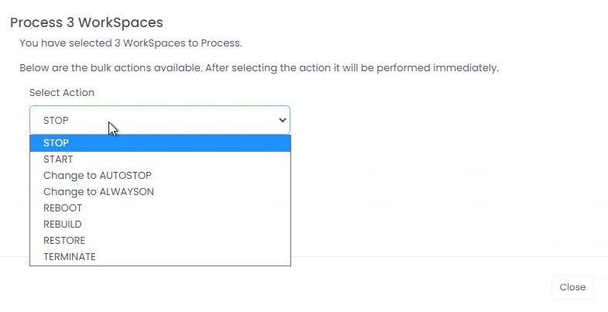
You can export these to Excel if you have a good many. Select the WorkSpaces you wish to act on. Select ‘Process Selected’ and you now get a drop-down list with a selected list of actions. In reality, you’d only need to select ‘Terminate’ (delete).

To terminate them, select ‘TERMINATE’ and then type CONFIRM and select ‘Go’. You will now receive a confirmation message.
You can also click on a WorkSpace and it will hyperlink directly to the information on that WorkSpace. You can then perform actions on it as normal.

4.4.10 Orphaned Computer Object
This report uses the OU defined in the WorkSpaces Directory in the Settings section. If empty, no data can be queried. The OU must be dedicated to WorkSpaces for this to work. Basically, this means that a computer object in Active Directory does not have an associated WorkSpaces. This report may be empty if no object is detected as orphaned.
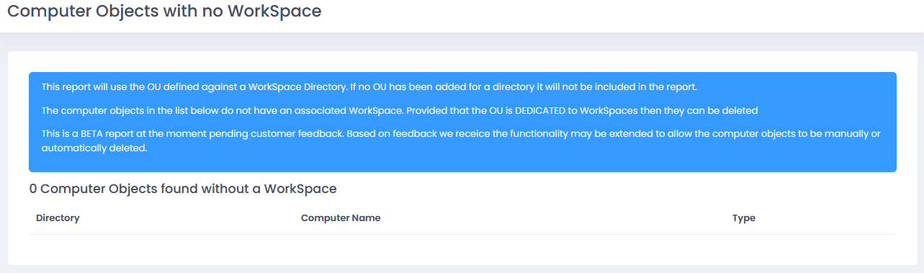
4.4.11 WorkSpaces Tag Report
This report will query all the tags from WorkSpaces. Currently, it support a maximum of 15 Tag Names assigned to the object.
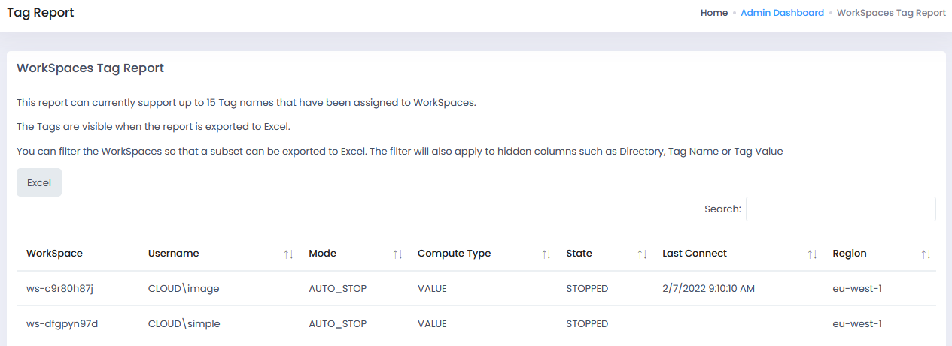

The tags are visible only when the report is exported to Excel:

4.4.12 Bundle/Image in Use
This report will list all the custom bundles that are currently in use for deployed WorkSpaces.

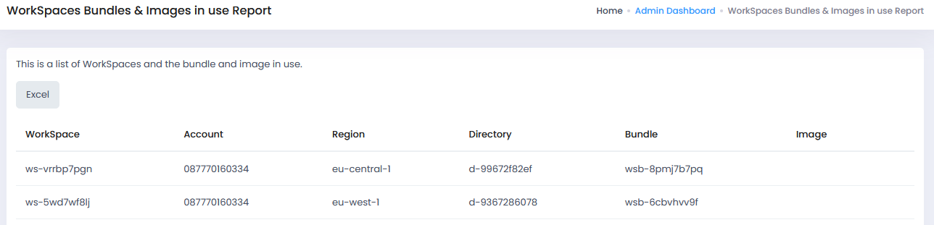

4.4.13 WorkSpaces Service Limits
This report requires to have a specific AWS managed policy to the WorkSpaces Manager role. The Policy in question is called "ServiceQuotasReadOnlyAccess". It will list the service limits and its usage for all regions enabled in the account.

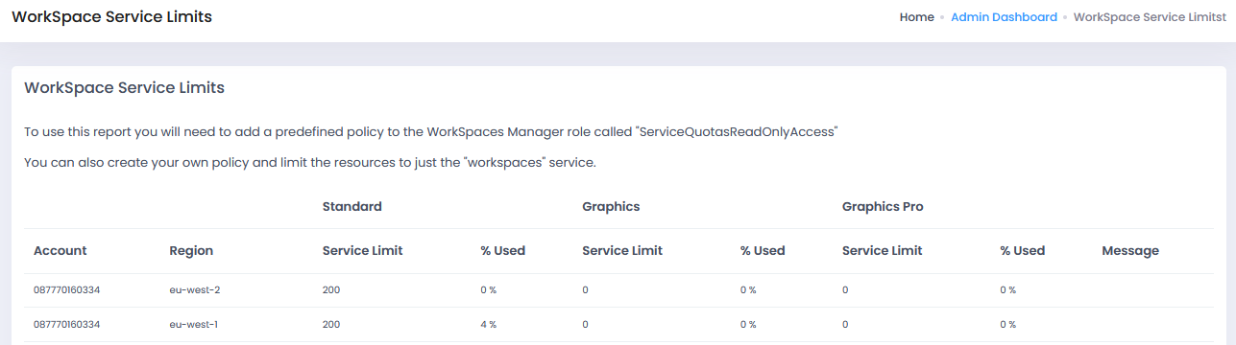

4.4.14 Hours since Reboot
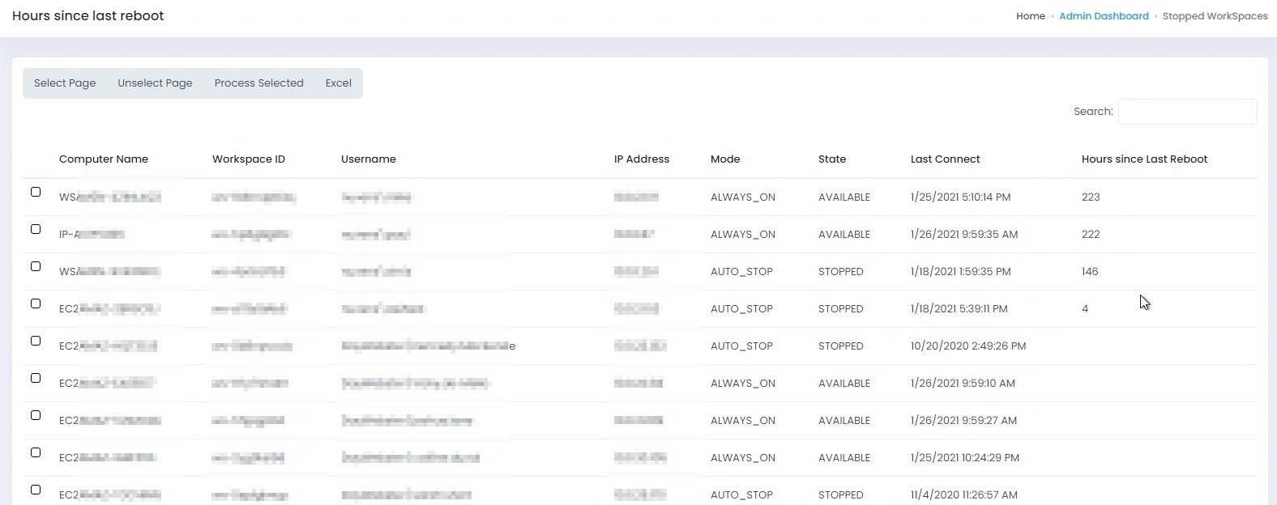
This gives information on the hours since the WorkSpace was last rebooted.

If you want to reboot WorkSpaces that have not been rebooted for some time, you can select them all, or select them one by one, and perform an action. (You can also click on a WorkSpace and it will hyperlink directly to its information and perform actions on it as normal). This report can also be exported to Excel.
You can export these to Excel if you have a good many. Select the WorkSpaces you wish to act on. Select ‘Process Selected’ and you now get a drop-down list with a selected list of actions. Select ‘REBOOT’ if you wanted to reboot them. Then type CONFIRM and select ‘Go’.
You will now receive a confirmation message.

4.4.14 WorkSpaces Provisioning
This report will check the number of created and deleted WorkSpaces per day.
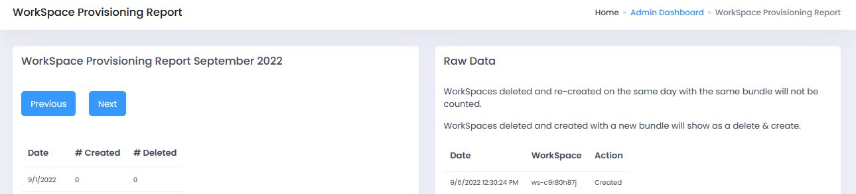

4.4.15 WSUS Require Reboot
This report is only available when the integration with WSUS has been configured. It will show the WorkSpaces that have a pending reboot.
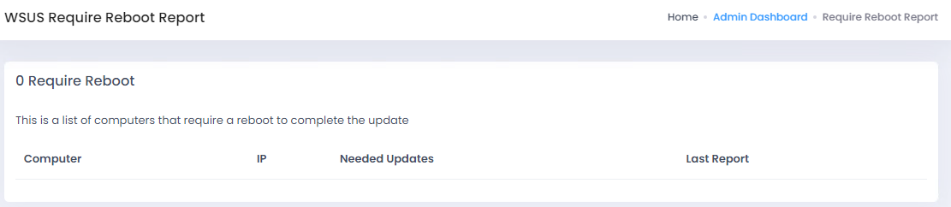

4.4.16 WSUS Compliance
As before, only visible when WSUS is enabled. It will add the label of “compliant” oe “non-compliant” to the WorkSpaces based on the number of patches that have been installed. Some non-compliant systems may require a reboot to have patches completely applied, so it is recommended to do a healthy monthly reboot.
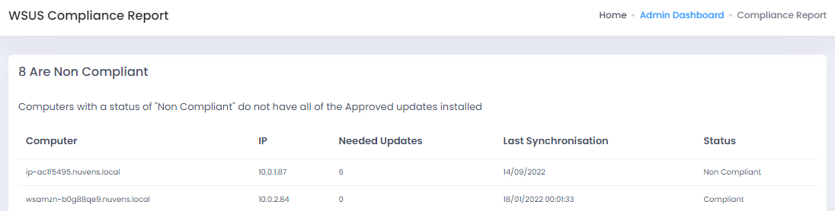

Also, depending on how WSUS and the GPO policies are configured, some patches may give the users the chance to install them by themselves by clicking on the “Install Now” button:
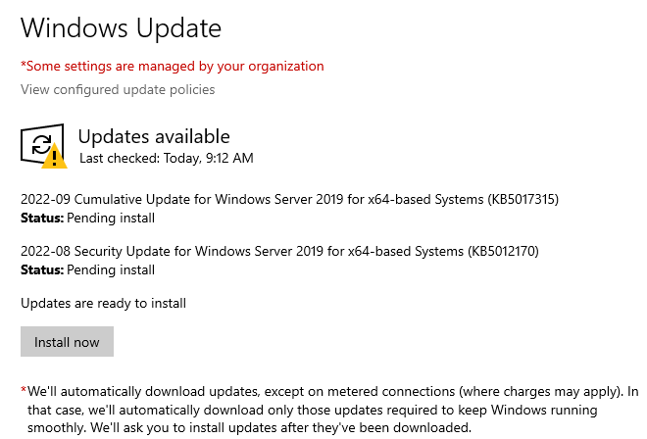

4.4.17 AS2 Sessions
This report can only be seen when AppStream 2.0 integration is enabled. It will list the usage of fleet and stacks that have happened in a given period of time.
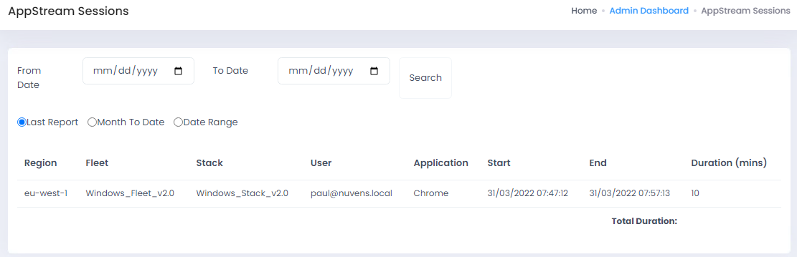

4.4.18 AS2 Users
Also only available when the option is enabled. This report is similar to the previous one, but it will show the applications/fleet usage based on how many users have consumed it.
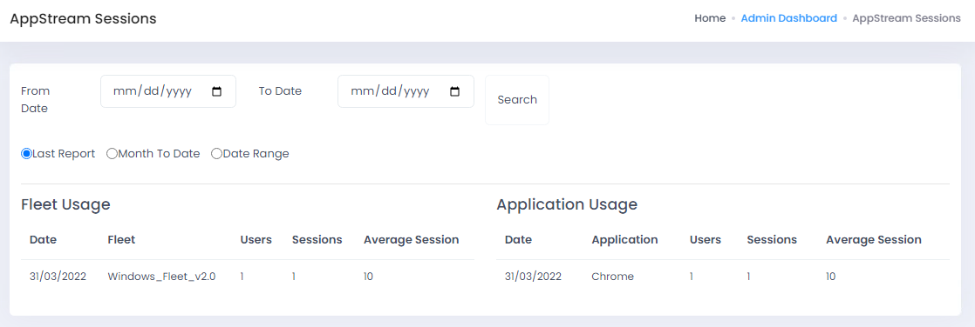

4.4.19 Importing Spreadsheets
From version 4.7.0, the new AMI includes all the software requirements to import spreadsheets. If the version is lower than this, we will have to execute it manually by downloading the MS Access Database Engine 2016 Redistributable from:
https://www.microsoft.com/en-us/download/details.aspx?id=54920

5. Presenting applications to users via various delivery methods
Applications can be delivered to users via either:
- In a WorkSpace (using Active Directory group membership and products such as App-V, FlexApp, etc) or via Numecent Cloudpaging
- The likes of FlexApp and Numecent Cloudpaging is a separate application suite where applications are packaged and delivered in containers. If you need to know more about how they could fit your organisation, please contact us here at Nuvens
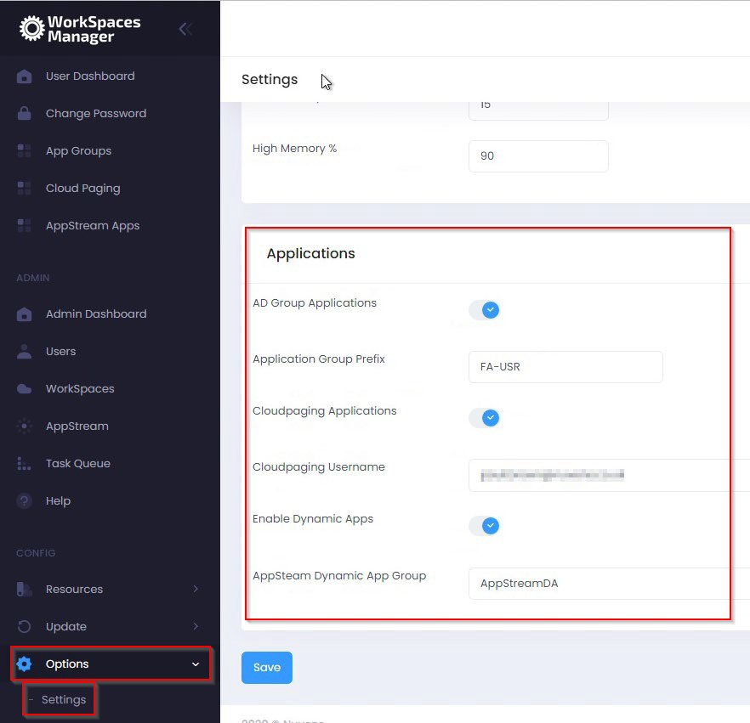
- In an AppStream session

5.1 Active Directory (AD) Group Applications
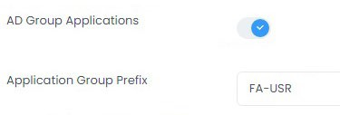
Firstly, enable “AD Group Applications” in the Applications menu above.

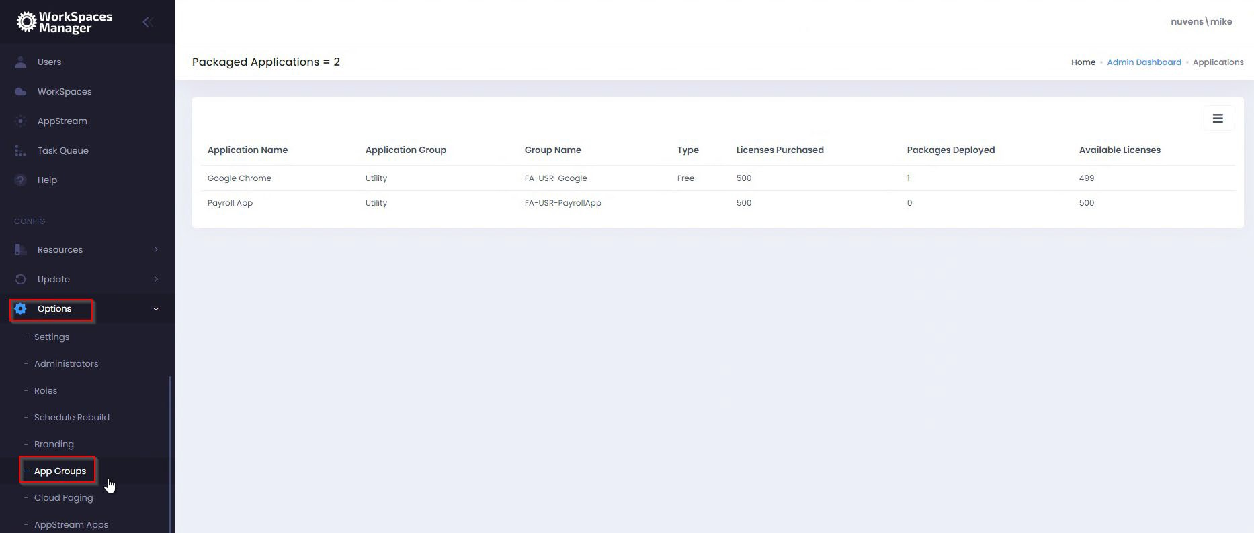
When you have enabled this option, you will get an ‘App Groups’ option on the menu.

To add a new application to the user’s menu which is delivered via an Active Directory group membership, select ‘Add Application from the ‘Packaged Applications’ menu.
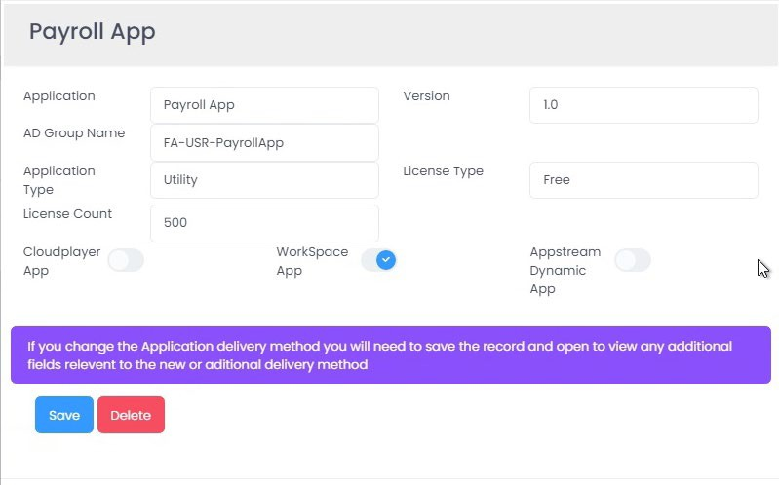

5.1.1 Application
Name of your application.

5.1.2 Version
The application version.

5.1.3 AD Group Name
The Active Directory group name that the user must be a member of to obtain this application.

5.1.4 Application Type
Random field where you can put in what you like (e.g., Payroll, HR, IT, etc).

5.1.5 License Type
This is either ‘Free’ (the user can add\remove this application via Self-Service) or ‘Paid’ (which requires administrator intervention).

5.1.6 License Count
This is the total number of licenses for the application. This will go against the License Type above if it is put as ‘Paid’.

5.1.7 WorkSpace App
Select this option for Active Directory group delivered applications.

5.2 Cloudpaging applications
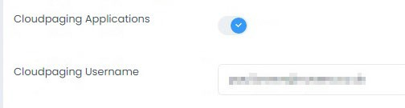
Firstly, enable “Cloudpaging Applications” in the ‘Applications’ menu and enter your Cloudpaging username that is used to control the delivery of the applications.

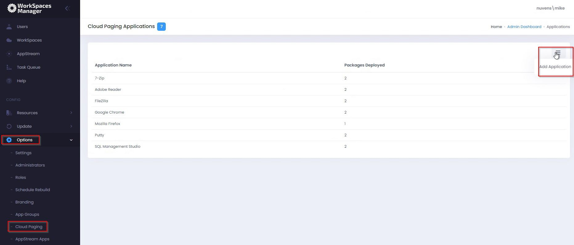
This will enable the ‘Cloud Paging’ menus for administration and on the user Self-Service portal.

You can now add your Cloudpaging applications. Enable ‘Cloudplayer app’ function for it to be delivered via the Cloudpaging application.
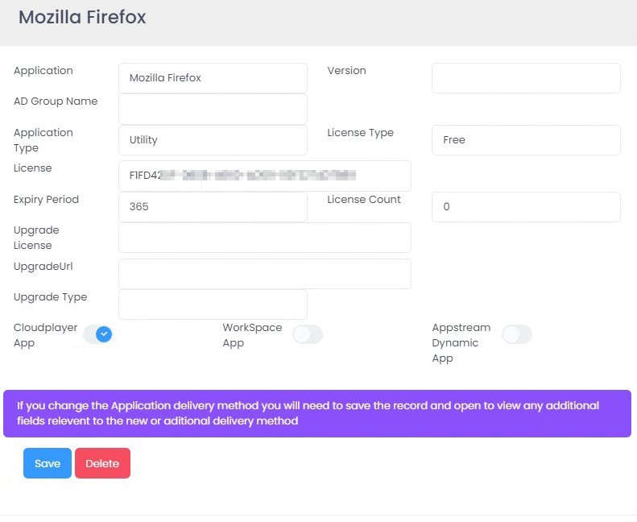

5.2.1 Application
Name of your application

5.2.2 Version
The application version

5.2.3 AD Group Name
For applications deployed based on AD group membership

5.2.4 Application Type
Random field where you can put in what you like (e.g., Payroll, HR, IT, etc)

5.2.5 License Type
This is either ‘Free’ (the user can add\remove this application via Self-Service) or ‘Paid’ (which requires administrator intervention)

5.2.6 License (Cloudpaging Only)
The license is determined when the application is packaged which will generate a license GUID

5.2.7 Expiry Period (Cloudpaging Only)
The number of days that the license is assigned for before being returned to the pool

5.2.8 License Count
The number of licenses purchased/available for the product

5.2.9 Upgrade License (Cloudpaging Only)
If a Cloudpaging application is provided with an Upgrade License GUID, Numecent will automatically provision the upgraded version of the product

5.2.10 Upgrade URL (Cloudpaging Only)
The URL for the upgraded application package

5.2.11 Upgrade Type (Cloudpaging Only)
The upgrade can be optional or enforced
5.2.12 Cloudplayer App
Enables this as a Cloudplayer (Cloudpaging) application in the users’ Self-Service portal.

5.3 AppStream applications
If the application is delivered into an AppStream session as a Dynamic Application. This points to the path of the application executable to launch.
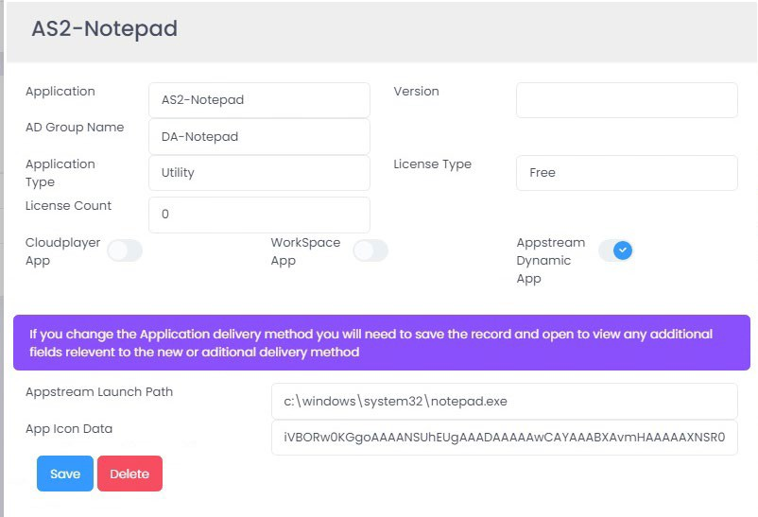
Please refer to Section 8 for information on ‘AppStream Dynamic Applications’.

5.3.1 Application
Name of your application.

5.3.2 Version
The application version.

5.3.3 AD Group Name
The Active Directory group that the user must be a member of to get the application via Dynamic Application delivery.

5.3.4 Application Type
Random field where you can put in what you like (e.g., Payroll, HR, IT, etc).

5.3.5 License Type
This is either ‘Free’ (the user can add\remove this application via Self-Service) or ‘Paid’ (which requires administrator intervention).

5.3.6 License Count
This is the number of licenses available if the application is marked as ‘Paid’.

5.3.7 AppStream Launch Path
If the application is delivered into an AppStream session as a Dynamic Application. This points to the path of the application executable to launch. Please refer to the separate ‘AppStream Dynamic Applications’ document.

5.3.8 App Icon Data
If the application is delivered into an AppStream session as a Dynamic Application. This is the Base64 representation of the application icon. Please refer to the separate ‘AppStream Dynamic Applications’ document.

5.3.9 AppStream Dynamic App
Enables this as a AppStream Dynamic application in the users’ Self-Service portal. Please refer to Section 8 for information on ‘AppStream Dynamic Applications’.

6. Multi-Domain forest
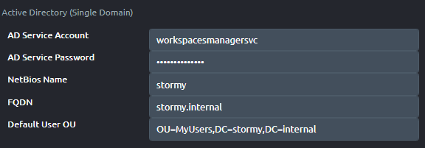
If you have users in a multi-domain forest, you can add your domains to the WorkSpaces Manager portal. For this configuration, you will need to switch the Multiple Domains function in Additional Options to ‘On’. You will have a single domain by default.

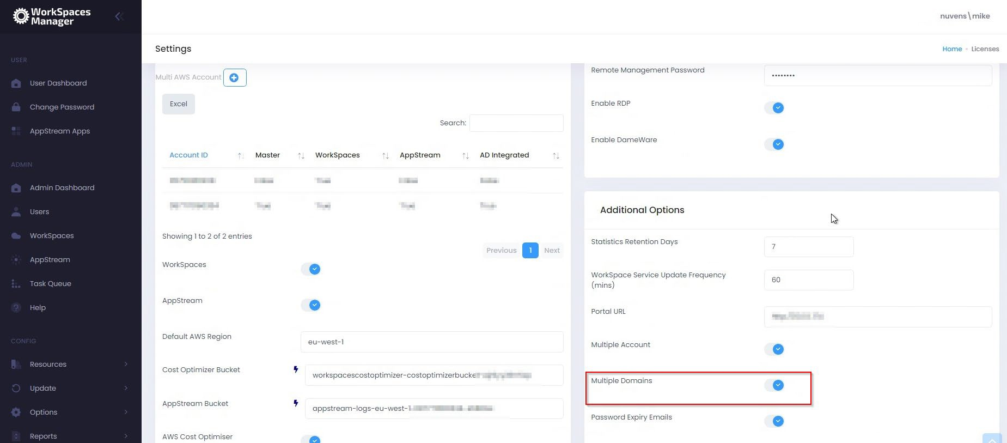
Enable ‘Multiple Domains’ in the Additional Options section of ‘Options > Settings’.

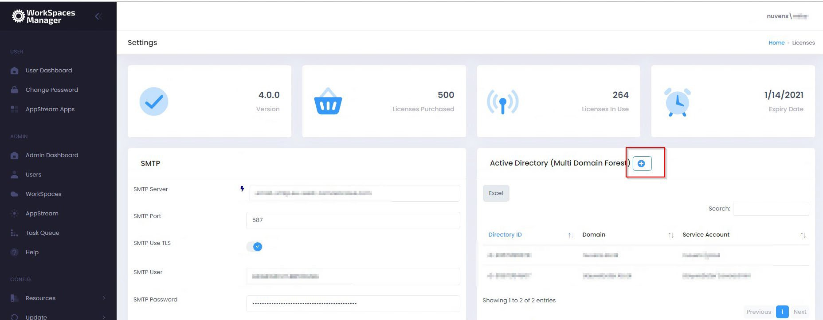
You add more domains by clicking on the ‘+’ button.

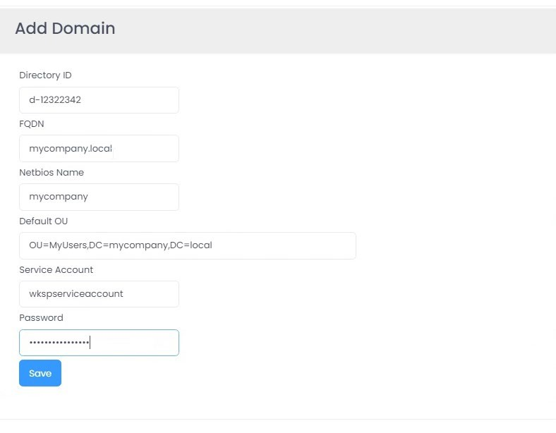
You now add your WorkSpaces Directory ID, FQDN and NetBIOS name of your Active Directory domain, the default OU for your user accounts in that domain, and the username and password for the service account in that domain that you are using to add and remove WorkSpaces.

7. Multi AWS Accounts
Using WorkSpaces Manager, it is possible to manage WorkSpaces in different AWS accounts in the same console.

7.1 Step 1: In Account A
(which is the main account that the WorkSpaces Manager instance resides in)
Firstly, make a note of the following:
- The account number of Account A (where your WorkSpaces Manager instance resides). For this example, we will refer to it as 111111111111
- The account number of Account B (where your other WorkSpaces reside that you want to manage). For this example, we will refer to it as 222222222222
- The IAM role that is associated with your WorkSpaces Manager in Account A. For this example, we will refer to it as WSM320-YourWSMRole (if deployed via CloudFormation, name can be similar to CF-WSM-WorkSpacesManagerRole-1XXXXXXXXXXXX)
- The Instance ID of your WorkSpaces Manager. For this example, we will refer to it as i-99999999999999999

1. Insert an inline policy which gives access to the second account with the WorkSpaces in. Call the inline policy ‘WSMAllowAccountBAccess’. We will call the role in Account B ‘AllowWSMAccess’ and will be creating it in the next section:
{
"Version": "2012-10-17",
"Statement": [
{
"Sid": "VisualEditor0",
"Effect": "Allow",
"Action": "sts:AssumeRole",
"Resource": "arn:aws:iam::222222222222:role/AllowWSMAccess"
}
]
}

2. Insert an inline policy which gives access to the second account with the WorkSpaces in. Call the inline policy ‘WorkSpacesManagerCloudwatchPolicy’. Insert this JSON.
{
"Version": "2012-10-17",
"Statement": [
{
"Sid": "VisualEditor0",
"Effect": "Allow",
"Action": [
"cloudwatch:DescribeAlarmHistory",
"cloudwatch:GetDashboard",
"cloudwatch:GetMetricData",
"cloudwatch:DescribeAlarmsForMetric",
"cloudwatch:DescribeAlarms",
"workspaces:*",
"cloudwatch:GetMetricStatistics",
"cloudwatch:GetMetricWidgetImage",
"ce:*"
],
"Resource": [
"*",
"arn:aws:iam::222222222222:role/AllowWSMAccess"
]
}
]
}

3. Insert an inline policy which gives access to the second account with the WorkSpaces in. Call the inline policy ‘WorkSpacesManagerPricingPolicy’. Insert this JSON.
{
"Statement": [
{
"Sid": "VisualEditor0",
"Effect": "Allow",
"Action": "pricing:*",
"Resource": [
"*",
"arn:aws:iam::222222222222:role/AllowWSMAccess"
]
}
]
}

4. Insert an inline policy which gives access to the second account with the WorkSpaces in. Call the inline policy ‘WorkSpacesManagerCostExplorerPolicy’. Insert this JSON.
{
"Version": "2012-10-17",
"Statement": [
{
"Sid": "VisualEditor0",
"Effect": "Allow",
"Action": "ce:*",
"Resource": [
"*",
"arn:aws:iam::222222222222:role/AllowWSMAccess"
]
}
]
}

7.2 Step 2: In Account B
(where the WorkSpaces are that you need to administer with WorkSpaces Manager).
1. In IAM, create a policy called ‘WorkSpacesManagerAdminPortal’ with the following JSON.
{
"Version": "2012-10-17",
"Statement": [
{
"Sid": "VisualEditor0",
"Effect": "Allow",
"Action": [
"cloudwatch:GetMetricData",
"cloudwatch:DescribeAlarmHistory",
"cloudwatch:DescribeAlarmsForMetric",
"cloudwatch:GetMetricWidgetImage",
"cloudwatch:GetDashboard",
"cloudwatch:GetMetricStatistics",
"cloudwatch:DescribeAlarms",
"logs:*",
"sts:GetAccessKeyInfo",
"sts:GetSessionToken",
"sts:GetServiceBearerToken",
"sts:GetCallerIdentity",
"workspaces:*"
],
"Resource": "*"
},
{
"Sid": "VisualEditor1",
"Effect": "Allow",
"Action": [
"sts:AssumeRole", "sts:GetFederationToken"
],
"Resource": [
"arn:aws:iam::111111111111:role/WSM320-YourWSMRole",
"arn:aws:iam::222222222222:role/AllowWSMAccess"
]
}
]
}

2. Create a role called ‘AllowWSMAccess’ and attach the policy ‘WorkSpacesManagerAdminPortal’ that you created above.

3. Attach an inline policy to the role ‘AllowWSMAccess’ role and call it ‘WSMIAMPassPolicy’. Insert this JSON.
{
"Version": "2012-10-17",
"Statement": [
{
"Sid": "VisualEditor0",
"Effect": "Allow",
"Action": [
"iam:GetRole", "iam:PassRole", "sts:AssumeRole"
],
"Resource": [
"arn:aws:iam::111111111111:role/WSM320-YourWSMRole",
"arn:aws:sts::111111111111:assumed-role/WSM320-YourWSMRole/i-
99999999999999999"
]
}
]
}

4. Go to the ‘AllowWSMAccess’, select ‘Trust Relationships’ and then ‘Edit Trust Relationships’. Insert this JSON and select ‘Update Trust Policy’.
{
"Version": "2008-10-17",
"Statement": [
{
"Effect": "Allow",
"Principal": {
"AWS": [
"arn:aws:iam::111111111111:root",
"arn:aws:iam::111111111111:role/WSM320-YourWSMRole",
"arn:aws:sts::111111111111:assumed-role/WSM320-YourWSMRole/i-99999999999999999"
],
"Service": [ "workspaces.amazonaws.com", "ec2.amazonaws.com"
]
},
"Action": "sts:AssumeRole"
}
]
}

5. Create a policy called ‘WSMS3Access’ with the content below and attach it to the ‘AllowWSMAccess’ role. Insert this JSON.
Replace ‘workspacescostoptimizer-costoptimizerbucket-1234567890123’ with the S3 bucket name of your WorkSpaces Cost Optimiser in Account B.
{
"Version": "2012-10-17",
"Statement": [
{
"Sid": "VisualEditor0",
"Effect": "Allow",
"Action": [
"s3:GetObject",
"s3:ListBucket",
"s3:GetBucketVersioning"
],
"Resource": [
"arn:aws:s3:::workspacescostoptimizer-costoptimizerbucket-1234567890123",
"arn:aws:s3:::*/*"
]
},
{
"Sid": "VisualEditor1",
"Effect": "Allow",
"Action": [
"s3:GetObject",
"s3:ListBucket",
"s3:GetBucketVersioning"
],
"Resource": "arn:aws:s3:::*/*"
},
{
"Sid": "VisualEditor2",
"Effect": "Allow",
"Action": [
"s3:ListAllMyBuckets", "s3:HeadBucket"
],
"Resource": "*"
},
{
"Sid": "VisualEditor3",
"Effect": "Allow",
"Action": [
"sts:AssumeRole",
"sts:GetFederationToken"
],
"Resource": [
"arn:aws:iam::111111111111:role/WSM320-YourWSMRole",
"arn:aws:iam::222222222222:role/AllowWSMAccess"
]
}
]
}

7.3 Step 3: Config WorkSpaces Manager in your main account (Account A)
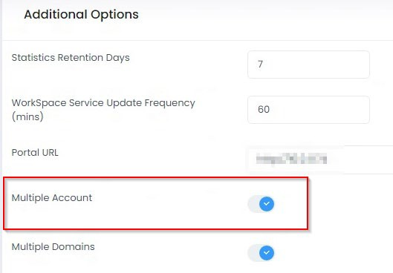
Configure the WorkSpaces Manager Portal to accept the new account. Go to Options > Settings > Additional Options and set ‘Multiple account’ to ‘On’.

In one left hand side pane, you will now see a Multi AWS Account option with your root (Master) WorkSpaces Manager account already filled in.
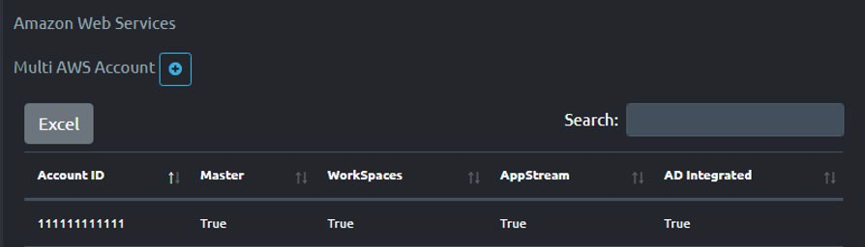
To add Account B, select the ‘+’. Enter the details for the AWS account.
- AD Integrated – Your WorkSpaces can either be domain joined or non-domain joined. If they are domain joined, select this.
- WorkSpaces – WorkSpaces are viewable and enabled in this account. Select this.
- AWS Cost Optimiser – Select.
- Cost Optimiser Bucket – This is the s3 bucket that represents the Cost Optimiser location on Account B.
- Access Log Group – Leave blank here for now
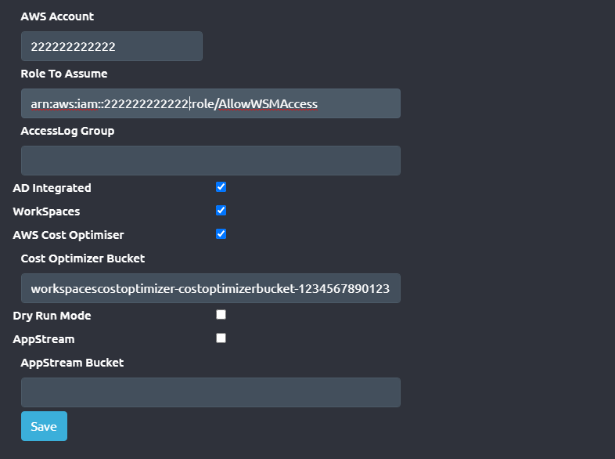
Leave AppStream option and AppStream Bucket

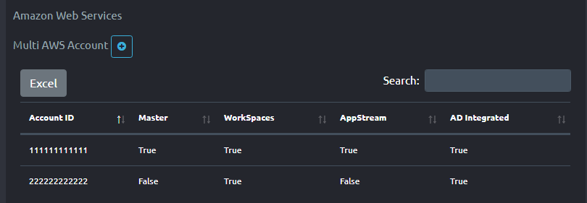
Your new account will show up as below. Up to 10 accounts can show on one list, and any more will be on the next page where you can select ‘Next’.

8. Creating Dynamic Applications in AppStream

8.1 Creation Process

8.1.1 Differences between Dynamic & AppStream application delivery?
When an administrator installs applications on an AppStream image, every icon on that image is delivered to every user that connects to that fleet when in ‘Application mode’. Whilst you can restrict these from launching, you will still be allocating an RDS CAL, which will incur additional costs.
Using Dynamic Applications, we completely remove the user’s visibility of applications they cannot use, reducing costs and providing a clean AppStream image. Applications are delivered based on Active Directory group membership.
It is also important not to give users access to AppStream services if they do not have any AppStream applications. This is explained in Section 8.11.
The end-user process to launch an AppStream Dynamic Application is:
(1) The user connects to the AppStream service (2) They enter their Active Directory password (3) The list of applications builds based on their Active Directory group membership (4) The user launches their application.
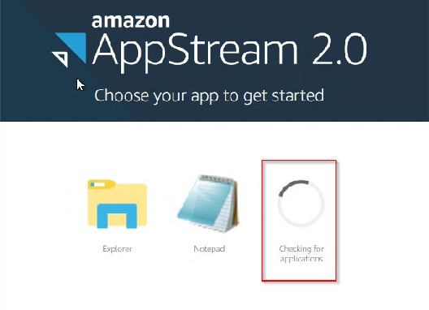

8.1.2 Image Builder Preparation
To install the Dynamic Applications components, the local Image Builder administrator will need to log on to the Image Builder and create the Dynamic Application Provider environment.
Step 1: Create a folder called C:\DynamicApps
Copy in and extract DynamicApps.zip (to be supplied by Nuvens) to this folder.
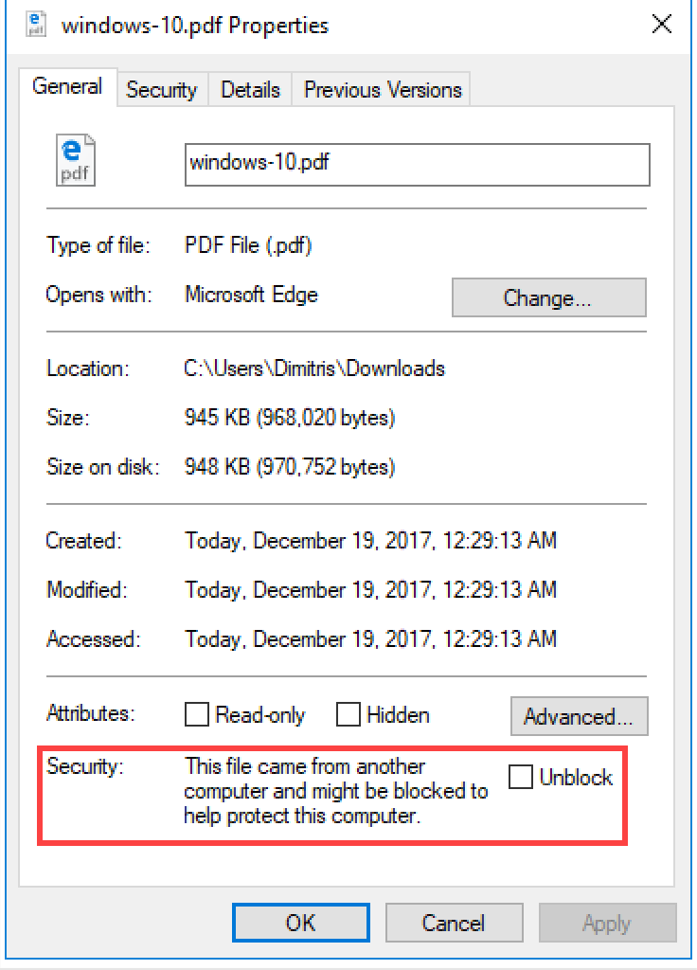
IMPORTANT: As these extracted files will be copied in from outside the instance, the administrator must ensure that each of these files is ‘Unblocked’ by the operating system. To do this, right click on each of the extracted files and select ‘Unblock’.

Step 2: Create a folder called C:\DynamicAppIcons
This is where the local administrator will put the application icons so they can be converted to Base64 format so the administrator can use this information later in WorkSpaces Manager to assign icons to the applications.
AppStream does not use these icons directly. It is just an area where the administrator can store ‘.png’ icons that represent the applications and have them created to Base64 via a PowerShell script.

Please refer to Section 8.1.4 for creating the application icons.
Step 3: Create a folder called C:\DynamicAppIcons\Encoded
This is where the Base64 encoded text files will reside when they are converted Section 8.1.3.

Step 4: Amend the AppStream Sessions Scripts script
Edit the file config.json in the location C:\AppStream\SessionScripts and put the following entry in the location shown. This will invoke the Dynamic Application functionality which supplies the applications to the users.
"filename": "C:\\Windows\\System32\\WindowsPowerShell\\v1.0\\powershell.exe",
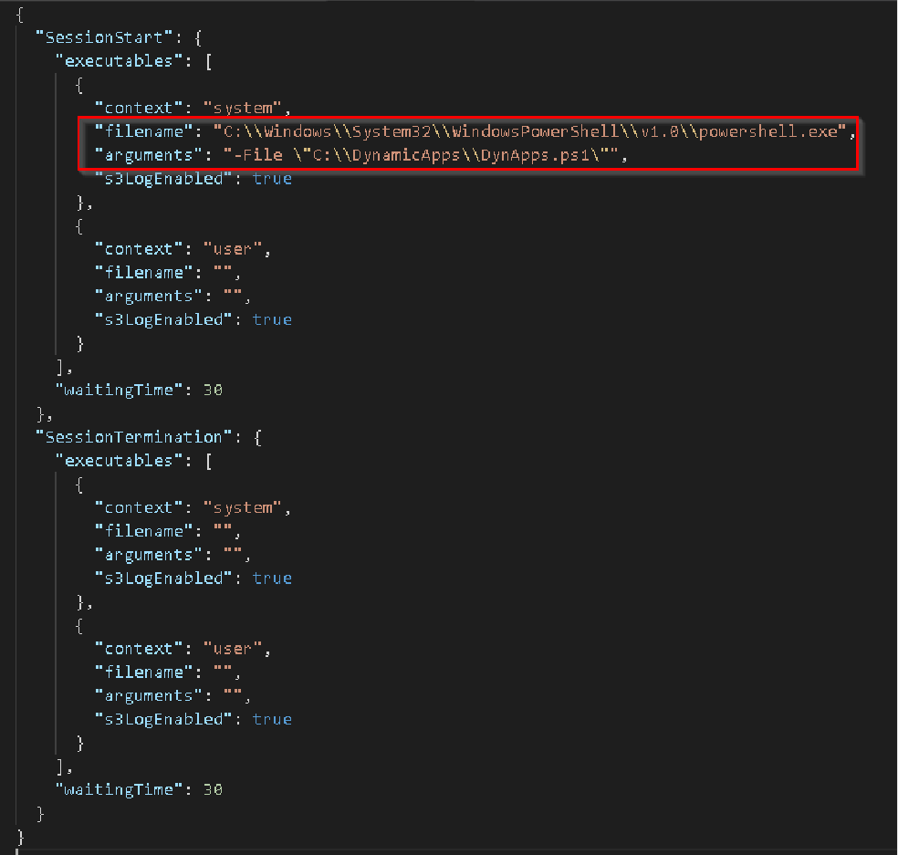
"arguments": "-File \"C:\\DynamicApps\\DynApps.ps1\"",

8.1.3 Creating a Base64 string for the application icons
Copy in the file ‘GetBase64ofPNG.ps1’ from the C:\DynamicApps folder into the C:\DynamicAppIcons folder. The administrator will need to amend this with your own application .png files.
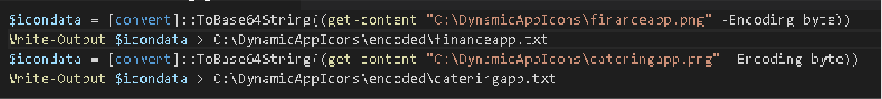
As an example, there are two icons for our Finance and Catering apps which have been copied into the C:\DynamicAppIcons folder.

Run this PowerShell script to obtain the Base64 files of those in text format. It puts them in the ‘encoded’ sub-folder. These will be used later to create a Dynamic Application in the WorkSpaces Manager admin portal.

8.1.4 How to create a PNG icon for my application?
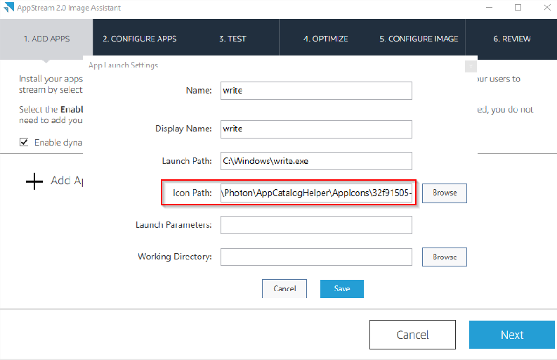
The local administrator can obtain an icon for the application by using the Image Assistant to create one. Go to Image Assistant on the Image Builder desktop and add the application. In the example below, an in-built application (Write) has been added. Note that there is an ‘Icon Path’ there.

To find the icon, go to C:\ProgramData\Amazon\Photon\AppCatalogHelper\AppIcons and there will be a list of png files in here which relate to the applications. Just double click on them to find the icon that is required. They will be named randomly.
Copy the relevant icon file to the C:\DynamicAppIcons folder and then go to Section 8.3 to convert it to Base64.

8.1.5 Testing applications from the Image Builder
Dynamic Applications behave differently on an image builder when testing applications from the Image Assistant and creating the new image. Dynamic Applications will not show up to test, but non-dynamic applications will.
For Dynamic Application functionality to be available, select ‘Enable dynamic app providers’ with the check box.
In the example below, an application is added that everyone will see on the image. This is not controlled by Active Directory group membership. This will show up all the way through the Image Assistant process to create a new image.
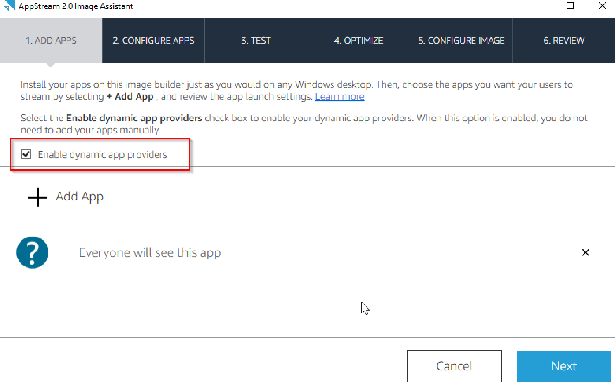
If the administrator wants to test the applications that are published dynamically, they must do so via the usual menu shortcuts, etc.

8.2 Administration Process

8.2.1 Top level AppStream Dynamic Applications access control group
An administrator can specify if a user is enumerated for applications in WorkSpaces Manager by using a general Active Directory control group. Below, there is an Active Directory group called
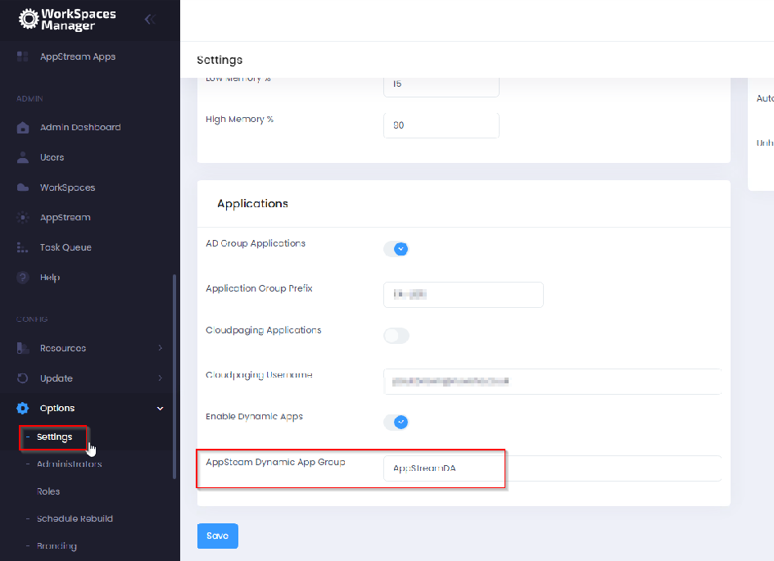
‘AppStreamDA’. If a user is not a member of this group, then a CSV will not be generated for them with application entitlements. However, if the administrator gives them access to the stack then they can still connect to it (which the administrator does not want as it will take resource). Control this access via Section 8.11.

8.2.2 Adding an AppStream Dynamic Application in WorkSpaces Manager
In the WorkSpaces Manager portal, go to ‘AppStream Apps’ in ‘Options’. The list of AppStream Dynamic Applications will be shown.
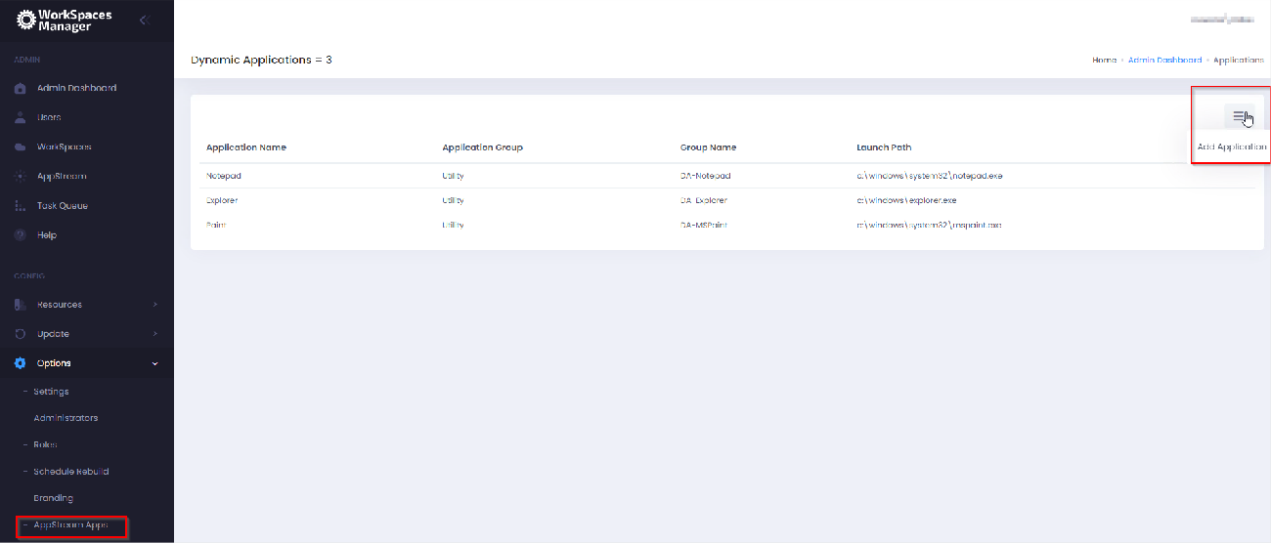
To add an application, select the menu on the right and select ‘Add Application’.

Now enter the details for the application. The AD Group Name will be the group that users will be a member of. They must be a direct member of this group as group nesting will not work.

8.2.3 Assigning an AppStream Dynamic Application to a user.
There are two ways of achieving this.

8.2.3.1 Assign the application to user in WorkSpaces Manager
PLEASE NOTE: AppStream users will need to be in a top-level access Active Directory group to get their applications.
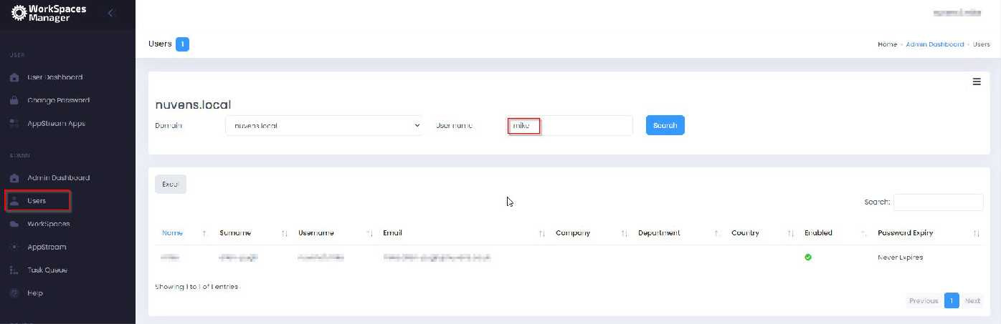
First, search for the user in the ‘Users’ menu.

Then select this user, select the menu item shown and then ‘Assign Application’.
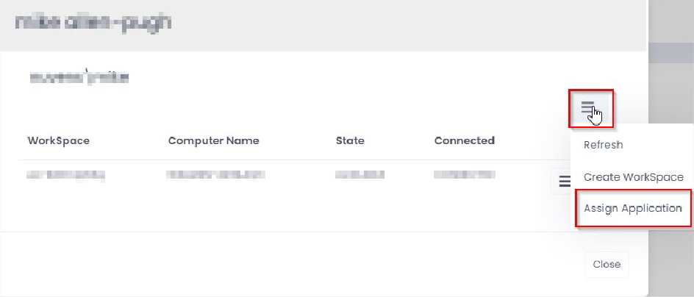
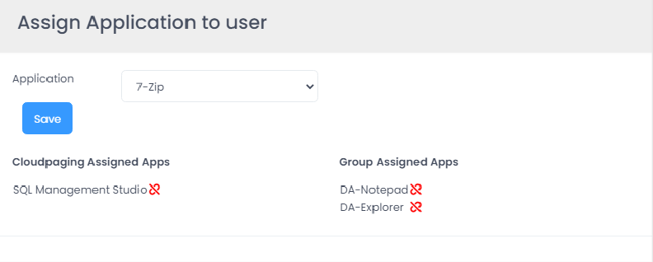
It can now be seen that there are two Dynamic Applications assigned to this user via AD groups (DA-Notepad and DA-Explorer of ‘Notepad’ and ‘Explorer’ apps respectively). The Active Directory groups have been stated the Active Directory groups for the Dynamic Applications when configuring them in Section 8.6.
Now select the application from the drop-down list and select ‘Save’.
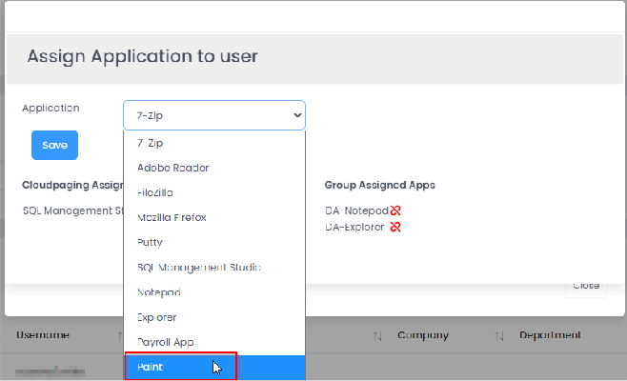
Go back to the user’s apps list and the new application will be visible. This is now available to them via Dynamic Apps once the update routine runs (every 20 minutes).

8.2.3.2 Put the user in the Active Directory Group associated with the Dynamic application.
PLEASE NOTE: AppStream users will need to be in a main access Active Directory group to get their applications. Without this, they will not get a configuration file generated.
This is the best method if there are a lot of users to assign the application to.
IMPORTANT NOTE REGARDING GROUP MEMBERSHIPS: Nested Group membership does not work. The user must explicitly be a member of the AD group assigned to that application for it to work.
An AD Sync process will be run each day from the WorkSpaces Manager application at 04:30 daily, or an administrator can manually instigate the process by going into the WorkSpaces Manager ‘Hangfire’ console (http://localhost/hangfire) and run the ‘syncAdGroups’ job.
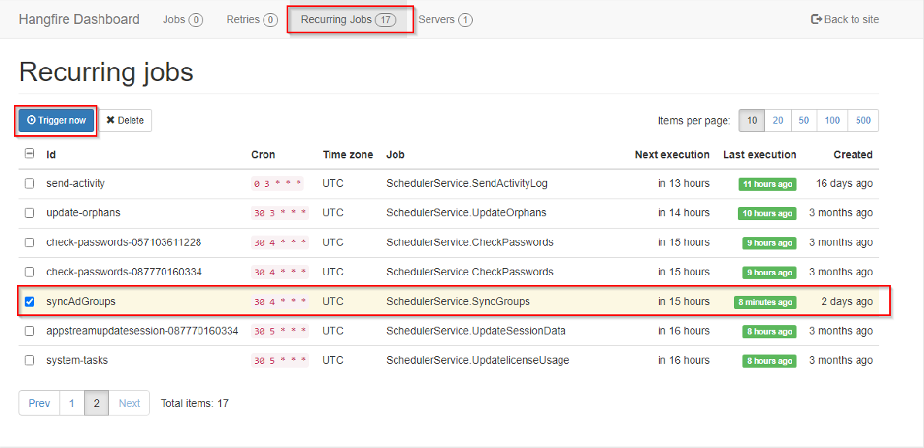
Go to ‘Recurring jobs’ at the top and look for the ‘syncAdGroups’ job. Select it and select ‘Trigger now’. ** DO NOT SELECT “DELETE” **

Additionally, do the same with the ‘dynamicAppFiles’ job.

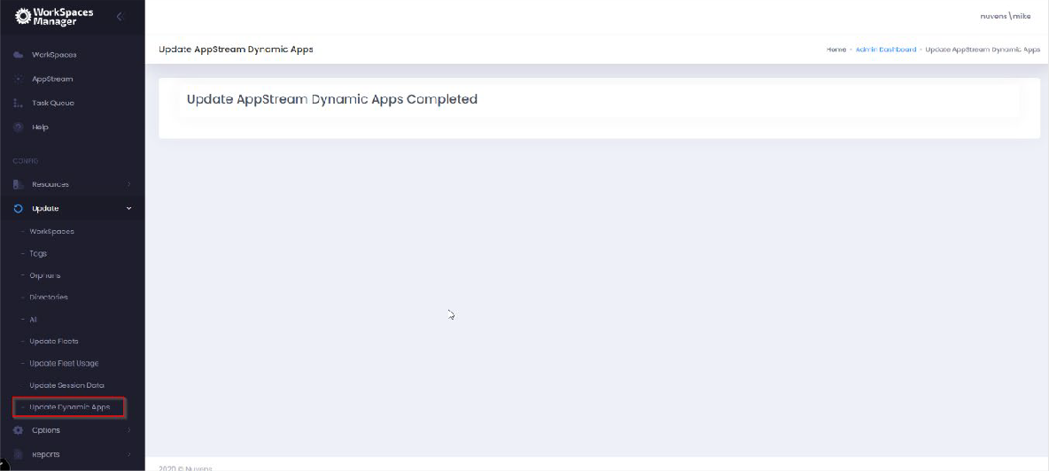
The user’s CSV file is updated on the 20-minute schedule or the administrator can invoke it themselves by going to the WorkSpaces Manager console and selecting ‘Update Dynamic Apps’ from the ‘Update’ menu.

8.2.4 Removing a Dynamic Application from the main list for all users
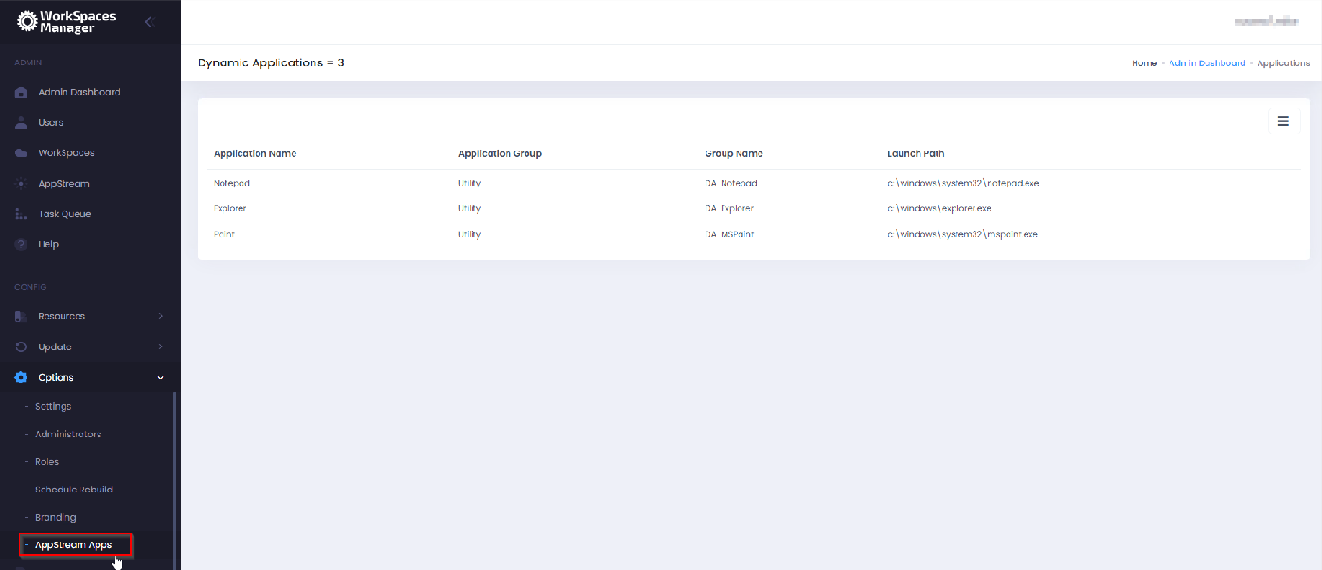
In WorkSpaces Manager, go to ‘AppStream Apps’ in Options.

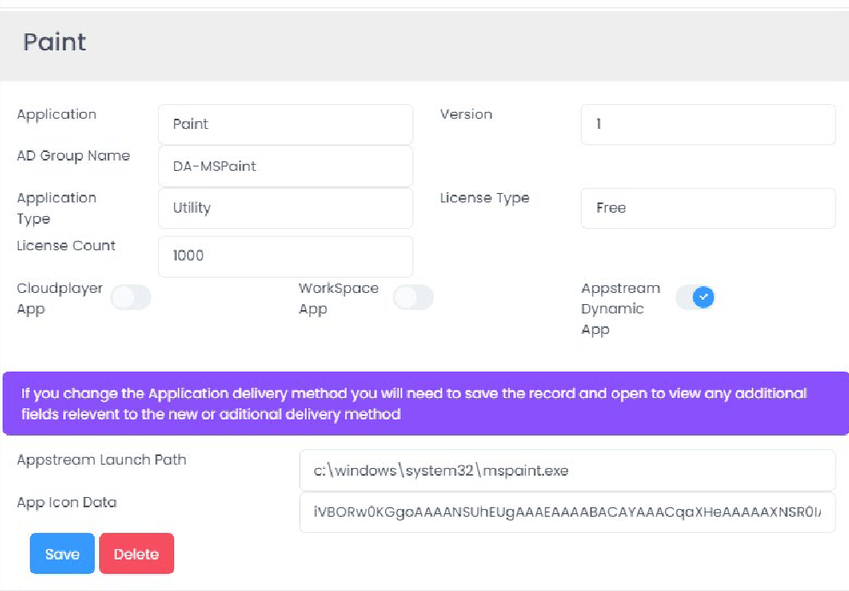
Click on the application to be deleted (Paint will be selected above). Then select ‘Delete’ to remove the application.

The user’s CSV file is updated on the 20-minute schedule or the administrator can invoke it themselves by going to the WorkSpaces Manager console and selecting ‘Update Dynamic Apps’ from the ‘Update’ menu.
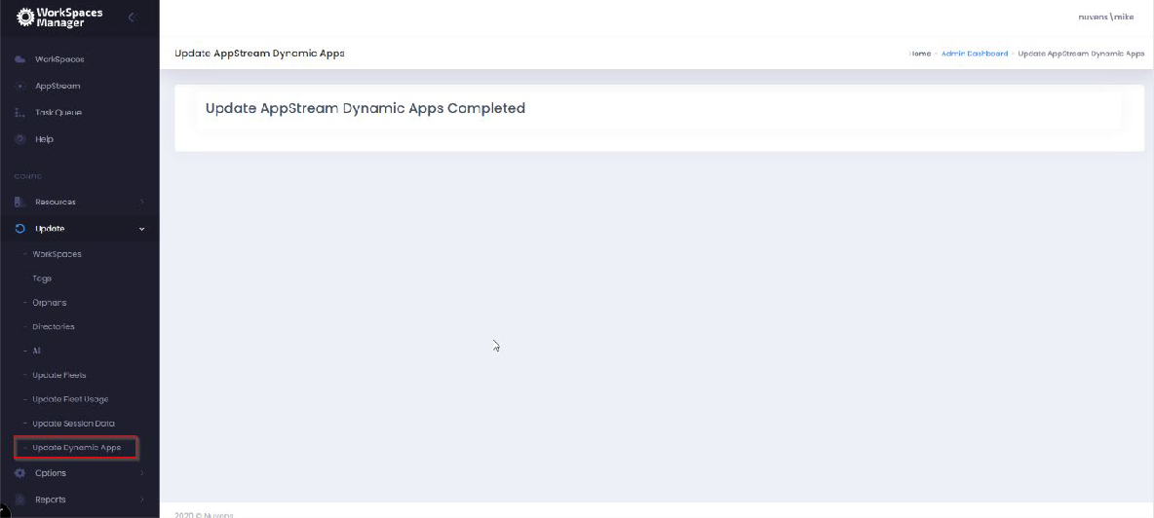
The application will now be there the next time they log in to AppStream.

8.2.5 Removing a Dynamic Application from a user
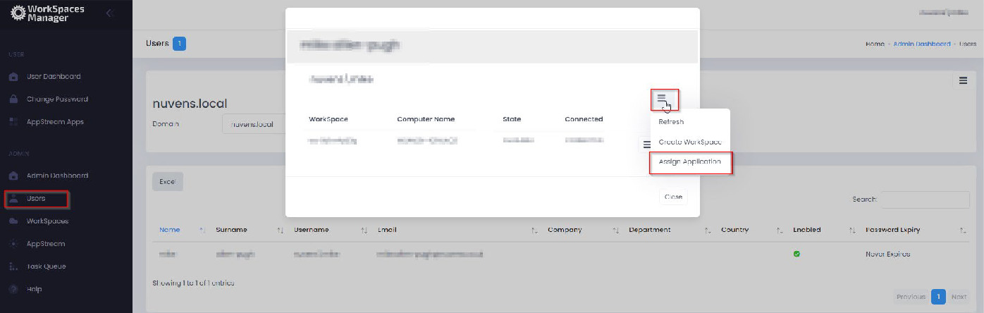
First, search for the user in WorkSpaces Manager and select ‘Assign Application’.

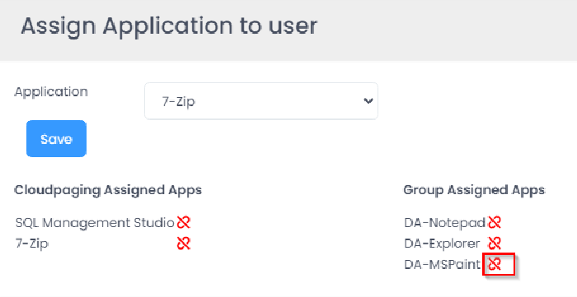
Then select the icon to the right of the application to be removed. Below, the MS Paint will be removed from the user.

Alternatively, you can also remove them directly from the Active Directory group assigned to that application.

8.2.6 Dynamic Application configuration files
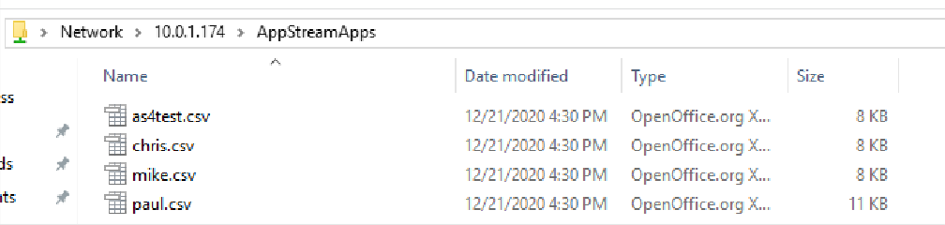
The configuration files that are used to deliver Dynamic Applications based on Active Directory groups are held on the WorkSpaces Manager appliance in a share called ‘AppStreamApps’. These will be Read Only to users. Each user who accesses AppStream and uses Dynamic Applications will have one and is written automatically by WorkSpaces Manager.

The information contained within each of these user files will provide access to the applications that user is granted via Active Directory group.

8.2.7 Prevent users accessing AppStream and running up a session when they do not have any application assigned
Yes. An administrator will have to control this at the first port of call for user access. For example, if using Okta, the administrator would use another Active Directory group to show the AppStream stack icon. If using GSuite only, the administrator would not configure the user to use AppStream based on their own account (hence the service would not be available to them).
Instructions on how to do this are outside the scope of this document.

